**S.P.Mandali’s**

Ramnarain Ruia Autonomous College

Mantunga,Mumbai-400019

Mumbai University

**Project Report**

On

“Medical Shop”

**Under the Guidnance of**

Prof.Rasika Munde

**Project By**

Prasad Shankar Yadav.

Department of Computer Science

2017-2018

Acknowledgement

* I, Mr.Prasad Shankar Yadav ,student of Ramnarain Ruia Autonomous College, acknowledgement my sincere gratitude to all those who helped me in the project work of T.Y.BSc Computer science.
* I extend my gratitude towards my project guide, Prof. Rasika Munde to help me to go ahead with my project and appreciating my work at every stage.
* I would like to thank my friends for helping me with the project whenever needed the most.

Prasad Shankar Yadav.

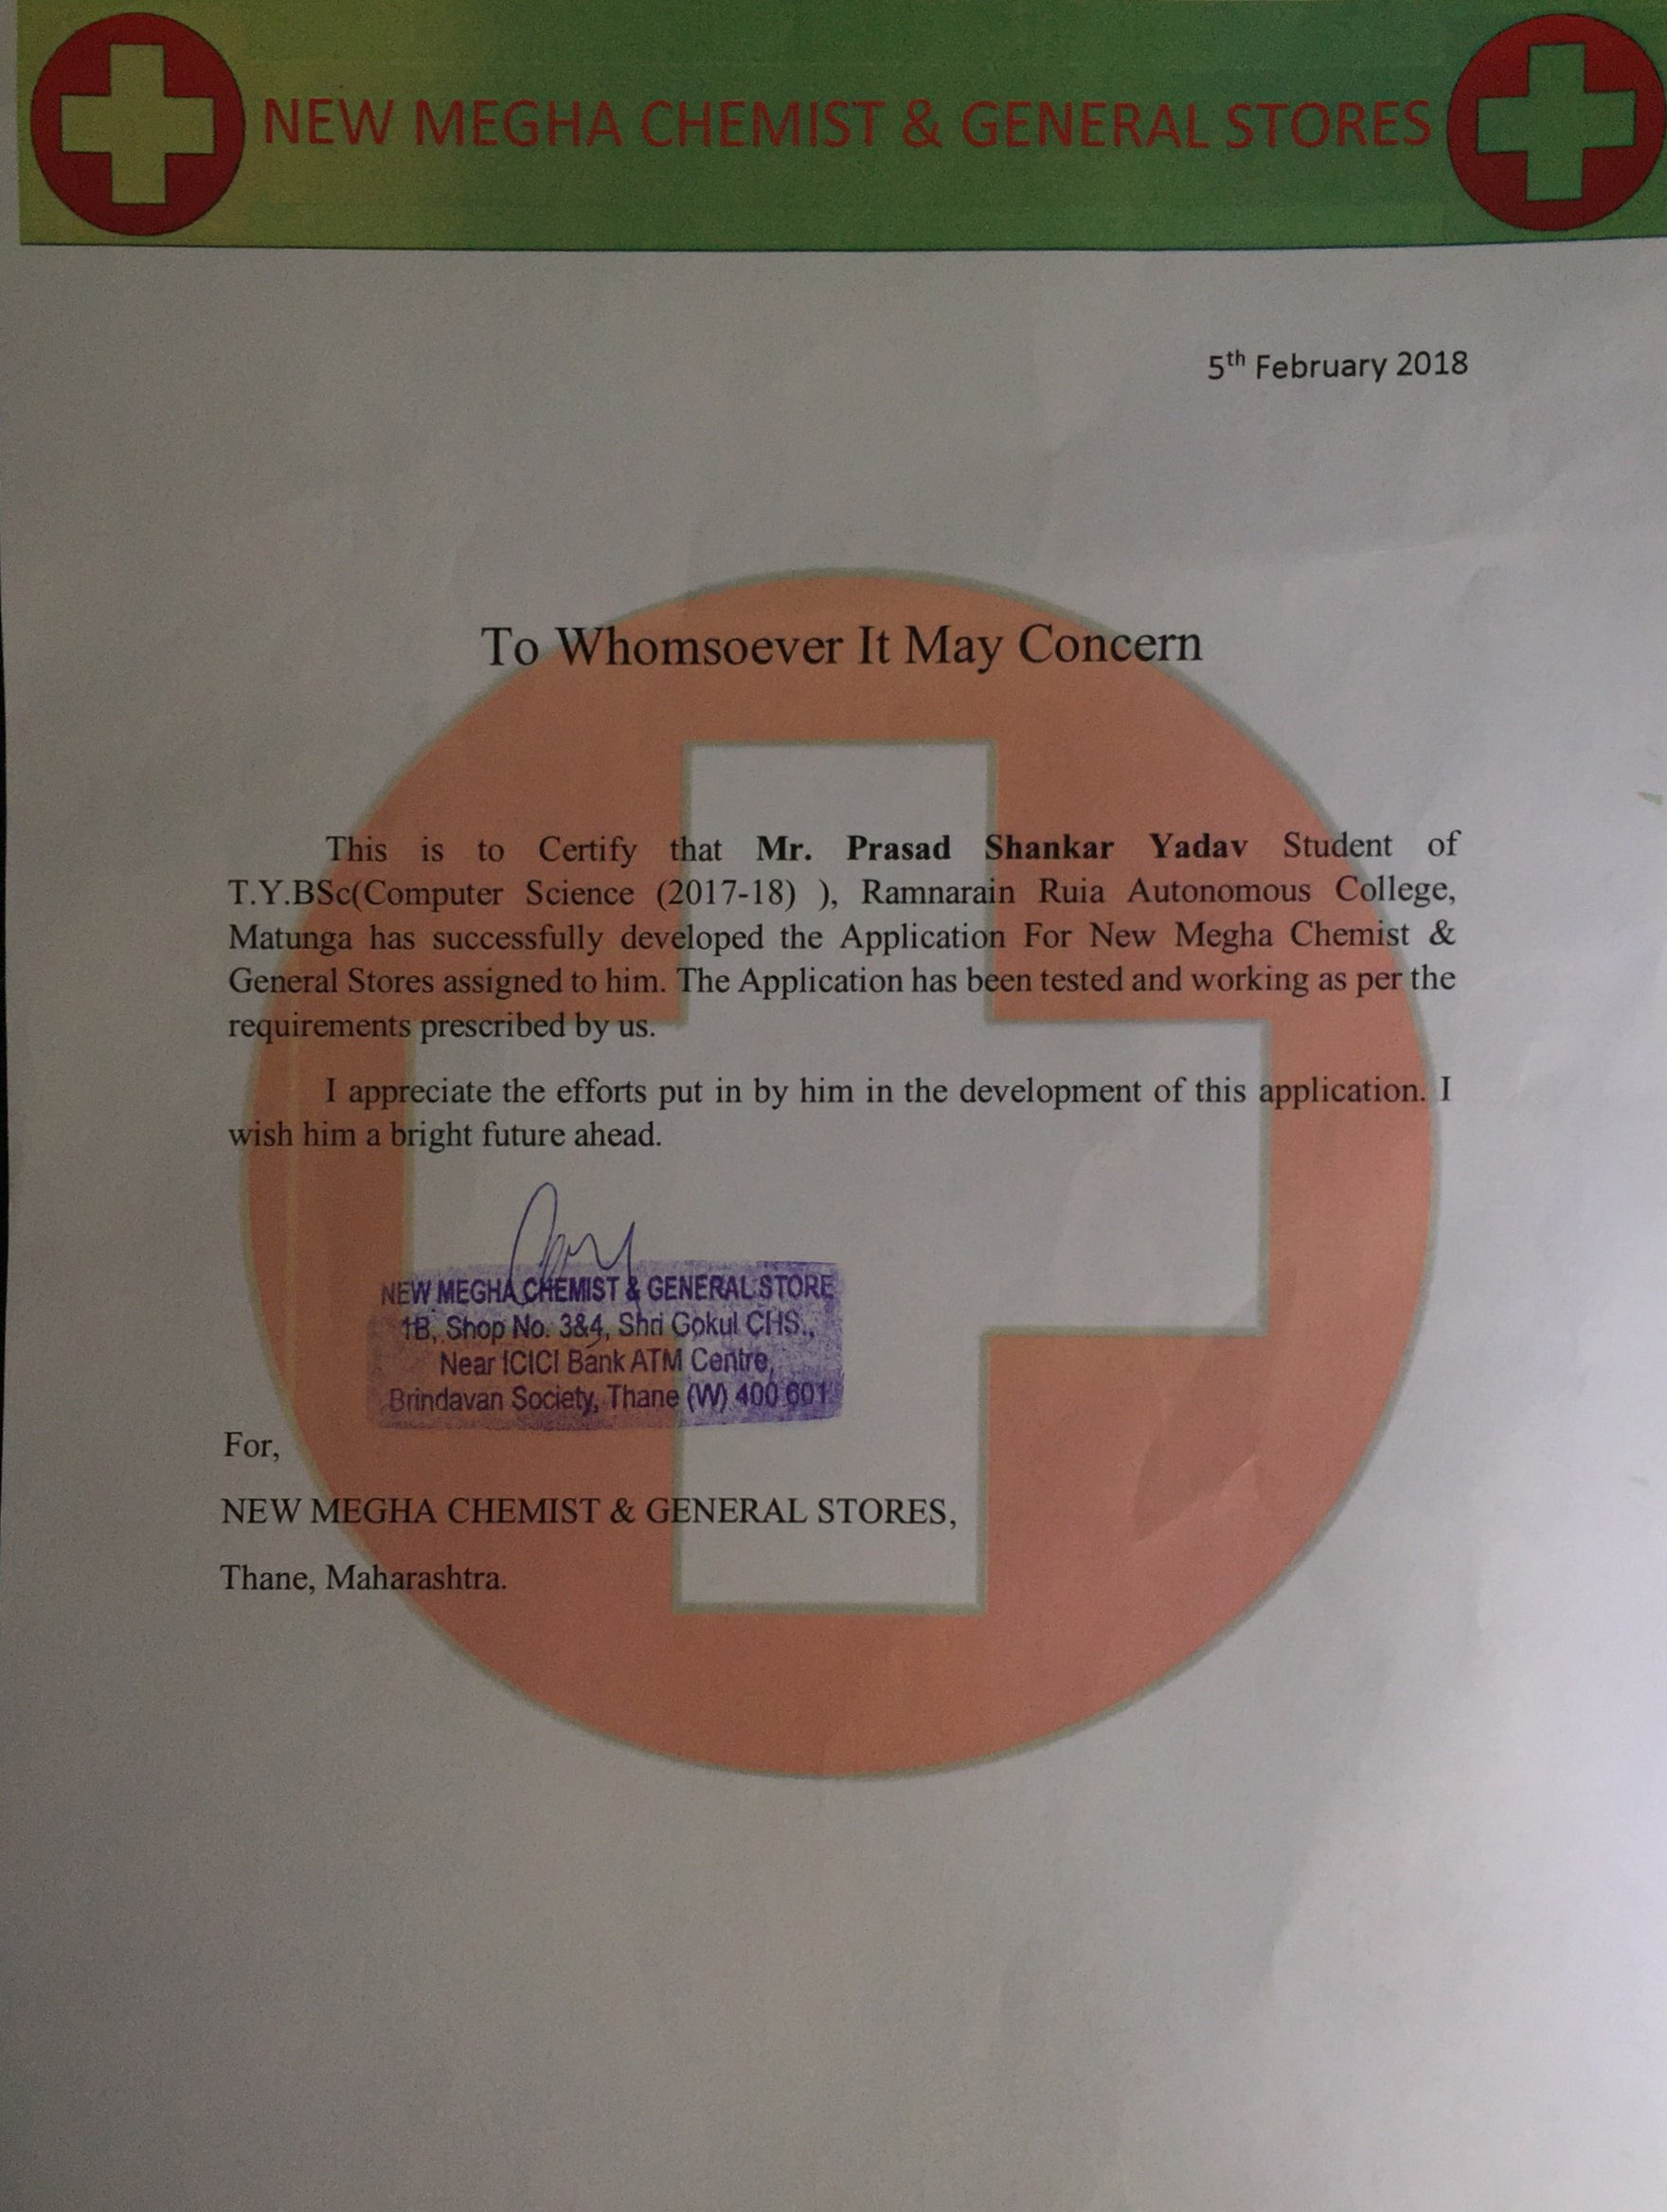

**Preliminary Investigation.**

* **The Current System.**

1. All the Records use paperwork.
2. New workers cannot find medicine easily where they put in shelf.
3. The customer employee expanses & order details is pointed on file or data.

* **Drawbacks.**

1. Process is time consuming.
2. They take more time to find medicine.
3. More expensive.
4. Searching problem.
5. Maintain problems of all registers.
6. Less accuracy.
7. Get all Expiry Medicine Easily.

* **Proposed Sysyem**.

1. Main goal of application is maintain records purchase sake & stock details with transaction maintaince.
2. Automatically shows expirary date when it comes to expire & delete product details automatically that has been expired.
3. User friendly.
4. The working through register system is not only labourites & time consuming.

* **Advantages of proposed system.**

1. Time saving.
2. More accuracy.
3. Powerful searching.
4. Less expansive.
5. Easy to keep.
6. Process work is computerised so errors will be reduced.

* **Feasbility study.**
* **Technical**

1. Involves study of various hardware and software components available.
2. It just requires window os.
3. The current manual working is not so much difficult.
4. It does not require much technical details.

* **Economic.**

1. The benefits cost analysis.
2. The orgainsation is ready to invest in proposed system for latest.
3. Technology & best result.

* **Operational.**

1. The operational feasibility is obtained by consulting with system uses.
2. The existing system is computerised & extremely user friendly.

* **Stake Holders** .

1. **Manager .**
2. **Employee.**

* Project requirements
* **Hardware**

1. 512Ram.
2. 1Gb secondary storage.

* **Software.**

1. O.S,Windows xp.
2. Sql plus.
3. Java netbeans.

**Gantt Chart**

|  |  |  |  |  |  |  |  |  |  |  |  |  |  |  |  |  |  |  |  |  |  |
| --- | --- | --- | --- | --- | --- | --- | --- | --- | --- | --- | --- | --- | --- | --- | --- | --- | --- | --- | --- | --- | --- |
| Phase Title | June | | | | | July | | | | | | August | | | | | September | | | | |
|  | 1 | 2 | 3 | 4 | 5 | 1 | 2 | 3 | 4 | 5 | 6 | 1 | 2 | 3 | 4 | 5 | 1 | 2 | 3 | 4 | 5 |
| Project Approval |  |  |  |  |  |  |  |  |  |  |  |  |  |  |  |  |  |  |  |  |  |
|  |  |  |  |  |  |  |  |  |  |  |  |  |  |  |  |  |  |  |  |  |
|  |  |  |  |  |  |  |  |  |  |  |  |  |  |  |  |  |  |  |  |  |
| Preliminary Investigation |  |  |  |  |  |  |  |  |  |  |  |  |  |  |  |  |  |  |  |  |  |
|  |  |  |  |  |  |  |  |  |  |  |  |  |  |  |  |  |  |  |  |  |
|  |  |  |  |  |  |  |  |  |  |  |  |  |  |  |  |  |  |  |  |  |
| System Analysis and Design | | | | | | | | | | | | | | | | | | | | | |
| Event Table |  |  |  |  |  |  |  |  |  |  |  |  |  |  |  |  |  |  |  |  |  |
|  |  |  |  |  |  |  |  |  |  |  |  |  |  |  |  |  |  |  |  |  |
|  |  |  |  |  |  |  |  |  |  |  |  |  |  |  |  |  |  |  |  |  |
| Class Diagram |  |  |  |  |  |  |  |  |  |  |  |  |  |  |  |  |  |  |  |  |  |
|  |  |  |  |  |  |  |  |  |  |  |  |  |  |  |  |  |  |  |  |  |
|  |  |  |  |  |  |  |  |  |  |  |  |  |  |  |  |  |  |  |  |  |
| Use Case Diagram |  |  |  |  |  |  |  |  |  |  |  |  |  |  |  |  |  |  |  |  |  |
|  |  |  |  |  |  |  |  |  |  |  |  |  |  |  |  |  |  |  |  |  |
|  |  |  |  |  |  |  |  |  |  |  |  |  |  |  |  |  |  |  |  |  |
| Use Case Specification |  |  |  |  |  |  |  |  |  |  |  |  |  |  |  |  |  |  |  |  |  |
|  |  |  |  |  |  |  |  |  |  |  |  |  |  |  |  |  |  |  |  |  |
|  |  |  |  |  |  |  |  |  |  |  |  |  |  |  |  |  |  |  |  |  |
| Sequence Diagram |  |  |  |  |  |  |  |  |  |  |  |  |  |  |  |  |  |  |  |  |  |
|  |  |  |  |  |  |  |  |  |  |  |  |  |  |  |  |  |  |  |  |  |
|  |  |  |  |  |  |  |  |  |  |  |  |  |  |  |  |  |  |  |  |  |
| Activity Diagram |  |  |  |  |  |  |  |  |  |  |  |  |  |  |  |  |  |  |  |  |  |
|  |  |  |  |  |  |  |  |  |  |  |  |  |  |  |  |  |  |  |  |  |
|  |  |  |  |  |  |  |  |  |  |  |  |  |  |  |  |  |  |  |  |  |
| State Chart Diagram |  |  |  |  |  |  |  |  |  |  |  |  |  |  |  |  |  |  |  |  |  |
|  |  |  |  |  |  |  |  |  |  |  |  |  |  |  |  |  |  |  |  |  |
|  |  |  |  |  |  |  |  |  |  |  |  |  |  |  |  |  |  |  |  |  |

|  |  |  |  |  |  |  |  |  |  |  |  |  |  |  |  |  |  |  |  |  |  |  |  |  |
| --- | --- | --- | --- | --- | --- | --- | --- | --- | --- | --- | --- | --- | --- | --- | --- | --- | --- | --- | --- | --- | --- | --- | --- | --- |
| Phase Title | October | | | | | November | | | | | December | | | | | Januray | | | | | February | | | |
|  | 1 | 2 | 3 | 4 | 5 | 1 | 2 | 3 | 4 | 5 | 1 | 2 | 3 | 4 | 5 | 1 | 2 | 3 | 4 | 5 | 1 | 2 | 3 | 4 |
| Coding |  |  |  |  |  |  |  |  |  |  |  |  |  |  |  |  |  |  |  |  |  |  |  |  |
|  |  |  |  |  |  |  |  |  |  |  |  |  |  |  |  |  |  |  |  |  |  |  |  |
|  |  |  |  |  |  |  |  |  |  |  |  |  |  |  |  |  |  |  |  |  |  |  |  |
| Testing |  |  |  |  |  |  |  |  |  |  |  |  |  |  |  |  |  |  |  |  |  |  |  |  |
|  |  |  |  |  |  |  |  |  |  |  |  |  |  |  |  |  |  |  |  |  |  |  |  |
|  |  |  |  |  |  |  |  |  |  |  |  |  |  |  |  |  |  |  |  |  |  |  |  |
| Implementation |  |  |  |  |  |  |  |  |  |  |  |  |  |  |  |  |  |  |  |  |  |  |  |  |
|  |  |  |  |  |  |  |  |  |  |  |  |  |  |  |  |  |  |  |  |  |  |  |  |
|  |  |  |  |  |  |  |  |  |  |  |  |  |  |  |  |  |  |  |  |  |  |  |  |

|  |  |  |  |  |  |
| --- | --- | --- | --- | --- | --- |
|  | Actual Time of Completion |  | Expected Time of Completion |  | Break |

**Event Table**

**Manager.**

|  |  |  |  |  |  |  |
| --- | --- | --- | --- | --- | --- | --- |
| **SR NO** | **EVENT** | **TRIGGER** | **SOURCE** | **ACITIVITY** | **RESPONSE** | **DESTINATION** |
| 1. | Manager logs in | Login Request | Manager | Manager Logs in | Registration Successfull | Manager |
| 2. | Adds Medicine | Request to add Medicine | Manager | Add medicine to Inventory | Information Saved | Medicine |
| 3. | Update Medicine | Request to  Update Medicine | Manager | Update Quantity | Information Update Medicine | Medicine |
| 4. | Delete Medicine | Medicine Deletion | Manager | Delete Expired Medicine | Information Deleted | Medicine |
| 5. | Add Employee | Request to Add Employee | Manager | Add Employee Details | Added Successful | Manager |
| 6. | Delete Employee | Request to Employee  Delete | Manager | Delete Employee Details | Information Details | Manager |
| 7. | Add Supplier | Request to Add Supplier | Manager | Add Supplier Details | Added Successful | Manager |
| 8. | Delete Supplier | Request to Delete Supplier | Manager | Delete Supplier  Details | Deleted Successful | Manager |
| 9. | View Medicine Details | Request to View medicine | Manager | Search Medicine Details | Search Successful | Manager |
| 10. | View Supplier details | Request to View Supplier | Manager | Search Supplier Details | Search Successful | Manager |
| 11. | View Employee Details | Request to View Employee | Manager | Search Employee  Details | Search Successful | Manager |
| 12. | View Bill Details | Request to view Bill details | Manager | Search Bill Details | Search Successful | Manager |
| 13. | View Order Details | Request to view Order Details | Manager | Search Order Details | Search Successful | Manager |
| 14. | Update Supplier details | Request to update supplier details | Manager | Update Supplier details | Information updated | Manager |
| 15. | Update Employee details | Request to update employeedetails | Manager | Update employee details | Information updated |  |

**Employee.**

|  |  |  |  |  |  |  |
| --- | --- | --- | --- | --- | --- | --- |
| **SR NO** | **EVENT** | **TRIGGER** | **SOURCE** | **ACITIVITY** | **RESPONSE** | **DESTINATION** |
| 1. | Employee Login | Request to Login | Employee | Verification | Logged In | Employee |
| 2. | Employee Search for Medicines | Medicine Search | Employee | Search for Medicine | Search Successfully | Employee |
| 3. | Employee Generates Bill | Request to generate Bill | Employee | Generate Bill | Bill Generated | Employee |
| 4. | Add Doctor Details | Request to Add Doctor Details | Employee | Add Doctor Details | Information Added | Employee |
| 5. | Add Customer Details | Request to Add Customer Details | Employee | Add Customer Details | Information Added | Employee |
| 6. | Print Bill | Request to print Bill | Employee | Print Bill | Printed Successful | Employee |

**Class Diagram**

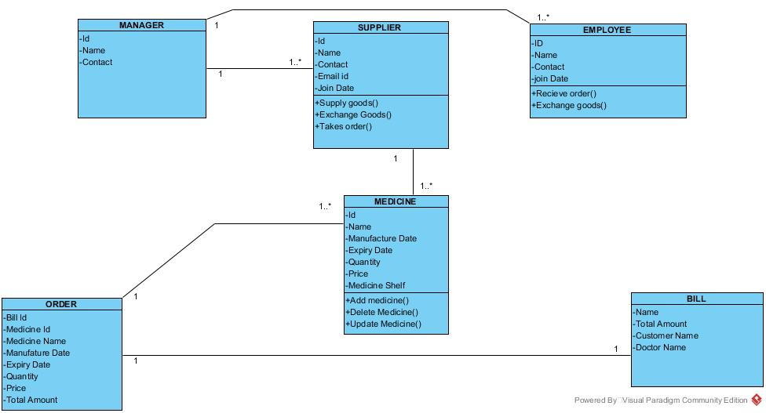

**Use case**

1. **Manager**

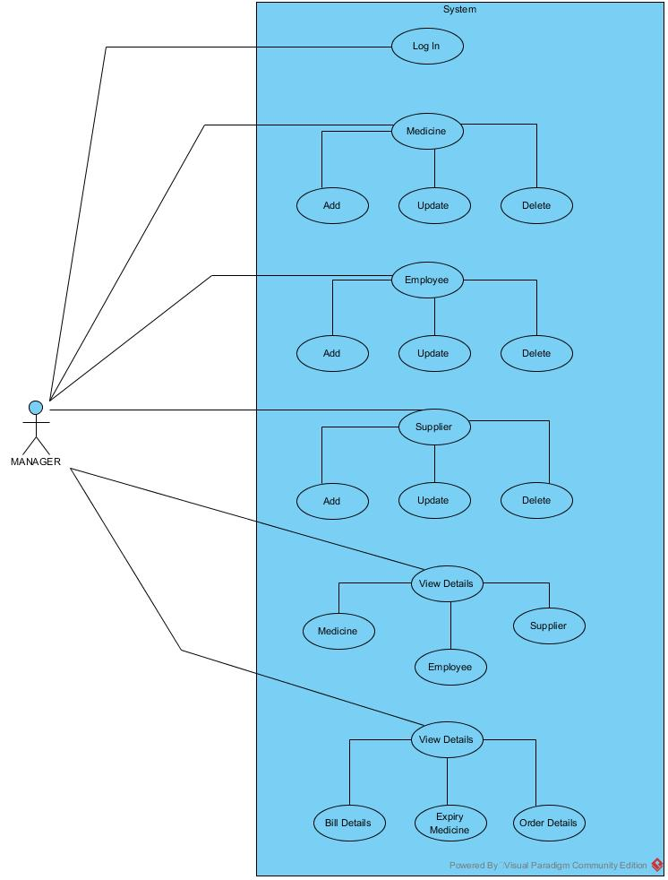

*2.***Employee.**

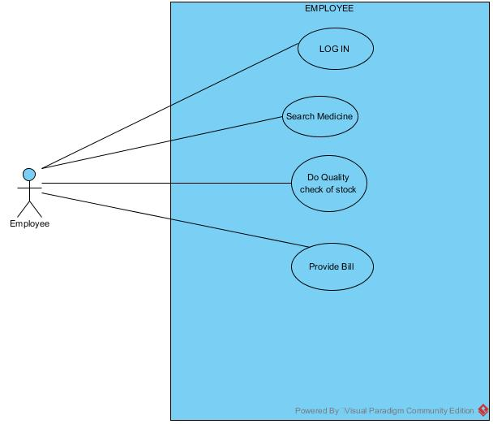

**Use case scenario.**

1. **MANAGER LOGS INTO HIS ACCOUNT**

This use case describes how the manager logs in his system

* **ACTORS:-**Manager
* **Flow of Event:-**
* **1)Basic flow**

i.) Manager requests to log into the system.

ii.) Login details are verified from the database.

iii.) Login request granted.

* **2)Alternative Flow.**

Login details are incorrect access denied.

* **PRE CONDITION:-**

manager must have registered earlier.

* **POST CONDITION:-**

User is logged in.

1. **MANAGER ADDS MEDICINE.**

This use case describes how to add medicine

* **ACTORS:-**Manager.
* **FLOW OF EVENTS:-**
* **Basic Flow**

i.)Manager provides medicine details.

ii.)Manager Adds the medicine to the system.

iii.)Save the details in the system.

iv.)System completes the proccesss & adds medicine successfully.

* **ALTERNATIVE FLOW.**

i.)Medicine Details not provided

ii.)Medicine not at good quality or expired.

* **PRE CONDITION:-**

Medicine details should be specified by manager.

* **POST CONDITION:-**

Medicine details successfully registered by manager

1. **UPDATE MEDICINE.**

Manager wants to update the medicine.

* **ACTORS:- MANAGER.**
* **BASIC FLOW.**

i.)Manager selects to update medicine details.

ii.)Manager updates medicine details by making changes in current

information.

iii.)Add new medicine to the system.

iv.)Complete the process of updation.

* **ALTERNATIVE FLOW.**

Invalid medicine id or name.

* **PRE CONDIOTION.:-**

**i.)**Manager logs into the system

ii.)Medicine details should be present for updating medicine details.

* **POST CONDITION.:-**

Information is updated System populated the details with update information.

1. **DELETE THE MEDICINE.**

Manager wants to delete the medicine.

* **ACTORS.:- Manager.**
* **FLOW OF EVENTS.**

i.) Manager selects to delete medicine.

ii.)Manager provides information of the medicine to be deleted.

* **ALTERNATIVE FLOW.**

i.)Invalid information provided.

ii.)Medicine not found.

* **PRE CONDITIONS.:-**

i.)Manager selects to delete.

ii.)All the information of the medicine to be deleted.

1. **ADD SUPPLIER DETAILS.**

Manager Add supplier details.

* **ACTORS.:-** Manager.
* **FLOW OF EVENTS.**
* **Basic flow**

i.)Manager provides supplier details.

ii.)Manager adds the supplier details.

iii.)saves the details in the system.

iv.)System completes the processes and adds supplier details.

* **ALTERNATIVE FLOW.**

Supplier details not provided.

* **PRE CONDITION.:-**

Supplier details should be specified by manager.

* **POST CONDITION. :-**

Supplier details successfully registered by manager.

1. **DELETE SUPPLIER DETAILS.**

Manager delete supplier details.

* **ACTORS.:-**Manager.
* **FLOW OF EVENTS.**
* **Basic flow**

**i.)**Manager selects to delete supplier details.

ii.)Manager provides information of the supplier details to be deleted.

* **ALTERNATIVE FLOW.**

Supplier details not provided.

* **PRE CONDITION.:-**

Supplier details should be specified by manager.

* **POST CONDITION. :-**

Supplier details successfully deleted by manager.

1. **UPDATE SUPPLIER DETAILS.**

Manager wants to update the supplier details.

* **ACTORS:- MANAGER.**
* **BASIC FLOW.**

i.)Manager selects to update supplier details.

ii.)Manager updates supplier details by making changes in current information.

iii.)Add new supplier to the system.

iv.)Complete the process of updation.

* **ALTERNATIVE FLOW.**

Invalid supplier id or name.

* **PRE CONDIOTION.:-**

i.)Manager logs into the system

ii.)supplier details should be present for updating details.

* **POST CONDITION.:-**

Information is updated System populated the details with update information

1. **ADD employee DETAILS.**

Manager Add employee details.

**ACTORS.:-** Manager.

* **FLOW OF EVENTS.**
* **Basic flow**

i.)Manager provides employee details.

ii.)Manager adds the employee details.

iii.)saves the details in the system.

iv.)System completes the processes and adds employee details.

* **ALTERNATIVE FLOW.**

employee details not provided.

* **PRE CONDITION.:-**

employee details should be specified by manager.

* **POST CONDITION. :-**

employee details successfully registered by manager.

1. **DELETE employee DETAILS.**

Manager delete employee details.

* **ACTORS.:-**Manager.
* **FLOW OF EVENTS.**
* **Basic flow**

**i.)**Manager selects to delete employee details.

ii.)Manager provides information of the employee details to be deleted.

* **ALTERNATIVE FLOW.**

Employee details not provided.

* **PRE CONDITION.:-**

Employee details should be specified by manager.

* **POST CONDITION. :-**

Employee details successfully deleted by manager.

1. **UPDATE EMPLOYEE DETAILS.**

Manager wants to update the employee details.

* **ACTORS:-MANAGER.**
* **BASIC FLOW.**

i.)Manager selects to update employee details.

ii.)Manager updates employee details by making changes in current information.

iii.)Add new employee to the system.

iv.)Complete the process of updation.

* **ALTERNATIVE FLOW.**

Invalid employee id or name.

* **PRE CONDIOTION.:-**

**i.)**Manager logs into the system

ii.)Employee details should be present for updating details.

* **POST CONDITION.:-**

Information is updated System populated the details with update information.

1. **Search Expiry Medicine**

This use case case describes how the manager search expiry medicine.

* **Actors:= Manager.**
* **Flow of Event:**
* **Basic Flow:-**

1)Enter Expiry medicine information.

2)Display Expiry medicine information.

* **Alternative Flow:-**

1)Invalid information.

* **Pre condition:-**

Medicine Should be Expired.

* **Post Condition:-**

Display medicine information.

1. **Search Medicine Details.**

This use case case describes how the manager search medicine.

* **Actors:= Manager.**
* **Flow of Event:**
* **Basic Flow:-**

1)Enter medicine information.

2)Display medicine information.

* **Alternative Flow:-**

1)Invalid information.

* **Pre condition:-**

Medicine Should be available.

* **Post Condition:-**

Display medicine information.

1. **Search Employee Details**

This use case case describes how the manager search employee details.

* **Actors:= Manager.**
* **Flow of Event:**
* **Basic Flow:-**

1)Enter employee information.

2)Display employee information.

* **Alternative Flow:-**

1)Invalid information.

* **Pre condition:-**

Employee details Should be available.

* **Post Condition:-**

Display employee information.

1. **Search Supplier Details**

This use case case describes how the manager search supplier.

* **Actors:= Supplier.**
* **Flow of Event:**
* **Basic Flow:-**

1)Enter supplier information.

2)Display supplier information.

* **Alternative Flow:-**

1)Invalid information.

* **Pre condition:-**

Supplier details Should be available.

* **Post Condition:-**

Display supplier information.

1. **Search Order details**

This use case case describes how the manager search order details.

* **Actors:= Manager.**
* **Flow of Event:**
* **Basic Flow:-**

1)Enter order information.

2)Display order information.

* **Alternative Flow:-**

1)Invalid information.

* **Pre condition:-**

Order details Should be available.

* **Post Condition:-**

Display Order information.

1. **Search Bill Details**

This use case case describes how the manager search bill details.

* **Actors:= Manager.**
* **Flow of Event:**
* **Basic Flow:-**

1)Enter bill information.

2)Display bill information.

* **Alternative Flow:-**

1)Invalid information.

* **Pre condition:-**

Bill details Should be available.

* **Post Condition:-**

Display Bill information.

1. **EMPLOYEE LOGS INTO HIS ACCOUNT**

This use case describes how the employee logs in his system

* **ACTORS:-** Employee
* **Flow of Event:-**
* **Basic flow**

i.) Employee requests to log into the system.

ii.) Login details are verified from the database.

iii.) Login request granted.

* **Alternative Flow.**

Login details are incorrect access denied.

* **PRE CONDITION:-**

**1)**Employee must have registered earlier.

* **POST CONDITION:-**

User is logged in

1. **Search Medicine**

This use case case describes how the employee search medicine.

* **Actors:= Employee.**
* **Flow of Event:**
* **Basic Flow:-**

1)Enter medicine information.

2)Display medicine information.

* **Alternative Flow:-**

1)Invalid information.

* **Pre condition:-**

Medicine Should be available.

* **Post Condition:-**

Display medicine information.

1. **Generate Bill**

This use case case describes how the employee generate bill.

* **Actors:=Employee.**
* **Flow of Event:**
* **Basic Flow:-**

1)Enter bill information.

2)Display bill information.

* **Alternative Flow:-**

1)Invalid information.

* **Pre condition:-**

Bill details Should be available.

* **Post Condition:-**

Display Bill information.

1. **Check stock.**

This use case describes how employee check the stock.

* **Actors:-**Employee.
* **Flow of events:-**
* **Basic flow:-**

Medicine is out of stock.

* **Pre conditions.:=** 
  + - 1. Request to search medicine.
      2. system check availibitlity of medicine.
      3. display the medicine stock.
* **Alternative Flow:-**

Employee should be know medicine details.

* **Post Conditions.**

Display medicine information.

**Activity Diagram**

1. **Manager Login**

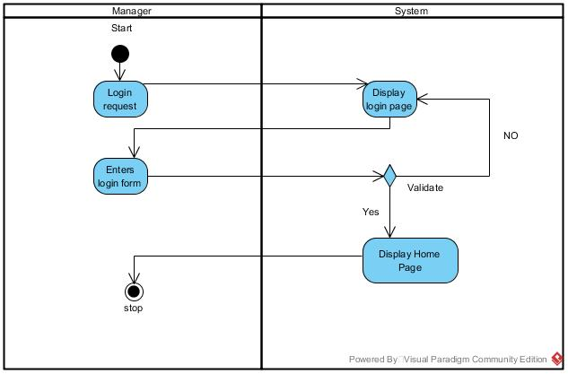

1. **Add Medicine**

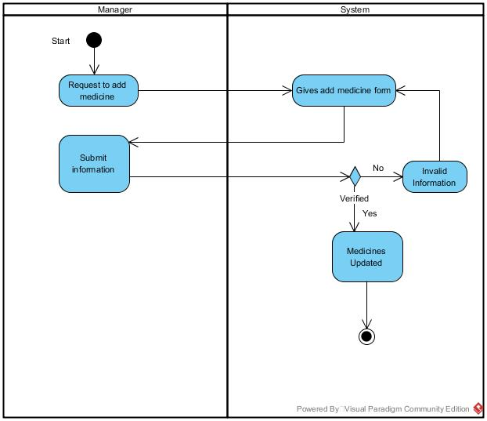

1. **Update Medicine**

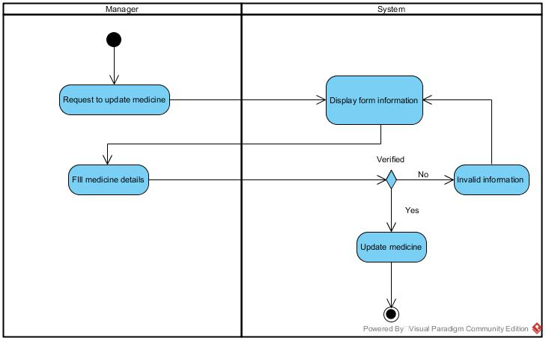

1. **Delete Medicine**

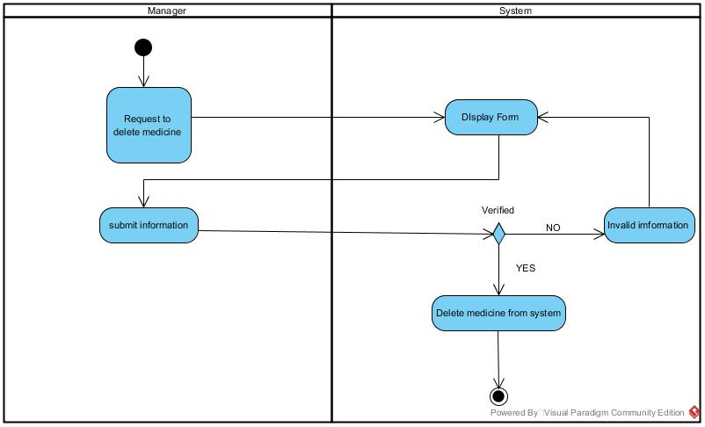

1. **Add Employee**

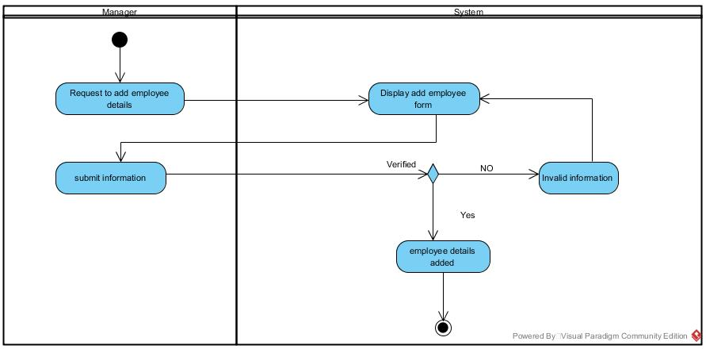

1. **Delete Employee**

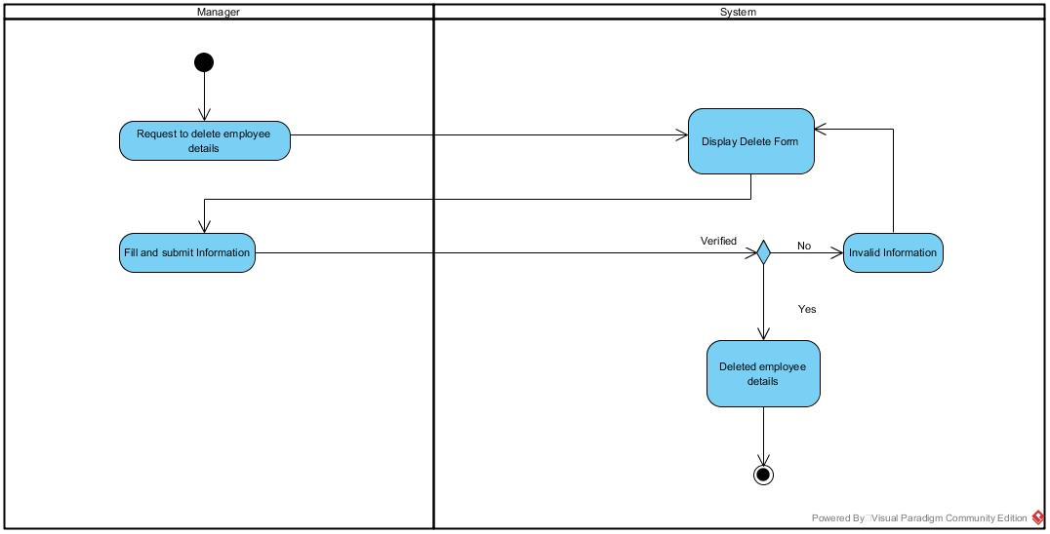

1. **Add Supplier**

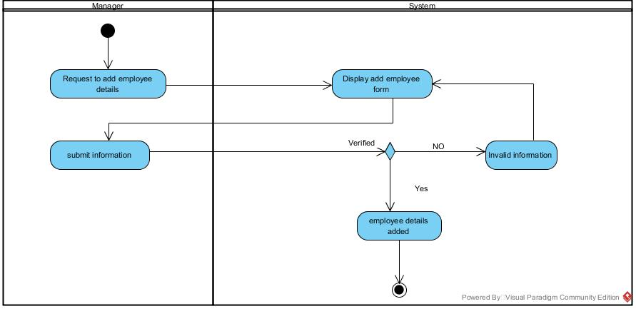

1. **Delete Supplier**



1. **Update Supplier Details**

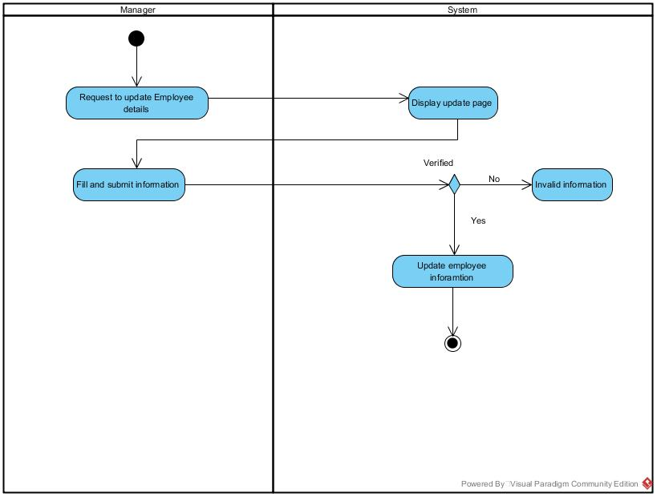

1. **Update Employee Details**

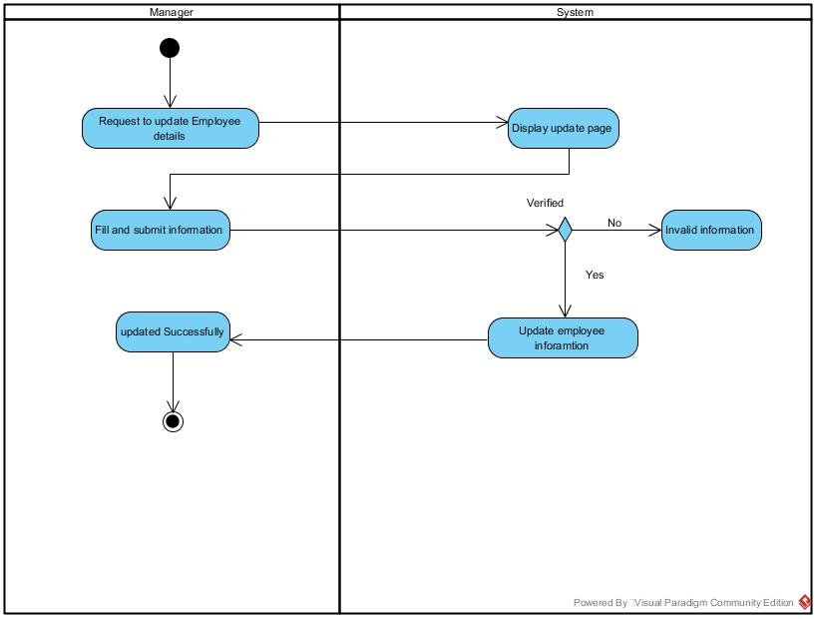

**11.View Employee details**

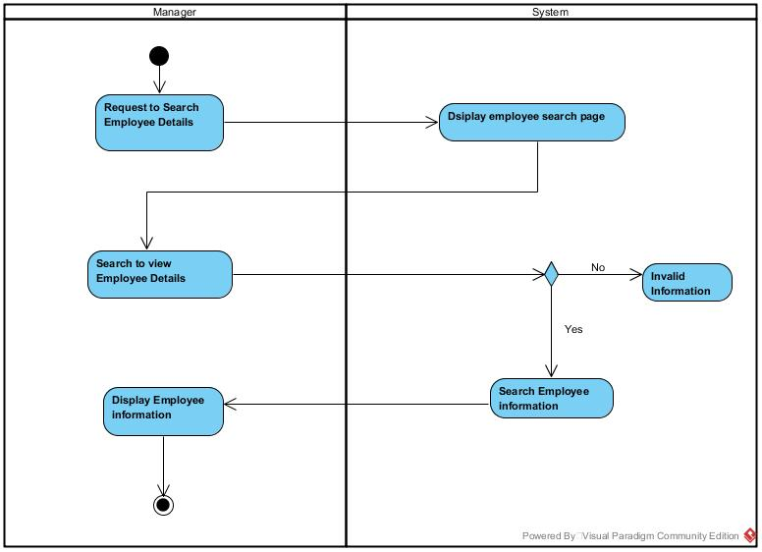

**12.View medicine details**

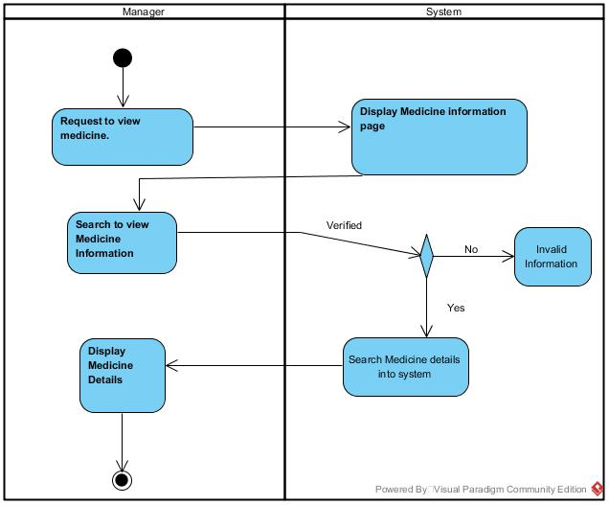

**13.View Supplier Details**

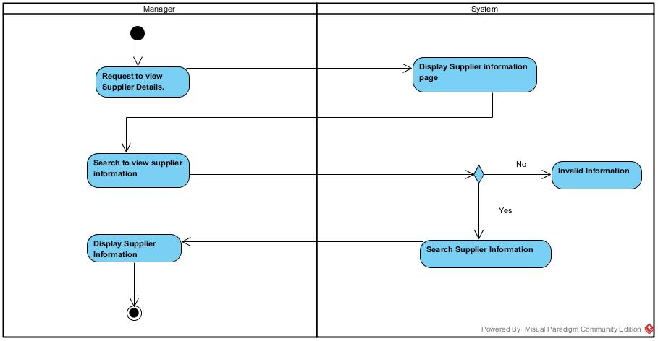

**14.View Expiry Medicine**

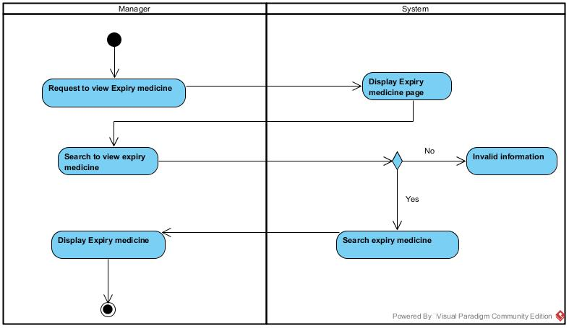

**15.View Bill Details**

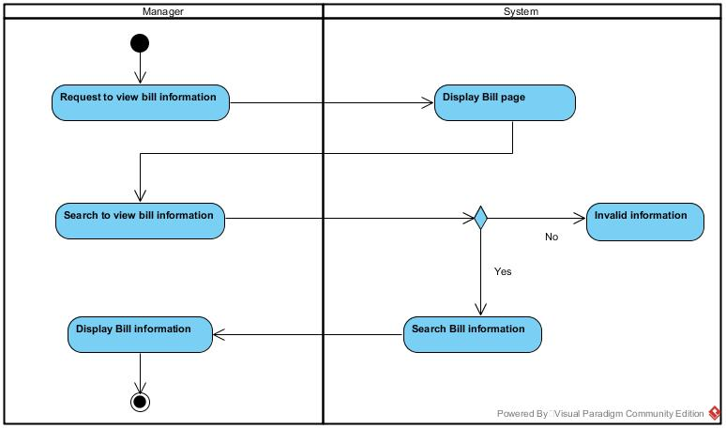

**16.View Order Details.**

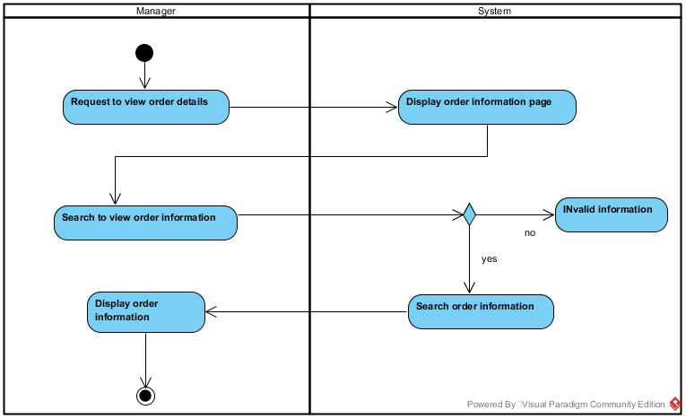

**Employee**

1. **Employee Login**

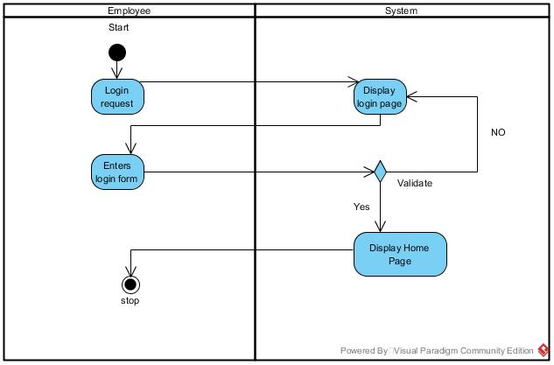

1. **Search Medicine**

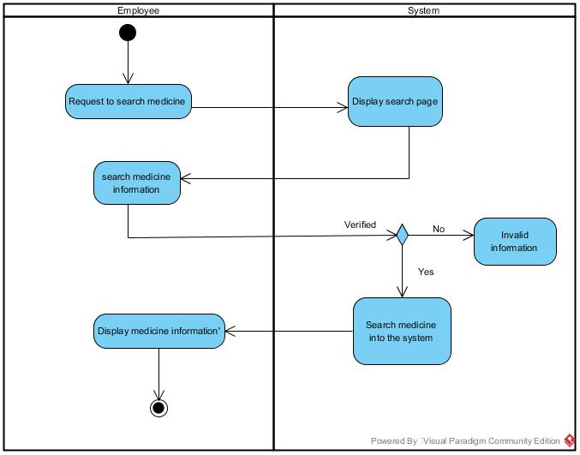

1. **Generate Bill**

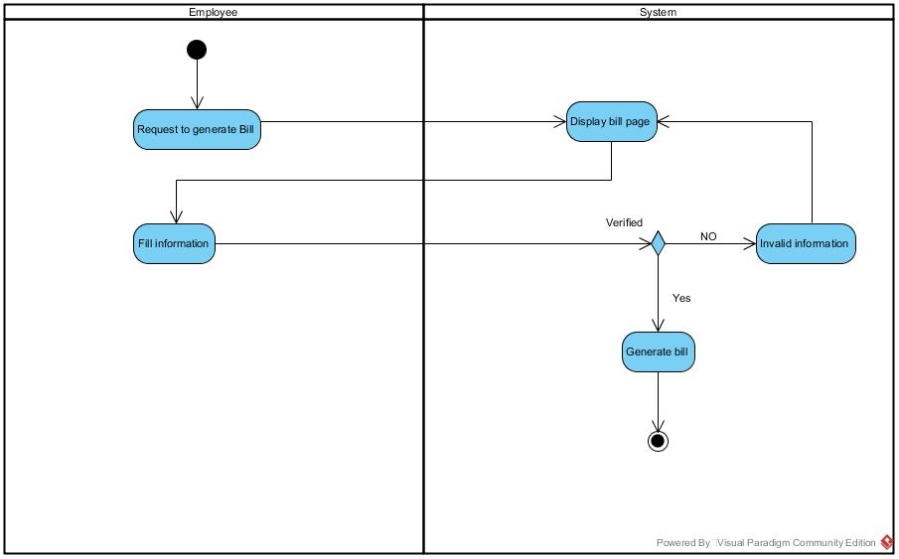

1. **Check Stock**

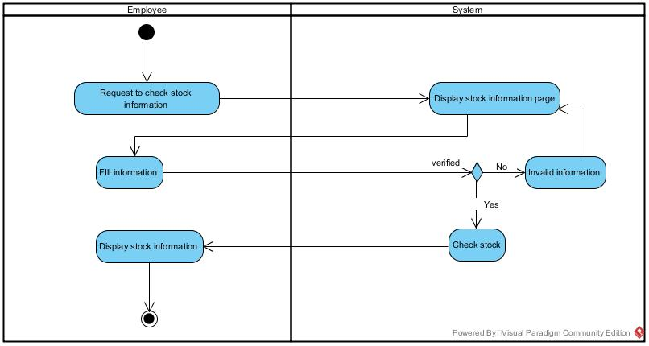

**SEQUENCE DIAGRAM**

**Manager**

1. **Login**

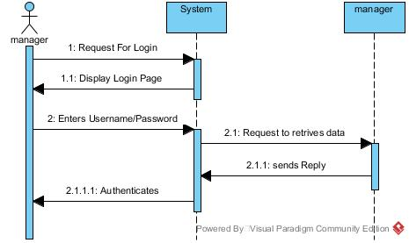

1. **Add Medicine**

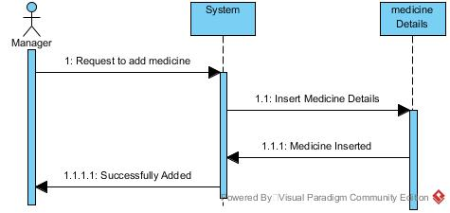

**3.Update Medicine**

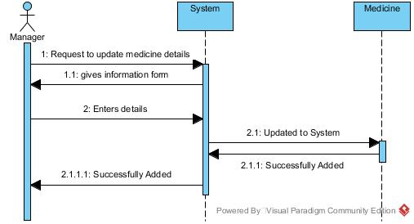

**4.Delete Medicine**

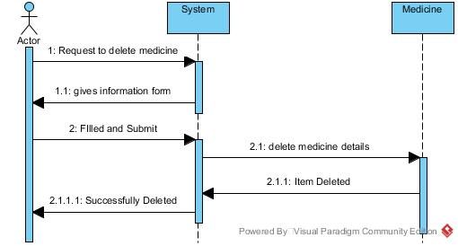

**5.Add Supplier**

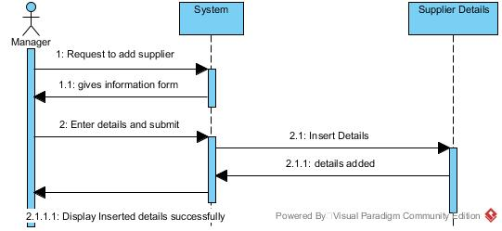

**6.Delete Supplier**

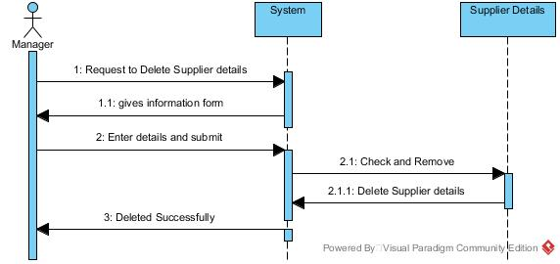

**7.Update Supplier**

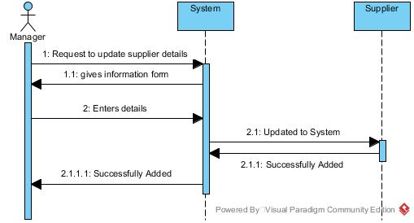

**8.Add Employee**

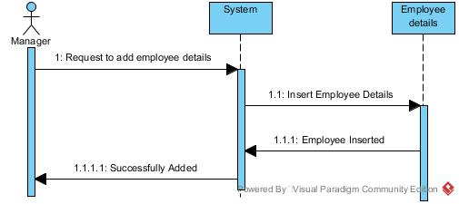

**9.Update Employee**

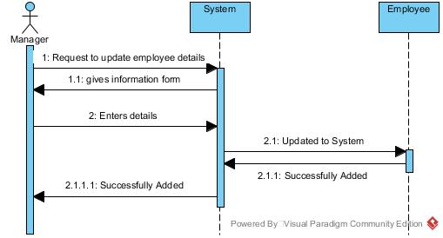

**10.Delete Employee**

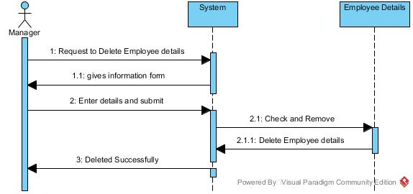

**11.View Expiry Medicine**

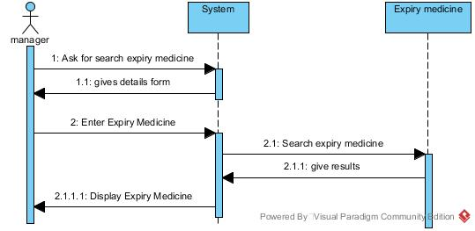

**12.View Order Details**



**13.View Bill Details**

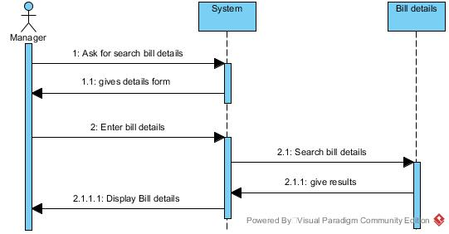

**14.View Medicine Details**

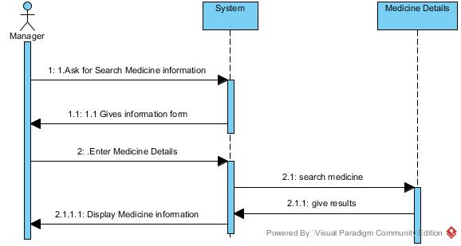

**15.View Supplier Details**

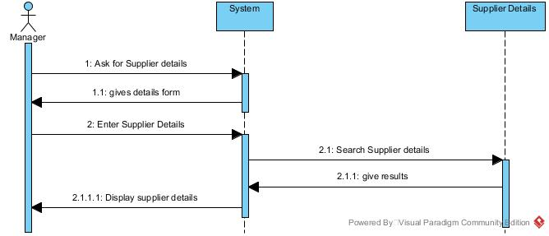

**16.View Employee Details.**

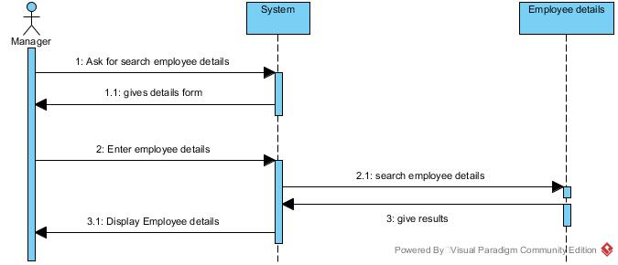

1. **Employee Login**

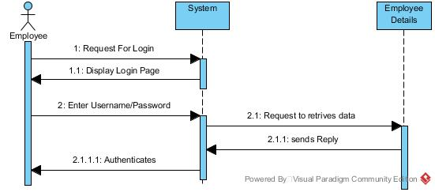

1. **Generate Bill**

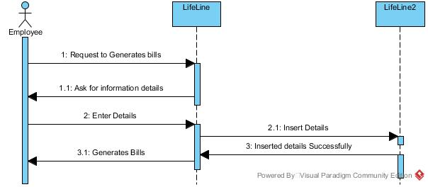

1. **Search Medicine**

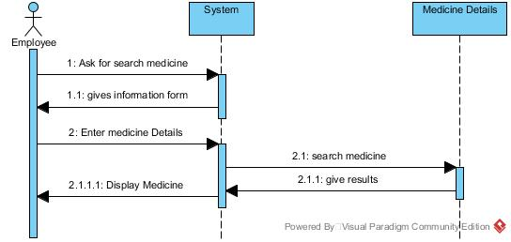

**STATE DIAGRAM**

1. **Customer**

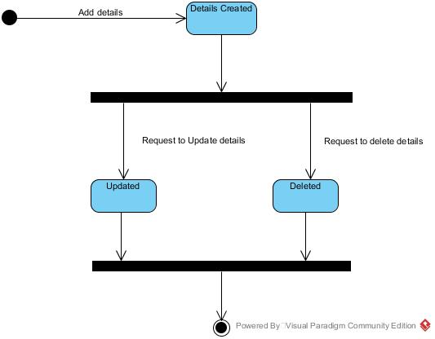

1. **Employee**

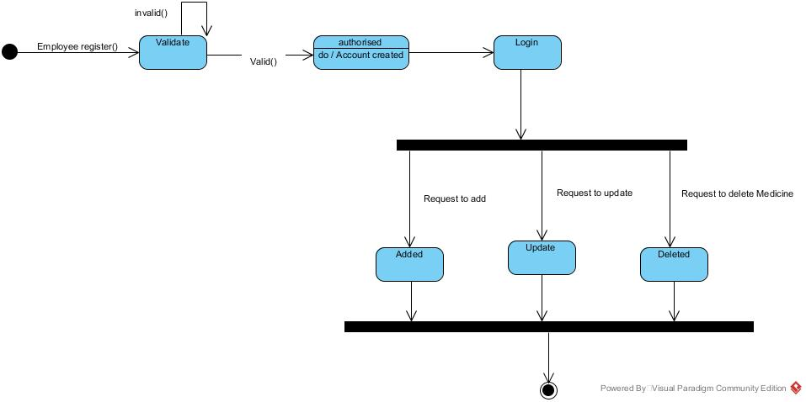

1. **Manager**

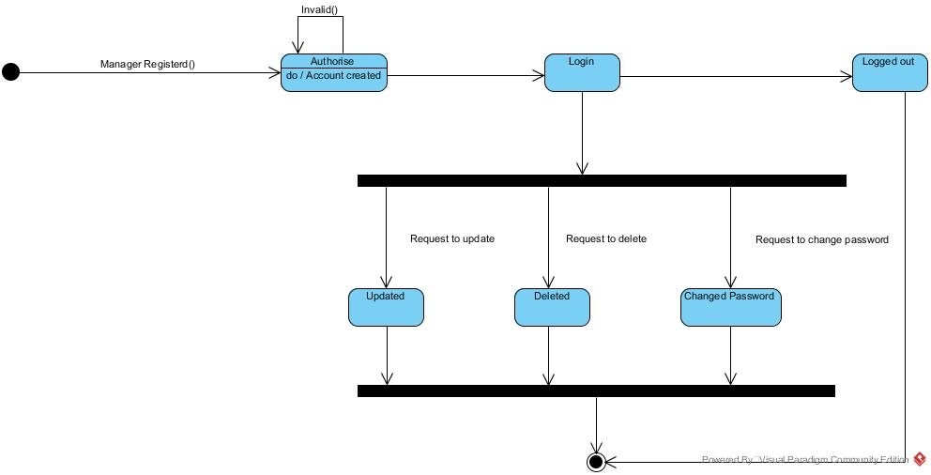

1. **Medicine**

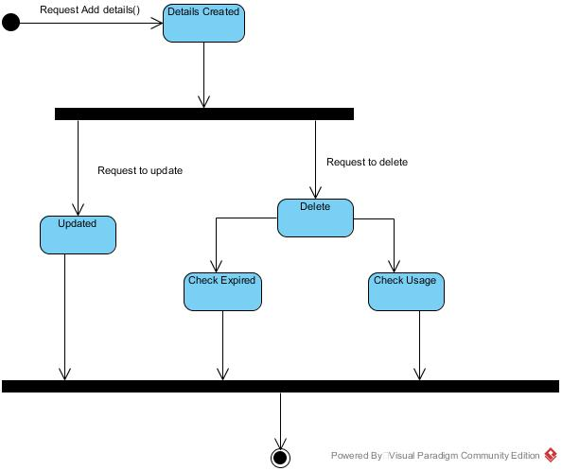

1. **Order**

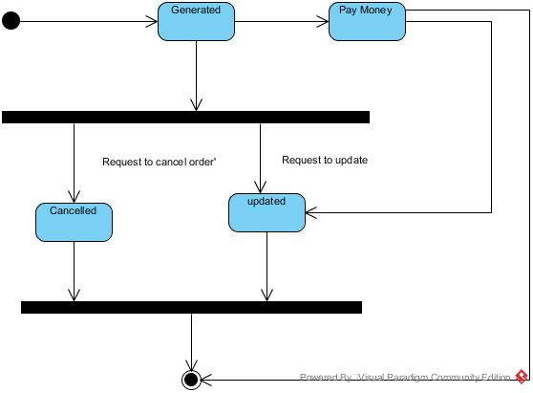

1. **Bill**

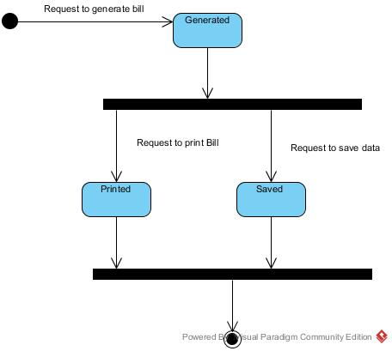

**Gui**

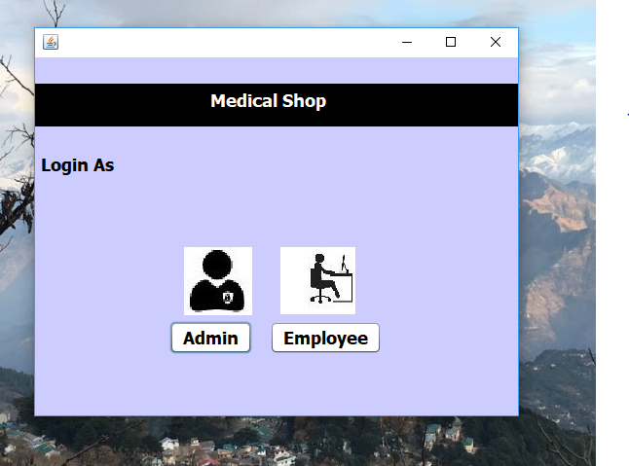

**Admin Login**

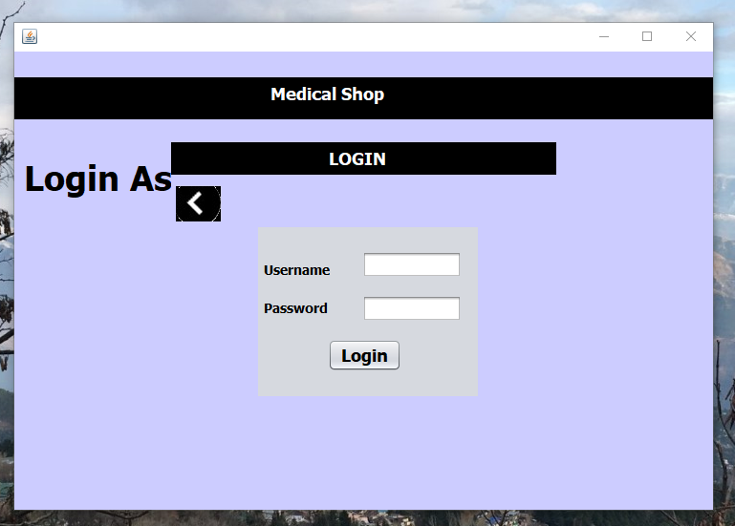

**Admin Homepage**





Add Supplier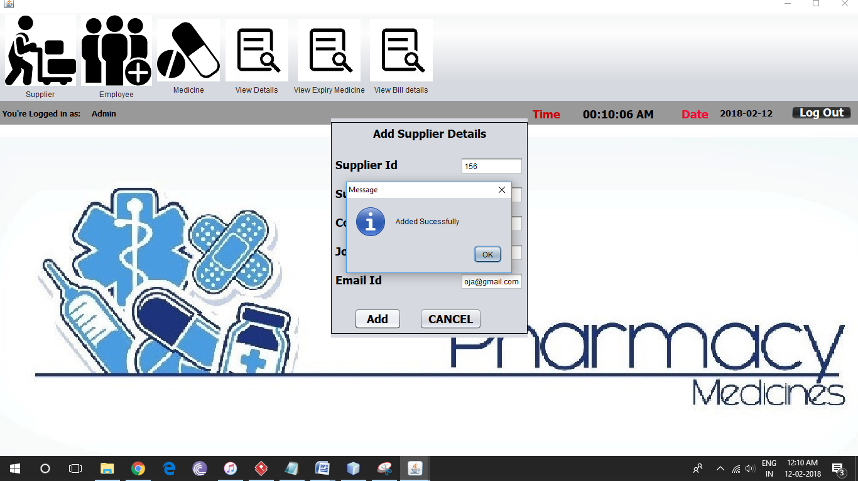

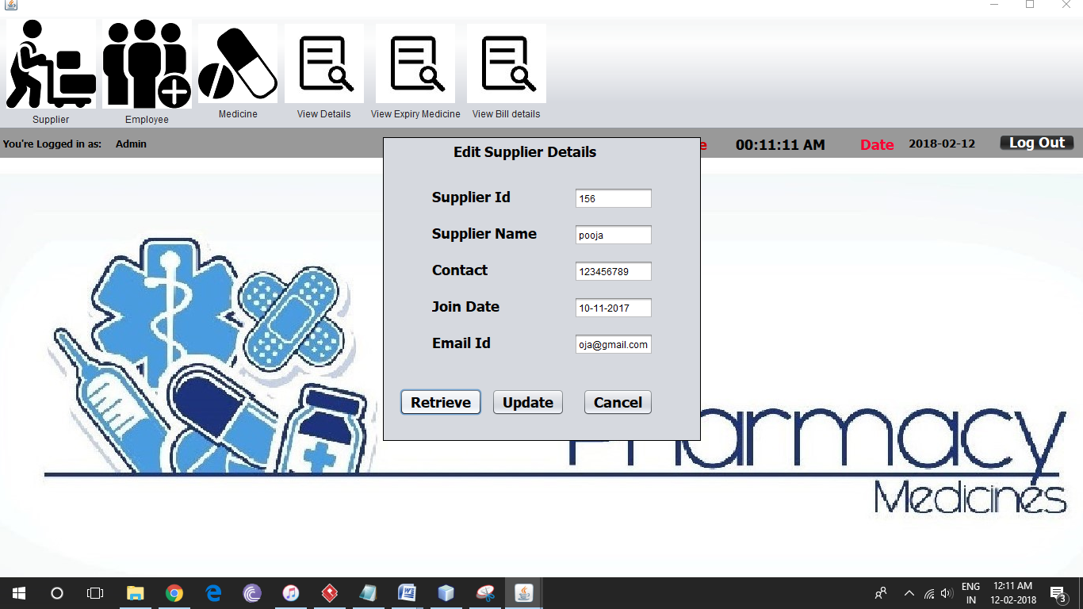

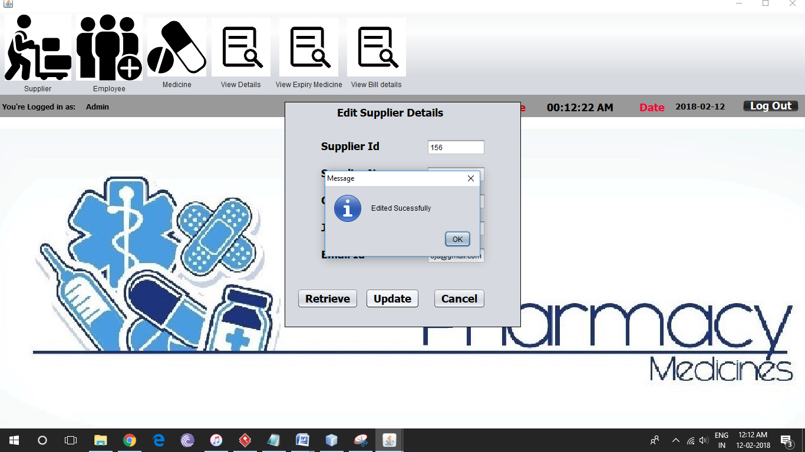

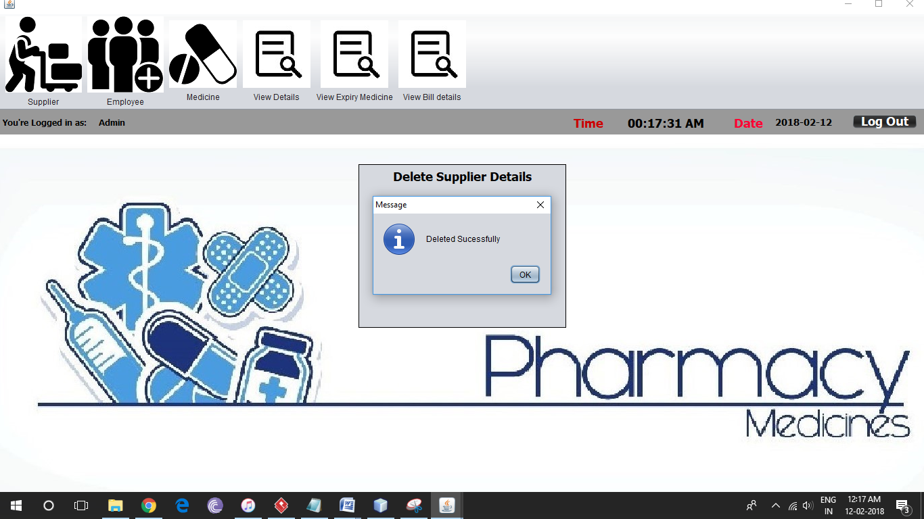

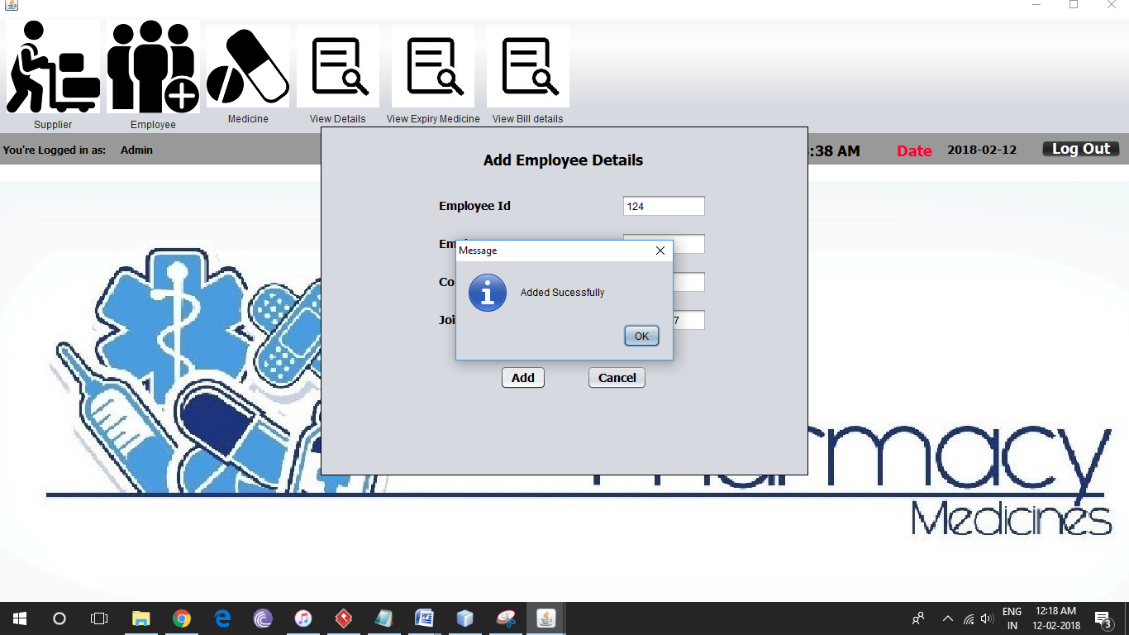

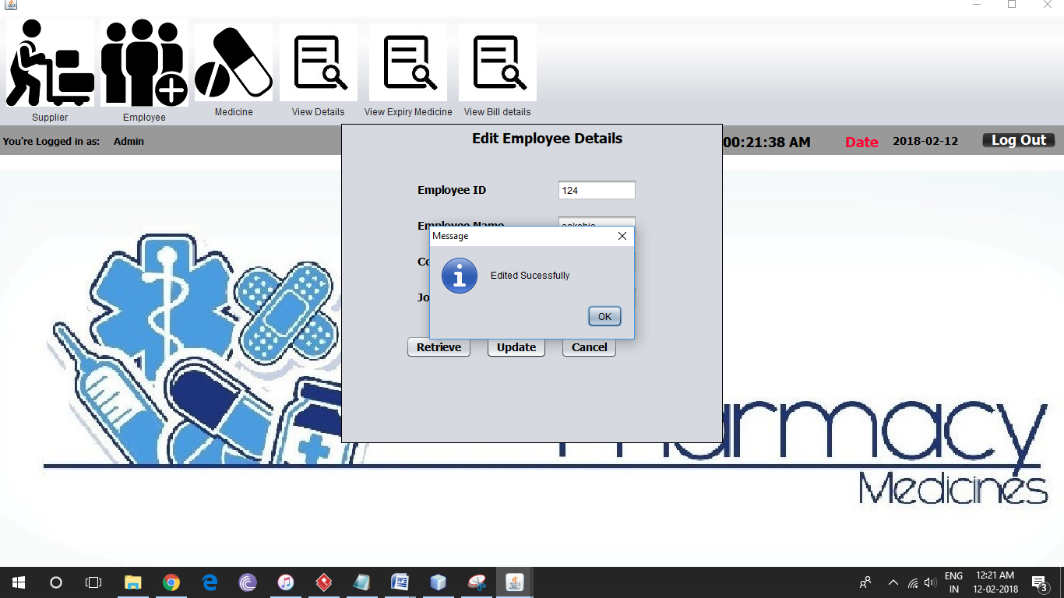

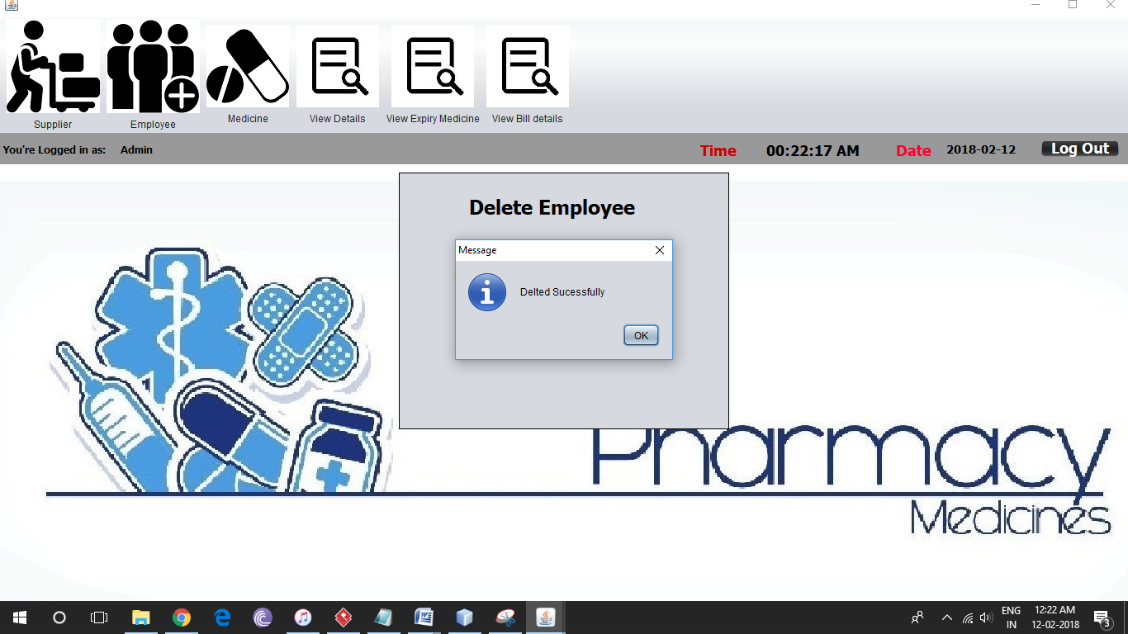

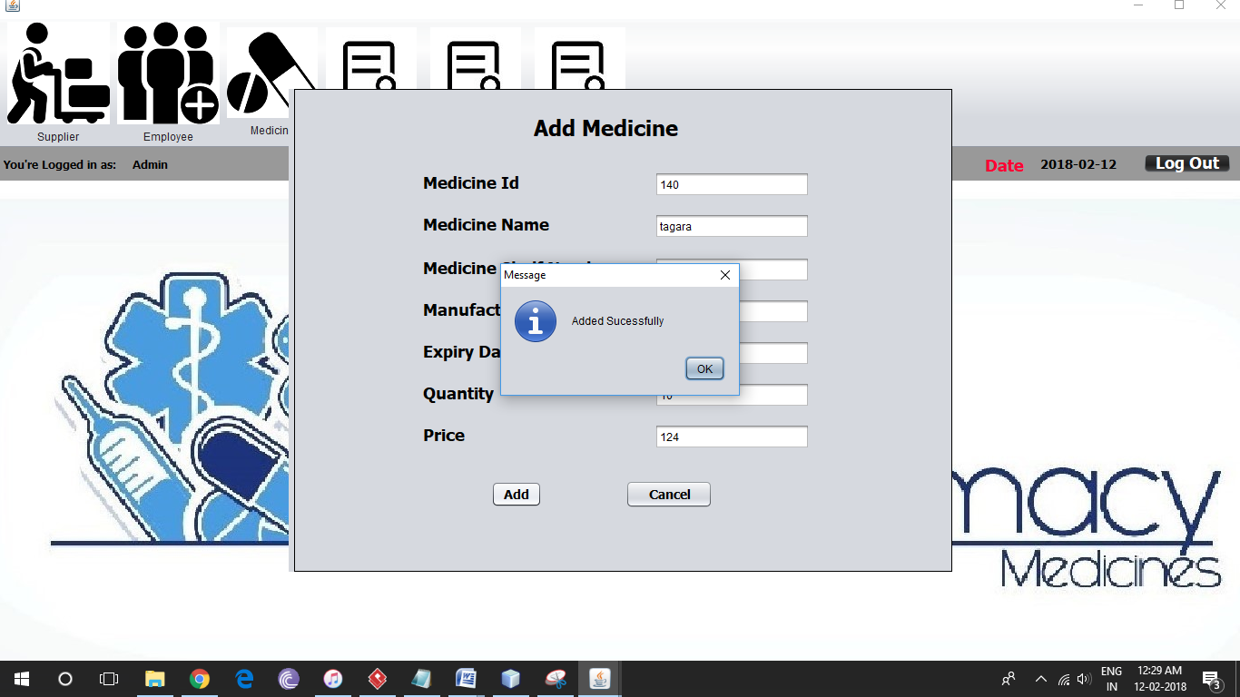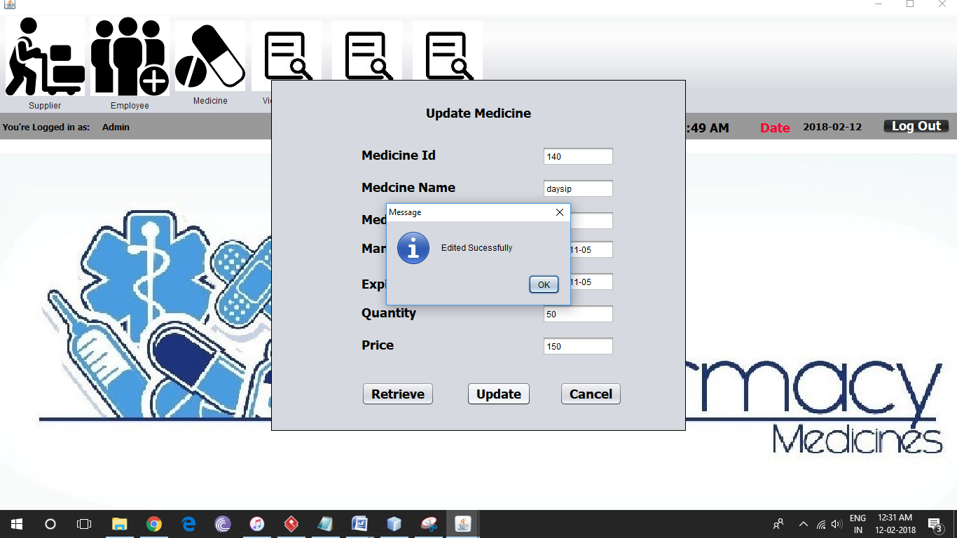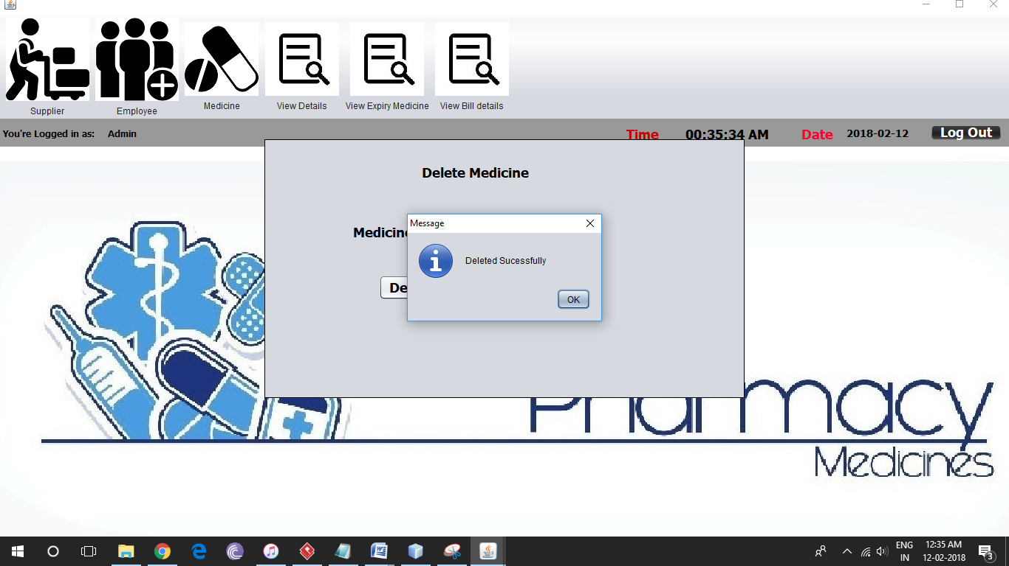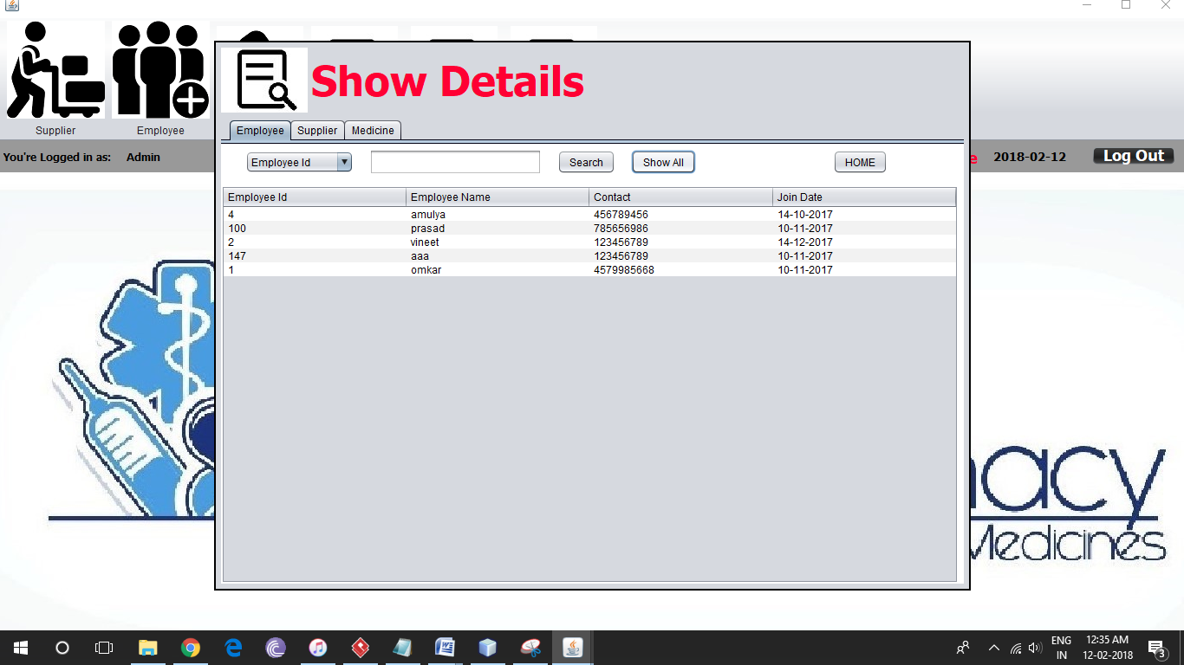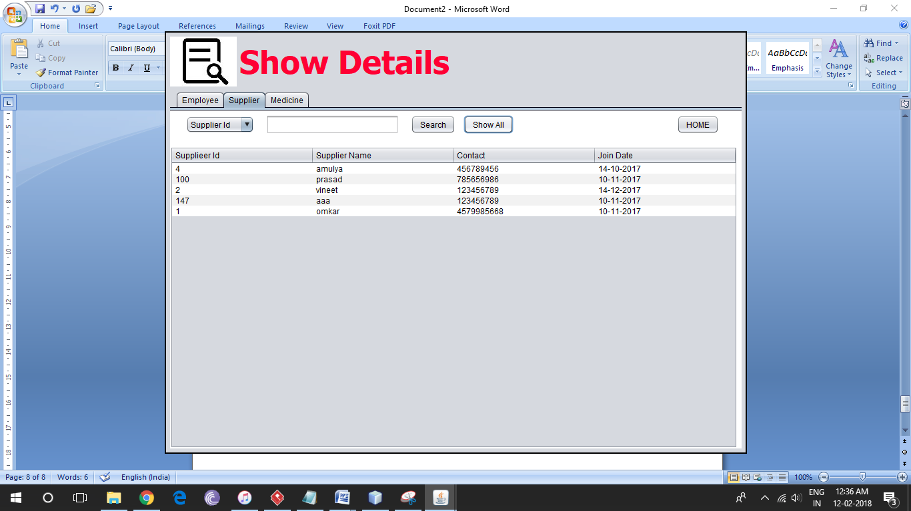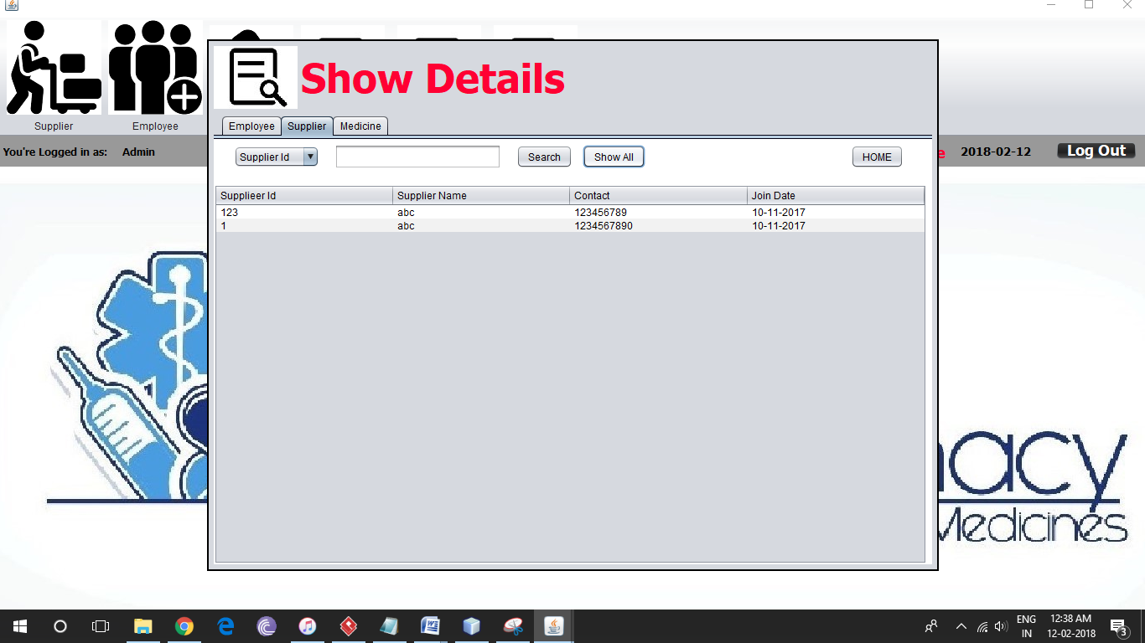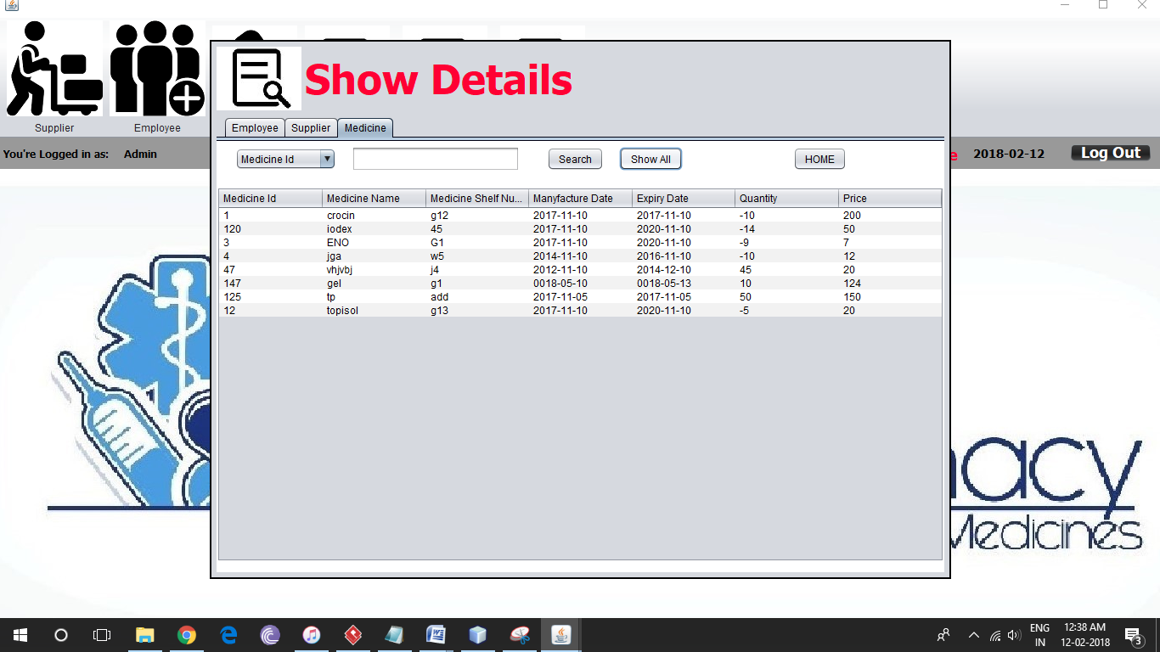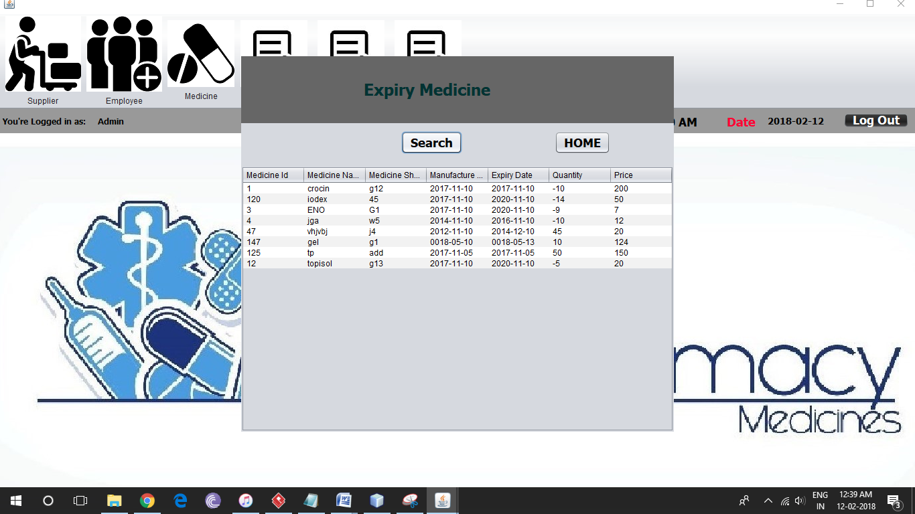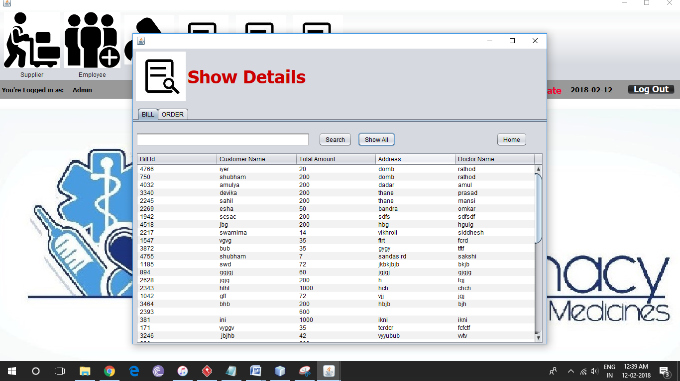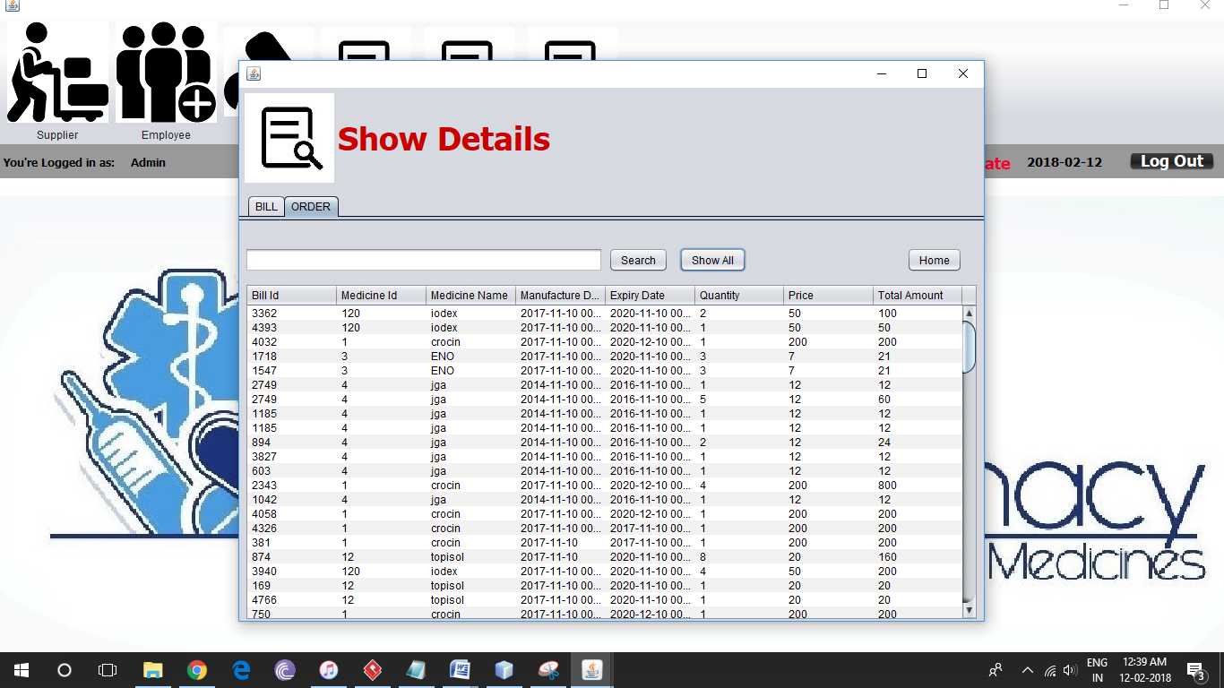

**Employee**

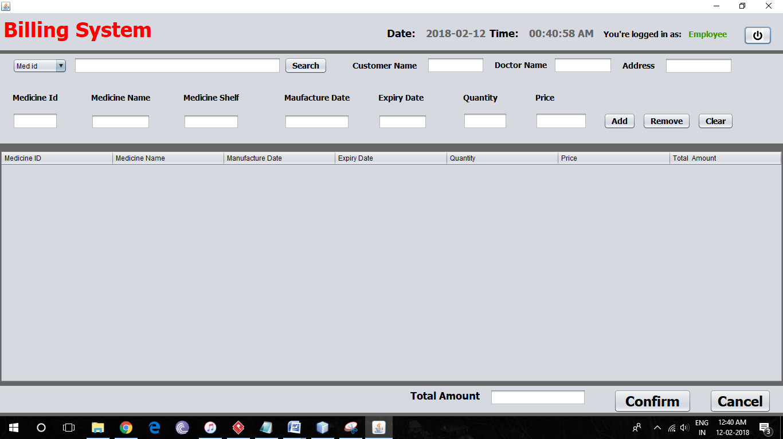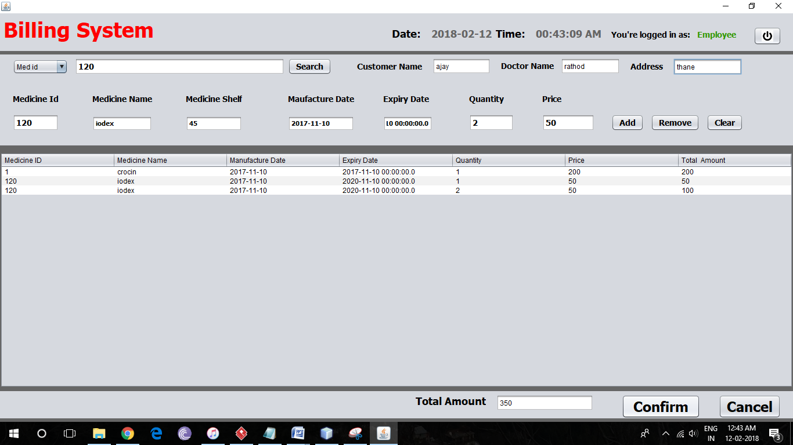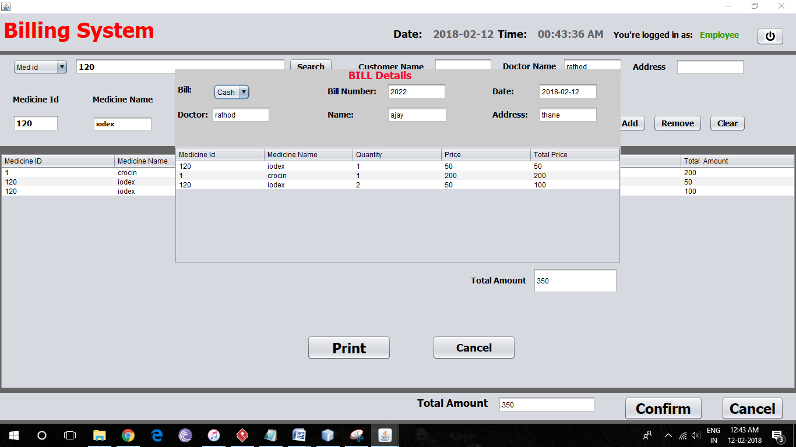

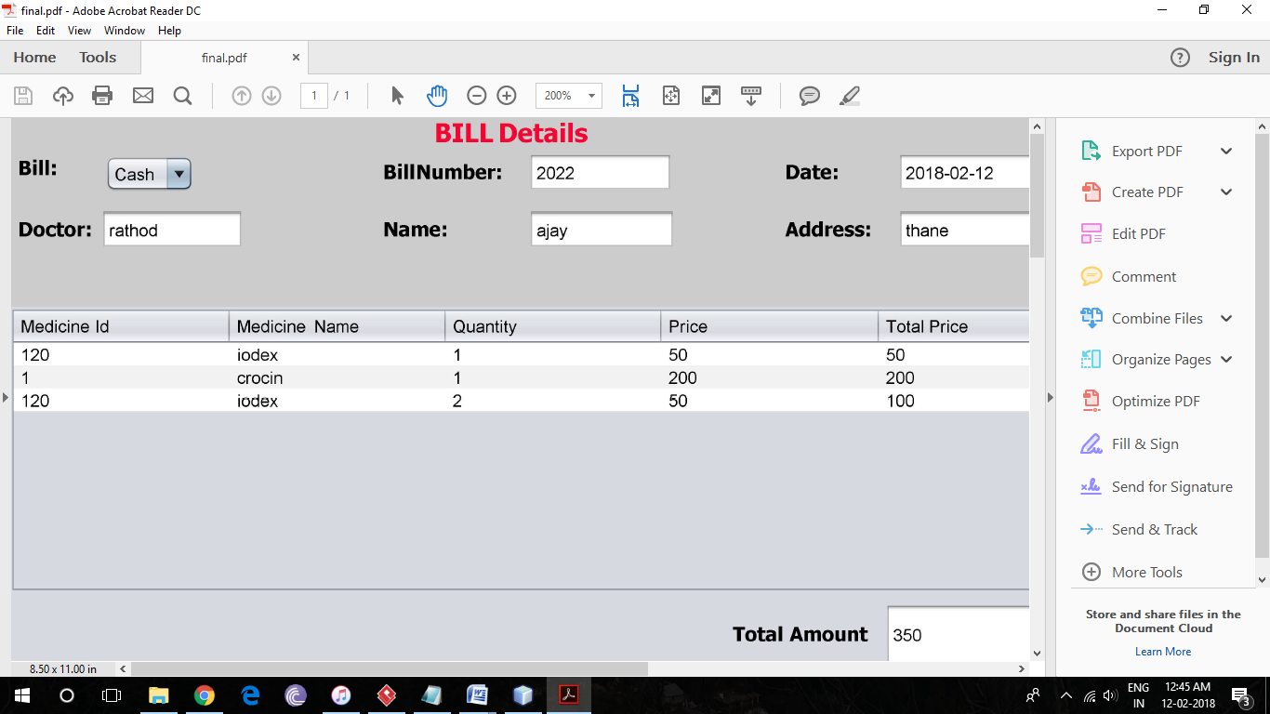

**Coding**

**Homepage**

import medicalshop.Manager;

import medicalshop.adminlogin;

public class homepage extends javax.swing.JFrame {

public homepage() {

initComponents();

this.setLocationRelativeTo(null);

}

@SuppressWarnings("unchecked")

// <editor-fold defaultstate="collapsed" desc="Generated Code">

private void initComponents() {

jFormattedTextField1 = new javax.swing.JFormattedTextField();

jPanel1 = new javax.swing.JPanel();

jPanel2 = new javax.swing.JPanel();

jLabel1 = new javax.swing.JLabel();

jLabel2 = new javax.swing.JLabel();

jButton1 = new javax.swing.JButton();

jButton2 = new javax.swing.JButton();

jLabel3 = new javax.swing.JLabel();

jLabel4 = new javax.swing.JLabel();

jFormattedTextField1.setText("jFormattedTextField1");

setDefaultCloseOperation(javax.swing.WindowConstants.EXIT_ON_CLOSE);

jPanel1.setBackground(new java.awt.Color(204, 204, 255));

jPanel2.setBackground(new java.awt.Color(0, 0, 0));

jLabel1.setBackground(new java.awt.Color(51, 255, 255));

jLabel1.setFont(new java.awt.Font("Tahoma", 1, 18)); // NOI18N

jLabel1.setForeground(new java.awt.Color(255, 255, 255));

jLabel1.setText("Medical Shop");

javax.swing.GroupLayout jPanel2Layout = new javax.swing.GroupLayout(jPanel2);

jPanel2.setLayout(jPanel2Layout);

jPanel2Layout.setHorizontalGroup(

jPanel2Layout.createParallelGroup(javax.swing.GroupLayout.Alignment.LEADING)

.addGroup(jPanel2Layout.createSequentialGroup()

.addGap(268, 268, 268)

.addComponent(jLabel1)

.addContainerGap(javax.swing.GroupLayout.DEFAULT_SIZE, Short.MAX_VALUE))

);

jPanel2Layout.setVerticalGroup(

jPanel2Layout.createParallelGroup(javax.swing.GroupLayout.Alignment.LEADING)

.addGroup(jPanel2Layout.createSequentialGroup()

.addContainerGap()

.addComponent(jLabel1)

.addContainerGap(16, Short.MAX_VALUE))

);

jLabel2.setBackground(new java.awt.Color(255, 255, 255));

jLabel2.setFont(new java.awt.Font("Tahoma", 1, 36)); // NOI18N

jLabel2.setHorizontalAlignment(javax.swing.SwingConstants.RIGHT);

jLabel2.setText("Login As");

jLabel2.setHorizontalTextPosition(javax.swing.SwingConstants.CENTER);

jButton1.setBackground(new java.awt.Color(255, 255, 255));

jButton1.setFont(new java.awt.Font("Tahoma", 1, 18)); // NOI18N

jButton1.setText("Admin");

jButton1.addActionListener(new java.awt.event.ActionListener() {

public void actionPerformed(java.awt.event.ActionEvent evt) {

jButton1ActionPerformed(evt);

}

});

jButton2.setBackground(new java.awt.Color(255, 255, 255));

jButton2.setFont(new java.awt.Font("Tahoma", 1, 18)); // NOI18N

jButton2.setText("Employee");

jButton2.addActionListener(new java.awt.event.ActionListener() {

public void actionPerformed(java.awt.event.ActionEvent evt) {

jButton2ActionPerformed(evt);

}

});

jLabel3.setIcon(new javax.swing.ImageIcon("C:\\Users\\acer\\Desktop\\project\\pic\\2018-27-01-12-40-24.jpeg")); // NOI18N

jLabel4.setIcon(new javax.swing.ImageIcon("C:\\Users\\acer\\Desktop\\project\\pic\\2018-27-01-12-36-42.jpeg")); // NOI18N

javax.swing.GroupLayout jPanel1Layout = new javax.swing.GroupLayout(jPanel1);

jPanel1.setLayout(jPanel1Layout);

jPanel1Layout.setHorizontalGroup(

jPanel1Layout.createParallelGroup(javax.swing.GroupLayout.Alignment.LEADING)

.addComponent(jPanel2, javax.swing.GroupLayout.DEFAULT_SIZE, javax.swing.GroupLayout.DEFAULT_SIZE, Short.MAX_VALUE)

.addGroup(javax.swing.GroupLayout.Alignment.TRAILING, jPanel1Layout.createSequentialGroup()

.addGap(0, 250, Short.MAX_VALUE)

.addGroup(jPanel1Layout.createParallelGroup(javax.swing.GroupLayout.Alignment.LEADING)

.addComponent(jLabel4, javax.swing.GroupLayout.Alignment.TRAILING)

.addComponent(jButton1, javax.swing.GroupLayout.Alignment.TRAILING))

.addGap(46, 46, 46)

.addGroup(jPanel1Layout.createParallelGroup(javax.swing.GroupLayout.Alignment.LEADING)

.addComponent(jButton2)

.addComponent(jLabel3, javax.swing.GroupLayout.PREFERRED_SIZE, 77, javax.swing.GroupLayout.PREFERRED_SIZE))

.addGap(235, 235, 235))

.addGroup(jPanel1Layout.createSequentialGroup()

.addContainerGap()

.addComponent(jLabel2, javax.swing.GroupLayout.PREFERRED_SIZE, 159, javax.swing.GroupLayout.PREFERRED_SIZE)

.addContainerGap(javax.swing.GroupLayout.DEFAULT_SIZE, Short.MAX_VALUE))

);

jPanel1Layout.setVerticalGroup(

jPanel1Layout.createParallelGroup(javax.swing.GroupLayout.Alignment.LEADING)

.addGroup(jPanel1Layout.createSequentialGroup()

.addGap(27, 27, 27)

.addComponent(jPanel2, javax.swing.GroupLayout.PREFERRED_SIZE, javax.swing.GroupLayout.DEFAULT_SIZE, javax.swing.GroupLayout.PREFERRED_SIZE)

.addGap(40, 40, 40)

.addComponent(jLabel2, javax.swing.GroupLayout.PREFERRED_SIZE, 43, javax.swing.GroupLayout.PREFERRED_SIZE)

.addPreferredGap(javax.swing.LayoutStyle.ComponentPlacement.RELATED, 62, Short.MAX_VALUE)

.addGroup(jPanel1Layout.createParallelGroup(javax.swing.GroupLayout.Alignment.LEADING)

.addGroup(jPanel1Layout.createSequentialGroup()

.addComponent(jLabel3, javax.swing.GroupLayout.PREFERRED_SIZE, 69, javax.swing.GroupLayout.PREFERRED_SIZE)

.addGap(38, 38, 38)

.addGroup(jPanel1Layout.createParallelGroup(javax.swing.GroupLayout.Alignment.BASELINE)

.addComponent(jButton2)

.addComponent(jButton1)))

.addComponent(jLabel4))

.addGap(123, 123, 123))

);

javax.swing.GroupLayout layout = new javax.swing.GroupLayout(getContentPane());

getContentPane().setLayout(layout);

layout.setHorizontalGroup(

layout.createParallelGroup(javax.swing.GroupLayout.Alignment.LEADING)

.addComponent(jPanel1, javax.swing.GroupLayout.DEFAULT_SIZE, javax.swing.GroupLayout.DEFAULT_SIZE, Short.MAX_VALUE)

);

layout.setVerticalGroup(

layout.createParallelGroup(javax.swing.GroupLayout.Alignment.LEADING)

.addComponent(jPanel1, javax.swing.GroupLayout.DEFAULT_SIZE, javax.swing.GroupLayout.DEFAULT_SIZE, Short.MAX_VALUE)

);

pack();

}// </editor-fold>

/*

private void jButton1ActionPerformed(java.awt.event.ActionEvent evt) {

this.setVisible(true);

new adminlogin().setVisible(true); // TODO add your handling code here:

}

private void jButton2ActionPerformed(java.awt.event.ActionEvent evt) {

this.setVisible(true);

new adminlogin().setVisible(true); // TODO add your handling code here:

} **\*/**

public static void main(String args[]) {

java.awt.EventQueue.invokeLater(new Runnable() {

public void run() {

new homepage().setVisible(true);

}

});

}

// Variables declaration - do not modify

private javax.swing.JButton jButton1;

private javax.swing.JButton jButton2;

private javax.swing.JFormattedTextField jFormattedTextField1;

private javax.swing.JLabel jLabel1;

private javax.swing.JLabel jLabel2;

private javax.swing.JLabel jLabel3;

private javax.swing.JLabel jLabel4;

private javax.swing.JPanel jPanel1;

private javax.swing.JPanel jPanel2;

**Login**

/*

* To change this license header, choose License Headers in Project Properties.

* To change this template file, choose Tools | Templates

* and open the template in the editor.

*/

package medicalshop;

import javax.swing.JOptionPane;

public class adminlogin extends javax.swing.JFrame {

public adminlogin() {

initComponents();

this.setLocationRelativeTo(null);

}

@SuppressWarnings("unchecked")

private void initComponents() {

jPanel1 = new javax.swing.JPanel();

jPanel2 = new javax.swing.JPanel();

jLabel1 = new javax.swing.JLabel();

jButton1 = new javax.swing.JButton();

jPanel3 = new javax.swing.JPanel();

jLabel2 = new javax.swing.JLabel();

username = new javax.swing.JTextField();

jLabel3 = new javax.swing.JLabel();

jButton2 = new javax.swing.JButton();

password = new javax.swing.JPasswordField();

setDefaultCloseOperation(javax.swing.WindowConstants.EXIT_ON_CLOSE);

setUndecorated(true);

jPanel1.setBackground(new java.awt.Color(204, 204, 255));

jPanel1.setBorder(new javax.swing.border.MatteBorder(null));

jPanel2.setBackground(new java.awt.Color(0, 0, 0));

jLabel1.setBackground(new java.awt.Color(204, 204, 255));

jLabel1.setFont(new java.awt.Font("Tahoma", 1, 18)); // NOI18N

jLabel1.setForeground(new java.awt.Color(255, 255, 255));

jLabel1.setText("LOGIN");

javax.swing.GroupLayout jPanel2Layout = new javax.swing.GroupLayout(jPanel2);

jPanel2.setLayout(jPanel2Layout);

jPanel2Layout.setHorizontalGroup(

jPanel2Layout.createParallelGroup(javax.swing.GroupLayout.Alignment.LEADING)

.addGroup(jPanel2Layout.createSequentialGroup()

.addGap(166, 166, 166)

.addComponent(jLabel1)

.addContainerGap(javax.swing.GroupLayout.DEFAULT_SIZE, Short.MAX_VALUE))

);

jPanel2Layout.setVerticalGroup(

jPanel2Layout.createParallelGroup(javax.swing.GroupLayout.Alignment.LEADING)

.addGroup(jPanel2Layout.createSequentialGroup()

.addContainerGap()

.addComponent(jLabel1)

.addContainerGap(javax.swing.GroupLayout.DEFAULT_SIZE, Short.MAX_VALUE))

);

jButton1.setIcon(new javax.swing.ImageIcon("C:\\Users\\acer\\Desktop\\project\\pic\\2018-27-01-12-54-28.jpeg")); // NOI18N

jButton1.addActionListener(new java.awt.event.ActionListener() {

public void actionPerformed(java.awt.event.ActionEvent evt) {

jButton1ActionPerformed(evt);

}

});

jLabel2.setFont(new java.awt.Font("Tahoma", 1, 14)); // NOI18N

jLabel2.setText("Username");

jLabel3.setFont(new java.awt.Font("Tahoma", 1, 14)); // NOI18N

jLabel3.setText("Password");

jButton2.setFont(new java.awt.Font("Tahoma", 1, 18)); // NOI18N

jButton2.setText("Login");

jButton2.addActionListener(new java.awt.event.ActionListener() {

public void actionPerformed(java.awt.event.ActionEvent evt) {

jButton2ActionPerformed(evt);

}

});

password.setToolTipText("");

javax.swing.GroupLayout jPanel3Layout = new javax.swing.GroupLayout(jPanel3);

jPanel3.setLayout(jPanel3Layout);

jPanel3Layout.setHorizontalGroup(

jPanel3Layout.createParallelGroup(javax.swing.GroupLayout.Alignment.LEADING)

.addGroup(jPanel3Layout.createSequentialGroup()

.addContainerGap()

.addGroup(jPanel3Layout.createParallelGroup(javax.swing.GroupLayout.Alignment.LEADING)

.addComponent(jLabel2)

.addComponent(jLabel3))

.addPreferredGap(javax.swing.LayoutStyle.ComponentPlacement.RELATED, 34, Short.MAX_VALUE)

.addGroup(jPanel3Layout.createParallelGroup(javax.swing.GroupLayout.Alignment.LEADING, false)

.addComponent(username, javax.swing.GroupLayout.DEFAULT_SIZE, 104, Short.MAX_VALUE)

.addComponent(password))

.addGap(17, 17, 17))

.addGroup(jPanel3Layout.createSequentialGroup()

.addGap(73, 73, 73)

.addComponent(jButton2)

.addContainerGap(javax.swing.GroupLayout.DEFAULT_SIZE, Short.MAX_VALUE))

);

jPanel3Layout.setVerticalGroup(

jPanel3Layout.createParallelGroup(javax.swing.GroupLayout.Alignment.LEADING)

.addGroup(jPanel3Layout.createSequentialGroup()

.addGap(25, 25, 25)

.addGroup(jPanel3Layout.createParallelGroup(javax.swing.GroupLayout.Alignment.TRAILING)

.addComponent(username, javax.swing.GroupLayout.PREFERRED_SIZE, javax.swing.GroupLayout.DEFAULT_SIZE, javax.swing.GroupLayout.PREFERRED_SIZE)

.addComponent(jLabel2))

.addGap(18, 18, 18)

.addGroup(jPanel3Layout.createParallelGroup(javax.swing.GroupLayout.Alignment.BASELINE)

.addComponent(jLabel3)

.addComponent(password, javax.swing.GroupLayout.PREFERRED_SIZE, javax.swing.GroupLayout.DEFAULT_SIZE, javax.swing.GroupLayout.PREFERRED_SIZE))

.addGap(18, 18, 18)

.addComponent(jButton2)

.addContainerGap(26, Short.MAX_VALUE))

);

javax.swing.GroupLayout jPanel1Layout = new javax.swing.GroupLayout(jPanel1);

jPanel1.setLayout(jPanel1Layout);

jPanel1Layout.setHorizontalGroup(

jPanel1Layout.createParallelGroup(javax.swing.GroupLayout.Alignment.LEADING)

.addComponent(jPanel2, javax.swing.GroupLayout.DEFAULT_SIZE, javax.swing.GroupLayout.DEFAULT_SIZE, Short.MAX_VALUE)

.addGroup(jPanel1Layout.createSequentialGroup()

.addContainerGap()

.addComponent(jButton1, javax.swing.GroupLayout.PREFERRED_SIZE, 47, javax.swing.GroupLayout.PREFERRED_SIZE)

.addContainerGap(javax.swing.GroupLayout.DEFAULT_SIZE, Short.MAX_VALUE))

.addGroup(javax.swing.GroupLayout.Alignment.TRAILING, jPanel1Layout.createSequentialGroup()

.addContainerGap(92, Short.MAX_VALUE)

.addComponent(jPanel3, javax.swing.GroupLayout.PREFERRED_SIZE, javax.swing.GroupLayout.DEFAULT_SIZE, javax.swing.GroupLayout.PREFERRED_SIZE)

.addGap(83, 83, 83))

);

jPanel1Layout.setVerticalGroup(

jPanel1Layout.createParallelGroup(javax.swing.GroupLayout.Alignment.LEADING)

.addGroup(jPanel1Layout.createSequentialGroup()

.addGap(23, 23, 23)

.addComponent(jPanel2, javax.swing.GroupLayout.PREFERRED_SIZE, javax.swing.GroupLayout.DEFAULT_SIZE, javax.swing.GroupLayout.PREFERRED_SIZE)

.addPreferredGap(javax.swing.LayoutStyle.ComponentPlacement.UNRELATED)

.addComponent(jButton1, javax.swing.GroupLayout.PREFERRED_SIZE, 37, javax.swing.GroupLayout.PREFERRED_SIZE)

.addPreferredGap(javax.swing.LayoutStyle.ComponentPlacement.RELATED)

.addComponent(jPanel3, javax.swing.GroupLayout.PREFERRED_SIZE, javax.swing.GroupLayout.DEFAULT_SIZE, javax.swing.GroupLayout.PREFERRED_SIZE)

.addContainerGap(23, Short.MAX_VALUE))

);

javax.swing.GroupLayout layout = new javax.swing.GroupLayout(getContentPane());

getContentPane().setLayout(layout);

layout.setHorizontalGroup(

layout.createParallelGroup(javax.swing.GroupLayout.Alignment.LEADING)

.addComponent(jPanel1, javax.swing.GroupLayout.DEFAULT_SIZE, javax.swing.GroupLayout.DEFAULT_SIZE, Short.MAX_VALUE)

);

layout.setVerticalGroup(

layout.createParallelGroup(javax.swing.GroupLayout.Alignment.LEADING)

.addComponent(jPanel1, javax.swing.GroupLayout.DEFAULT_SIZE, javax.swing.GroupLayout.DEFAULT_SIZE, Short.MAX_VALUE)

);

pack();

}// </editor-fold>

**/\***

private void jButton1ActionPerformed(java.awt.event.ActionEvent evt) {

this.setVisible(false);

new homepage().setVisible(true);

}

private void jButton2ActionPerformed(java.awt.event.ActionEvent evt) {

String uname=username.getText();

String pass=password.getText();

if(uname.equals("admin") && pass.equals("admin"))

{

this.setVisible(false);

new Manager().setVisible(true);

}

else if(uname.equals("Employee") && pass.equals("Employee"))

{

this.setVisible(false);

new mainpage().setVisible(true);

}

else

{

JOptionPane.showMessageDialog(null,"Login Invalid");

}

} */

public static void main(String args[]) {

//<editor-fold defaultstate="collapsed" desc=" Look and feel setting code (optional) ">

try {

for (javax.swing.UIManager.LookAndFeelInfo info : javax.swing.UIManager.getInstalledLookAndFeels()) {

if ("Nimbus".equals(info.getName())) {

javax.swing.UIManager.setLookAndFeel(info.getClassName());

break;

}

}

} catch (ClassNotFoundException ex) {

java.util.logging.Logger.getLogger(adminlogin.class.getName()).log(java.util.logging.Level.SEVERE, null, ex);

} catch (InstantiationException ex) {

java.util.logging.Logger.getLogger(adminlogin.class.getName()).log(java.util.logging.Level.SEVERE, null, ex);

} catch (IllegalAccessException ex) {

java.util.logging.Logger.getLogger(adminlogin.class.getName()).log(java.util.logging.Level.SEVERE, null, ex);

} catch (javax.swing.UnsupportedLookAndFeelException ex) {

java.util.logging.Logger.getLogger(adminlogin.class.getName()).log(java.util.logging.Level.SEVERE, null, ex);

}

java.awt.EventQueue.invokeLater(new Runnable() {

public void run() {

new adminlogin().setVisible(true);

}

});

}

private javax.swing.JButton jButton1;

private javax.swing.JButton jButton2;

private javax.swing.JLabel jLabel1;

private javax.swing.JLabel jLabel2;

private javax.swing.JLabel jLabel3;

private javax.swing.JPanel jPanel1;

private javax.swing.JPanel jPanel2;

private javax.swing.JPanel jPanel3;

private javax.swing.JPasswordField password;

private javax.swing.JTextField username;

}

**Manager**

package medicalshop;

import employee.Editemp;

import employee.addemp;

import employee.delemp;

import java.awt.Dimension;

import java.awt.Toolkit;

import java.awt.event.ActionEvent;

import java.awt.event.ActionListener;

import java.text.SimpleDateFormat;

import java.util.Date;

import javax.swing.Timer;

import medicalshop.medicine.DeleteMedicine;

import medicalshop.medicine.UpdateMedicine;

import medicalshop.medicine.addmedicine;

public class Manager extends javax.swing.JFrame {

addSupp Add = new addSupp();

editSupp Edit = new editSupp();

delsup del = new delsup();

addemp Add1 = new addemp();

Editemp Edit1 = new Editemp();

delemp del1 = new delemp();

addmedicine Add3 = new addmedicine();

UpdateMedicine Edit3 = new UpdateMedicine();

DeleteMedicine del3 = new DeleteMedicine();

ViewDeatails Add5 = new ViewDeatails();

ViewExpiryMedicine Add6=new ViewExpiryMedicine();

viewBilldetails Add7=new viewBilldetails();

public Manager() {

initComponents();

Toolkit toolkit = getToolkit();

Dimension size = toolkit.getScreenSize();

setLocation(size.width / 2 - getWidth() / 2, size.height / 2 - getHeight() / 2);

showDate();

showTime();

}

void showDate() {

Date d = new Date();

SimpleDateFormat s = new SimpleDateFormat("yyyy-MM-dd");

dateLab.setText(s.format(d));

}

void showTime() {

new Timer(0, new ActionListener() {

@Override

public void actionPerformed(ActionEvent e) {

Date d = new Date();

SimpleDateFormat s = new SimpleDateFormat("HH:mm:ss a");

timeLab.setText(s.format(d));

}

}).start();

}

@SuppressWarnings("unchecked")

private void initComponents() {

jPanel1 = new javax.swing.JPanel();

jButton1 = new javax.swing.JButton();

jLabel1 = new javax.swing.JLabel();

jLabel2 = new javax.swing.JLabel();

jPanel3 = new javax.swing.JPanel();

jLabel3 = new javax.swing.JLabel();

dateLab = new javax.swing.JLabel();

jLabel4 = new javax.swing.JLabel();

timeLab = new javax.swing.JLabel();

jLabel5 = new javax.swing.JLabel();

jMenuBar2 = new javax.swing.JMenuBar();

jMenu1 = new javax.swing.JMenu();

jMenuItem1 = new javax.swing.JMenuItem();

jMenuItem2 = new javax.swing.JMenuItem();

jMenuItem3 = new javax.swing.JMenuItem();

jMenu2 = new javax.swing.JMenu();

jMenuItem4 = new javax.swing.JMenuItem();

jMenuItem5 = new javax.swing.JMenuItem();

jMenuItem6 = new javax.swing.JMenuItem();

jMenu3 = new javax.swing.JMenu();

jMenuItem7 = new javax.swing.JMenuItem();

jMenuItem8 = new javax.swing.JMenuItem();

jMenuItem9 = new javax.swing.JMenuItem();

viewDetails = new javax.swing.JMenu();

viewExpiryMedicine = new javax.swing.JMenu();

jMenu4 = new javax.swing.JMenu();

setDefaultCloseOperation(javax.swing.WindowConstants.EXIT_ON_CLOSE);

setBackground(new java.awt.Color(153, 255, 102));

jPanel1.setBackground(new java.awt.Color(153, 153, 153));

jButton1.setBackground(new java.awt.Color(0, 0, 0));

jButton1.setFont(new java.awt.Font("Tahoma", 1, 18)); // NOI18N

jButton1.setForeground(new java.awt.Color(255, 255, 255));

jButton1.setText("Log Out");

jButton1.addActionListener(new java.awt.event.ActionListener() {

public void actionPerformed(java.awt.event.ActionEvent evt) {

jButton1ActionPerformed(evt);

}

});

jLabel1.setFont(new java.awt.Font("Tahoma", 1, 12)); // NOI18N

jLabel1.setText("You're Logged in as:");

jLabel2.setFont(new java.awt.Font("Tahoma", 1, 12)); // NOI18N

jLabel2.setForeground(new java.awt.Color(102, 255, 0));

jLabel2.setText("Admin");

jLabel3.setForeground(new java.awt.Color(255, 0, 0));

jLabel3.setIcon(new javax.swing.ImageIcon("C:\\Users\\acer\\Desktop\\project\\pic\\2018-13-01-13-56-56.jpeg")); // NOI18N

javax.swing.GroupLayout jPanel3Layout = new javax.swing.GroupLayout(jPanel3);

jPanel3.setLayout(jPanel3Layout);

jPanel3Layout.setHorizontalGroup(

jPanel3Layout.createParallelGroup(javax.swing.GroupLayout.Alignment.LEADING)

.addComponent(jLabel3, javax.swing.GroupLayout.DEFAULT_SIZE, javax.swing.GroupLayout.DEFAULT_SIZE, Short.MAX_VALUE)

);

jPanel3Layout.setVerticalGroup(

jPanel3Layout.createParallelGroup(javax.swing.GroupLayout.Alignment.LEADING)

.addComponent(jLabel3, javax.swing.GroupLayout.DEFAULT_SIZE, javax.swing.GroupLayout.DEFAULT_SIZE, Short.MAX_VALUE)

);

dateLab.setFont(new java.awt.Font("Tahoma", 1, 14)); // NOI18N

dateLab.setText("date");

jLabel4.setFont(new java.awt.Font("Tahoma", 1, 18)); // NOI18N

jLabel4.setForeground(new java.awt.Color(255, 0, 51));

jLabel4.setText("Date");

timeLab.setFont(new java.awt.Font("Tahoma", 1, 18)); // NOI18N

timeLab.setText("jLabel5");

jLabel5.setBackground(new java.awt.Color(204, 0, 0));

jLabel5.setFont(new java.awt.Font("Tahoma", 1, 18)); // NOI18N

jLabel5.setForeground(new java.awt.Color(204, 0, 0));

Label5.setText("Time ");

javax.swing.GroupLayout jPanel1Layout = new javax.swing.GroupLayout(jPanel1);

jPanel1.setLayout(jPanel1Layout);

jPanel1Layout.setHorizontalGroup(

jPanel1Layout.createParallelGroup(javax.swing.GroupLayout.Alignment.LEADING)

.addGroup(jPanel1Layout.createSequentialGroup()

.addContainerGap()

.addComponent(jLabel1)

.addGap(18, 18, 18)

.addComponent(jLabel2, javax.swing.GroupLayout.PREFERRED_SIZE, 131, javax.swing.GroupLayout.PREFERRED_SIZE)

.addPreferredGap(javax.swing.LayoutStyle.ComponentPlacement.RELATED, javax.swing.GroupLayout.DEFAULT_SIZE, Short.MAX_VALUE)

.addComponent(jLabel5, javax.swing.GroupLayout.PREFERRED_SIZE, 74, javax.swing.GroupLayout.PREFERRED_SIZE)

.addPreferredGap(javax.swing.LayoutStyle.ComponentPlacement.RELATED)

.addComponent(timeLab, javax.swing.GroupLayout.PREFERRED_SIZE, 121, javax.swing.GroupLayout.PREFERRED_SIZE)

.addGap(36, 36, 36)

.addComponent(jLabel4)

.addGap(18, 18, 18)

.addComponent(dateLab, javax.swing.GroupLayout.PREFERRED_SIZE, 101, javax.swing.GroupLayout.PREFERRED_SIZE)

.addPreferredGap(javax.swing.LayoutStyle.ComponentPlacement.UNRELATED)

.addComponent(jButton1)

.addGap(41, 41, 41))

.addComponent(jPanel3, javax.swing.GroupLayout.DEFAULT_SIZE, javax.swing.GroupLayout.DEFAULT_SIZE, Short.MAX_VALUE)

);

jPanel1Layout.setVerticalGroup(

jPanel1Layout.createParallelGroup(javax.swing.GroupLayout.Alignment.LEADING)

.addGroup(jPanel1Layout.createSequentialGroup()

.addContainerGap() .addGroup(jPanel1Layout.createParallelGroup(javax.swing.GroupLayout.Alignment.LEADING) .addGroup(jPanel1Layout.createParallelGroup(javax.swing.GroupLayout.Alignment.BASELINE)

.addComponent(jLabel1, javax.swing.GroupLayout.PREFERRED_SIZE, 24, javax.swing.GroupLayout.PREFERRED_SIZE)

.addComponent(jLabel2)

.addComponent(jButton1, javax.swing.GroupLayout.PREFERRED_SIZE, 23, javax.swing.GroupLayout.PREFERRED_SIZE)

.addComponent(dateLab))

.addGroup(javax.swing.GroupLayout.Alignment.TRAILING, jPanel1Layout.createParallelGroup(javax.swing.GroupLayout.Alignment.BASELINE)

.addComponent(jLabel4)

.addComponent(timeLab)

.addComponent(jLabel5)))

.addPreferredGap(javax.swing.LayoutStyle.ComponentPlacement.RELATED)

.addComponent(jPanel3, javax.swing.GroupLayout.DEFAULT_SIZE, javax.swing.GroupLayout.DEFAULT_SIZE, Short.MAX_VALUE))

);

jMenuBar2.setBackground(new java.awt.Color(51, 51, 51));

jMenu1.setIcon(new javax.swing.ImageIcon("C:\\Users\\acer\\Desktop\\project\\pic\\supplier.png")); // NOI18N

jMenu1.setText("Supplier");

jMenu1.setHorizontalAlignment(javax.swing.SwingConstants.LEFT);

jMenu1.setHorizontalTextPosition(javax.swing.SwingConstants.CENTER);

jMenu1.setVerticalAlignment(javax.swing.SwingConstants.BOTTOM);

jMenu1.setVerticalTextPosition(javax.swing.SwingConstants.BOTTOM);

jMenuItem1.setIcon(new javax.swing.ImageIcon("C:\\Users\\acer\\Desktop\\project\\pic\\2018-13-01-12-44-37.jpeg")); // NOI18N

jMenuItem1.setText("Add Details");

jMenuItem1.addMenuDragMouseListener(new javax.swing.event.MenuDragMouseListener() {

public void menuDragMouseDragged(javax.swing.event.MenuDragMouseEvent evt) {

}

public void menuDragMouseEntered(javax.swing.event.MenuDragMouseEvent evt) {

jMenuItem1MenuDragMouseEntered(evt);

}

public void menuDragMouseExited(javax.swing.event.MenuDragMouseEvent evt) {

}

public void menuDragMouseReleased(javax.swing.event.MenuDragMouseEvent evt) {

}

});

jMenuItem1.addMouseListener(new java.awt.event.MouseAdapter() {

public void mouseClicked(java.awt.event.MouseEvent evt) {

jMenuItem1MouseClicked(evt);

}

});

jMenuItem1.addActionListener(new java.awt.event.ActionListener() {

public void actionPerformed(java.awt.event.ActionEvent evt) {

jMenuItem1ActionPerformed(evt);

}

});

jMenu1.add(jMenuItem1);

jMenuItem2.setIcon(new javax.swing.ImageIcon("C:\\Users\\acer\\Desktop\\project\\pic\\2018-13-01-12-50-36.jpeg")); // NOI18N

jMenuItem2.setText("Delete Details");

jMenuItem2.addMouseListener(new java.awt.event.MouseAdapter() {

public void mouseClicked(java.awt.event.MouseEvent evt) {

jMenuItem2MouseClicked(evt);

}

});

jMenuItem2.addActionListener(new java.awt.event.ActionListener() {

public void actionPerformed(java.awt.event.ActionEvent evt) {

jMenuItem2ActionPerformed(evt);

}

});

jMenu1.add(jMenuItem2);

jMenuItem3.setIcon(new javax.swing.ImageIcon("C:\\Users\\acer\\Desktop\\project\\pic\\2018-13-01-12-49-40.jpeg")); // NOI18N

jMenuItem3.setText("Update Details");

jMenuItem3.addActionListener(new java.awt.event.ActionListener() {

public void actionPerformed(java.awt.event.ActionEvent evt) {

jMenuItem3ActionPerformed(evt);

}

});

jMenu1.add(jMenuItem3);

jMenuBar2.add(jMenu1);

jMenu2.setIcon(new javax.swing.ImageIcon("C:\\Users\\acer\\Desktop\\project\\pic\\employee.png")); // NOI18N

jMenu2.setText("Employee");

jMenu2.setHorizontalAlignment(javax.swing.SwingConstants.CENTER);

jMenu2.setHorizontalTextPosition(javax.swing.SwingConstants.CENTER);

jMenu2.setVerticalTextPosition(javax.swing.SwingConstants.BOTTOM);

jMenuItem4.setIcon(new javax.swing.ImageIcon("C:\\Users\\acer\\Desktop\\project\\pic\\2018-13-01-12-44-37.jpeg")); // NOI18N

jMenuItem4.setText("Add Details");

jMenuItem4.addActionListener(new java.awt.event.ActionListener() {

public void actionPerformed(java.awt.event.ActionEvent evt) {

jMenuItem4ActionPerformed(evt);

}

});

jMenu2.add(jMenuItem4);

jMenuItem5.setIcon(new javax.swing.ImageIcon("C:\\Users\\acer\\Desktop\\project\\pic\\2018-13-01-12-50-36.jpeg")); // NOI18N

jMenuItem5.setText("Delete Details");

jMenuItem5.addActionListener(new java.awt.event.ActionListener() {

public void actionPerformed(java.awt.event.ActionEvent evt) {

jMenuItem5ActionPerformed(evt);

}

});

jMenu2.add(jMenuItem5);

jMenuItem6.setIcon(new javax.swing.ImageIcon("C:\\Users\\acer\\Desktop\\project\\pic\\2018-13-01-12-49-40.jpeg")); // NOI18N

jMenuItem6.setText("Update Details");

jMenuItem6.addActionListener(new java.awt.event.ActionListener() {

public void actionPerformed(java.awt.event.ActionEvent evt) {

jMenuItem6ActionPerformed(evt);

}

});

jMenu2.add(jMenuItem6);

jMenuBar2.add(jMenu2);

jMenu3.setIcon(new javax.swing.ImageIcon("C:\\Users\\acer\\Desktop\\project\\pic\\medicine.png")); // NOI18N

jMenu3.setText("Medicine");

jMenu3.setHorizontalTextPosition(javax.swing.SwingConstants.CENTER);

jMenu3.setVerticalTextPosition(javax.swing.SwingConstants.BOTTOM);

jMenuItem7.setIcon(new javax.swing.ImageIcon("C:\\Users\\acer\\Desktop\\project\\pic\\2018-13-01-12-44-37.jpeg")); // NOI18N

jMenuItem7.setText("Add Medicine");

jMenuItem7.addActionListener(new java.awt.event.ActionListener() {

public void actionPerformed(java.awt.event.ActionEvent evt) {

jMenuItem7ActionPerformed(evt);

}

});

jMenu3.add(jMenuItem7);

jMenuItem8.setIcon(new javax.swing.ImageIcon("C:\\Users\\acer\\Desktop\\project\\pic\\2018-13-01-12-50-36.jpeg")); // NOI18N

jMenuItem8.setText("Delete Medicine");

jMenuItem8.addActionListener(new java.awt.event.ActionListener() {

public void actionPerformed(java.awt.event.ActionEvent evt) {

jMenuItem8ActionPerformed(evt);

}

});

jMenu3.add(jMenuItem8);

jMenuItem9.setIcon(new javax.swing.ImageIcon("C:\\Users\\acer\\Desktop\\project\\pic\\2018-13-01-12-49-40.jpeg")); // NOI18N

jMenuItem9.setText("Update Medicine");

jMenuItem9.addActionListener(new java.awt.event.ActionListener() {

public void actionPerformed(java.awt.event.ActionEvent evt) {

jMenuItem9ActionPerformed(evt);

}

});

jMenu3.add(jMenuItem9);

jMenuBar2.add(jMenu3);

viewDetails.setIcon(new javax.swing.ImageIcon("C:\\Users\\acer\\Desktop\\project\\pic\\2018-13-01-13-07-11.jpeg")); // NOI18N

viewDetails.setText("View Details");

viewDetails.setHorizontalTextPosition(javax.swing.SwingConstants.CENTER);

viewDetails.setName("viewDetailsMenu"); // NOI18N

viewDetails.setVerticalTextPosition(javax.swing.SwingConstants.BOTTOM);

viewDetails.addMenuListener(new javax.swing.event.MenuListener() {

public void menuCanceled(javax.swing.event.MenuEvent evt) {

}

public void menuDeselected(javax.swing.event.MenuEvent evt) {

}

public void menuSelected(javax.swing.event.MenuEvent evt) {

viewDetailsMenuSelected(evt);

}

});

viewDetails.addMouseListener(new java.awt.event.MouseAdapter() {

public void mouseClicked(java.awt.event.MouseEvent evt) {

viewDetailsMouseClicked(evt);

}

});

viewDetails.addActionListener(new java.awt.event.ActionListener() {

public void actionPerformed(java.awt.event.ActionEvent evt) {

viewDetailsActionPerformed(evt);

}

});

jMenuBar2.add(viewDetails);

viewExpiryMedicine.setIcon(new javax.swing.ImageIcon("C:\\Users\\acer\\Desktop\\project\\pic\\2018-13-01-13-07-11.jpeg")); // NOI18N

viewExpiryMedicine.setText("View Expiry Medicine");

viewExpiryMedicine.setHorizontalTextPosition(javax.swing.SwingConstants.CENTER);

viewExpiryMedicine.setVerifyInputWhenFocusTarget(false);

viewExpiryMedicine.setVerticalTextPosition(javax.swing.SwingConstants.BOTTOM);

viewExpiryMedicine.addMenuListener(new javax.swing.event.MenuListener() {

public void menuCanceled(javax.swing.event.MenuEvent evt) {

}

public void menuDeselected(javax.swing.event.MenuEvent evt) {

}

public void menuSelected(javax.swing.event.MenuEvent evt) {

viewExpiryMedicineMenuSelected(evt);

}

});

jMenuBar2.add(viewExpiryMedicine);

jMenu4.setIcon(new javax.swing.ImageIcon("C:\\Users\\acer\\Desktop\\project\\pic\\2018-13-01-13-07-11.jpeg")); // NOI18N

jMenu4.setText("View Bill details");

jMenu4.setHorizontalAlignment(javax.swing.SwingConstants.CENTER);

jMenu4.setHorizontalTextPosition(javax.swing.SwingConstants.CENTER);

jMenu4.setVerticalTextPosition(javax.swing.SwingConstants.BOTTOM);

jMenu4.addMenuListener(new javax.swing.event.MenuListener() {

public void menuCanceled(javax.swing.event.MenuEvent evt) {

}

public void menuDeselected(javax.swing.event.MenuEvent evt) {

}

public void menuSelected(javax.swing.event.MenuEvent evt) {

jMenu4MenuSelected(evt);

}

});

jMenuBar2.add(jMenu4);

setJMenuBar(jMenuBar2);

javax.swing.GroupLayout layout = new javax.swing.GroupLayout(getContentPane());

getContentPane().setLayout(layout);

layout.setHorizontalGroup(

layout.createParallelGroup(javax.swing.GroupLayout.Alignment.LEADING)

.addComponent(jPanel1, javax.swing.GroupLayout.Alignment.TRAILING, javax.swing.GroupLayout.DEFAULT_SIZE, javax.swing.GroupLayout.DEFAULT_SIZE, Short.MAX_VALUE)

);

layout.setVerticalGroup(

layout.createParallelGroup(javax.swing.GroupLayout.Alignment.LEADING)

.addComponent(jPanel1, javax.swing.GroupLayout.DEFAULT_SIZE, javax.swing.GroupLayout.DEFAULT_SIZE, Short.MAX_VALUE)

);

pack();}

**/\***

private void jMenuItem1ActionPerformed(java.awt.event.ActionEvent evt) {

Add.setVisible(true);

Edit.setVisible(false);

del.setVisible(false);// TODO add your handling code here:

}

private void jMenuItem2ActionPerformed(java.awt.event.ActionEvent evt) {

Add.setVisible(false);

Edit.setVisible(false);

del.setVisible(true);

}

private void jMenuItem5ActionPerformed(java.awt.event.ActionEvent evt) {

Add1.setVisible(false);

Edit1.setVisible(false);

del1.setVisible(true);

}

private void jMenuItem8ActionPerformed(java.awt.event.ActionEvent evt) {

Add3.setVisible(false);

Edit3.setVisible(false);

del3.setVisible(true);

}

private void jMenuItem9ActionPerformed(java.awt.event.ActionEvent evt) {

Add3.setVisible(false);

Edit3.setVisible(true);

del3.setVisible(false); // TODO add your handling code here:

}

private void jMenuItem1MouseClicked(java.awt.event.MouseEvent evt) {

Add.setVisible(true);

Edit.setVisible(false);

del.setVisible(false);

// TODO add your handling code here:

}

private void jMenuItem1MenuDragMouseEntered(javax.swing.event.MenuDragMouseEvent evt) {

}

private void jMenuItem3ActionPerformed(java.awt.event.ActionEvent evt) {

Add.setVisible(false);

Edit.setVisible(true);

del.setVisible(false); // TODO add your handling code here:

}

private void jMenuItem4ActionPerformed(java.awt.event.ActionEvent evt) {

Add1.setVisible(true);

Edit1.setVisible(false);

del1.setVisible(false);// T // TODO add your handling code here:

}

private void jMenuItem6ActionPerformed(java.awt.event.ActionEvent evt) {

Add1.setVisible(false);

Edit1.setVisible(true);

del1.setVisible(false); // TODO add your handling code here:

}

private void jMenuItem7ActionPerformed(java.awt.event.ActionEvent evt) {

Add3.setVisible(true);

Edit1.setVisible(false);

del1.setVisible(false);// // TODO add your handling code here:

}

private void viewDetailsActionPerformed(java.awt.event.ActionEvent evt) {

// TODO add your handling code here:

}

private void viewDetailsMouseClicked(java.awt.event.MouseEvent evt) {

}

private void viewDetailsMenuSelected(javax.swing.event.MenuEvent evt) {

Add5.setVisible(true);

}

private void jButton1ActionPerformed(java.awt.event.ActionEvent evt) {

this.setVisible(false);

new homepage().setVisible(true);

}

private void viewExpiryMedicineMenuSelected(javax.swing.event.MenuEvent evt) {

Add6.setVisible(true); // TODO add your handling code here:

}

private void jMenu4MenuSelected(javax.swing.event.MenuEvent evt) {

Add7.setVisible(true); // TODO add your handling code here:

}

private void jMenuItem2MouseClicked(java.awt.event.MouseEvent evt) {

Add.setVisible(false);

Edit.setVisible(false);

del.setVisible(true); // TODO add your handling code here:

} **\*/**

try {

for (javax.swing.UIManager.LookAndFeelInfo info : javax.swing.UIManager.getInstalledLookAndFeels()) {

if ("Nimbus".equals(info.getName())) {

javax.swing.UIManager.setLookAndFeel(info.getClassName());

break;

}

}

} catch (ClassNotFoundException ex) {

java.util.logging.Logger.getLogger(Manager.class.getName()).log(java.util.logging.Level.SEVERE, null, ex);

} catch (InstantiationException ex) {

java.util.logging.Logger.getLogger(Manager.class.getName()).log(java.util.logging.Level.SEVERE, null, ex);

} catch (IllegalAccessException ex) {

java.util.logging.Logger.getLogger(Manager.class.getName()).log(java.util.logging.Level.SEVERE, null, ex);

} catch (javax.swing.UnsupportedLookAndFeelException ex) {

java.util.logging.Logger.getLogger(Manager.class.getName()).log(java.util.logging.Level.SEVERE, null, ex);

}

java.awt.EventQueue.invokeLater(new Runnable() {

public void run() {

new Manager().setVisible(true);

}

});

}

private javax.swing.JLabel dateLab;

private javax.swing.JButton jButton1;

private javax.swing.JLabel jLabel1;

private javax.swing.JLabel jLabel2;

private javax.swing.JLabel jLabel3;

private javax.swing.JLabel jLabel4;

private javax.swing.JLabel jLabel5;

private javax.swing.JMenu jMenu1;

private javax.swing.JMenu jMenu2;

private javax.swing.JMenu jMenu3;

private javax.swing.JMenu jMenu4;

private javax.swing.JMenuBar jMenuBar2;

private javax.swing.JMenuItem jMenuItem1;

private javax.swing.JMenuItem jMenuItem2;

private javax.swing.JMenuItem jMenuItem3;

private javax.swing.JMenuItem jMenuItem4;

private javax.swing.JMenuItem jMenuItem5;

private javax.swing.JMenuItem jMenuItem6;

private javax.swing.JMenuItem jMenuItem7;

private javax.swing.JMenuItem jMenuItem8;

private javax.swing.JMenuItem jMenuItem9;

private javax.swing.JPanel jPanel1;

private javax.swing.JPanel jPanel3;

private javax.swing.JLabel timeLab;

private javax.swing.JMenu viewDetails;

private javax.swing.JMenu viewExpiryMedicine;

}

**Add Medicine**

package medicalshop.medicine;

import java.sql.Connection;

import java.sql.Date;

import java.sql.DriverManager;

import java.sql.PreparedStatement;

import java.sql.ResultSet;

import java.sql.SQLException;

import java.text.DateFormat;

import java.text.SimpleDateFormat;

import java.util.logging.Level;

import java.util.logging.Logger;

import javax.swing.JOptionPane;

import medicalshop.Manager;

public addmedicine() {

initComponents();

this.setLocationRelativeTo(null);

}

@SuppressWarnings("unchecked")

private void initComponents() {

jPanel1 = new javax.swing.JPanel();

txtid = new javax.swing.JTextField();

txtname = new javax.swing.JTextField();

txtmftdate = new javax.swing.JTextField();

jLabel1 = new javax.swing.JLabel();

jLabel2 = new javax.swing.JLabel();

jLabel3 = new javax.swing.JLabel();

jLabel4 = new javax.swing.JLabel();

jButton1 = new javax.swing.JButton();

jLabel5 = new javax.swing.JLabel();

txtexpdate = new javax.swing.JTextField();

jLabel6 = new javax.swing.JLabel();

jLabel7 = new javax.swing.JLabel();

txtqty = new javax.swing.JTextField();

txtprice = new javax.swing.JTextField();

jButton2 = new javax.swing.JButton();

jLabel8 = new javax.swing.JLabel();

shelfno = new javax.swing.JTextField();

setDefaultCloseOperation(javax.swing.WindowConstants.EXIT_ON_CLOSE);

setUndecorated(true);

jPanel1.setBorder(javax.swing.BorderFactory.createLineBorder(new java.awt.Color(0, 0, 0)));

jLabel1.setBackground(new java.awt.Color(0, 0, 0));

jLabel1.setFont(new java.awt.Font("Tahoma", 1, 24)); // NOI18N

jLabel1.setText("Add Medicine");

jLabel2.setBackground(new java.awt.Color(0, 0, 0));

jLabel2.setFont(new java.awt.Font("Tahoma", 1, 18)); // NOI18N

jLabel2.setText("Medicine Id");

jLabel3.setBackground(new java.awt.Color(0, 0, 0));

jLabel3.setFont(new java.awt.Font("Tahoma", 1, 18)); // NOI18N

jLabel3.setText("Medicine Name");

jLabel4.setBackground(new java.awt.Color(0, 0, 0));

jLabel4.setFont(new java.awt.Font("Tahoma", 1, 18)); // NOI18N

jLabel4.setText("Price");

jButton1.setFont(new java.awt.Font("Tahoma", 1, 14)); // NOI18N

jButton1.setText("Add");

jButton1.addActionListener(new java.awt.event.ActionListener() {

public void actionPerformed(java.awt.event.ActionEvent evt) {

jButton1ActionPerformed(evt);

}

});

jLabel5.setFont(new java.awt.Font("Tahoma", 1, 18)); // NOI18N

jLabel5.setText("Manufacture Date");

jLabel6.setFont(new java.awt.Font("Tahoma", 1, 18)); // NOI18N

jLabel6.setText("Expiry Date");

jLabel7.setFont(new java.awt.Font("Tahoma", 1, 18)); // NOI18N

jabel7.setText("Quantity");

jButton2.setFont(new java.awt.Font("Tahoma", 1, 14)); // NOI18N

jButton2.setText("Cancel");

jButton2.addActionListener(new java.awt.event.ActionListener() {

public void actionPerformed(java.awt.event.ActionEvent evt) {

jButton2ActionPerformed(evt);

}

});

jLabel8.setFont(new java.awt.Font("Tahoma", 1, 18)); // NOI18N

jLabel8.setText("Medicine Shelf Number");

javax.swing.GroupLayout jPanel1Layout = new javax.swing.GroupLayout(jPanel1);

jPanel1.setLayout(jPanel1Layout);

jPanel1Layout.setHorizontalGroup(

jPanel1Layout.createParallelGroup(javax.swing.GroupLayout.Alignment.LEADING)

.addGroup(javax.swing.GroupLayout.Alignment.TRAILING, jPanel1Layout.createSequentialGroup()

.addGap(0, 141, Short.MAX_VALUE)

.addGroup(jPanel1Layout.createParallelGroup(javax.swing.GroupLayout.Alignment.TRAILING)

.addGroup(jPanel1Layout.createSequentialGroup()

.addGroup(jPanel1Layout.createParallelGroup(javax.swing.GroupLayout.Alignment.LEADING)

.addComponent(jLabel8)

.addComponent(jLabel3)

.addComponent(jLabel2, javax.swing.GroupLayout.PREFERRED_SIZE, 115, javax.swing.GroupLayout.PREFERRED_SIZE)

.addComponent(jLabel5)

.addComponent(jLabel6)

.addComponent(jLabel7)

.addComponent(jLabel4, javax.swing.GroupLayout.PREFERRED_SIZE, 70, javax.swing.GroupLayout.PREFERRED_SIZE))

.addGap(45, 45, 45)

.addGroup(jPanel1Layout.createParallelGroup(javax.swing.GroupLayout.Alignment.LEADING, false)

.addComponent(txtid, javax.swing.GroupLayout.Alignment.TRAILING, javax.swing.GroupLayout.DEFAULT_SIZE, 171, Short.MAX_VALUE)

.addComponent(txtname, javax.swing.GroupLayout.Alignment.TRAILING)

.addComponent(txtqty, javax.swing.GroupLayout.Alignment.TRAILING)

.addComponent(txtprice, javax.swing.GroupLayout.Alignment.TRAILING)

.addComponent(txtmftdate, javax.swing.GroupLayout.Alignment.TRAILING)

.addComponent(txtexpdate, javax.swing.GroupLayout.Alignment.TRAILING)

.addComponent(shelfno))

.addGap(156, 156, 156))

.addGroup(jPanel1Layout.createSequentialGroup()

.addComponent(jButton1)

.addGap(92, 92, 92)

.addComponent(jButton2, javax.swing.GroupLayout.PREFERRED_SIZE, 96, javax.swing.GroupLayout.PREFERRED_SIZE)

.addGap(263, 263, 263))))

.addGroup(jPanel1Layout.createSequentialGroup()

.addGap(263, 263, 263)

.addComponent(jLabel1, javax.swing.GroupLayout.PREFERRED_SIZE, 180, javax.swing.GroupLayout.PREFERRED_SIZE)

.addContainerGap(javax.swing.GroupLayout.DEFAULT_SIZE, Short.MAX_VALUE))

);

jPanel1Layout.setVerticalGroup(

jPanel1Layout.createParallelGroup(javax.swing.GroupLayout.Alignment.LEADING)

.addGroup(jPanel1Layout.createSequentialGroup()

.addGap(27, 27, 27)

.addComponent(jLabel1, javax.swing.GroupLayout.PREFERRED_SIZE, 29, javax.swing.GroupLayout.PREFERRED_SIZE)

.addGap(32, 32, 32)

.addGroup(jPanel1Layout.createParallelGroup(javax.swing.GroupLayout.Alignment.BASELINE)

.addComponent(txtid, javax.swing.GroupLayout.PREFERRED_SIZE, javax.swing.GroupLayout.DEFAULT_SIZE, javax.swing.GroupLayout.PREFERRED_SIZE)

.addComponent(jLabel2, javax.swing.GroupLayout.PREFERRED_SIZE, 28, javax.swing.GroupLayout.PREFERRED_SIZE))

.addGap(18, 18, 18)

.addGroup(jPanel1Layout.createParallelGroup(javax.swing.GroupLayout.Alignment.BASELINE)

.addComponent(txtname, javax.swing.GroupLayout.PREFERRED_SIZE, javax.swing.GroupLayout.DEFAULT_SIZE, javax.swing.GroupLayout.PREFERRED_SIZE)

.addComponent(jLabel3))

.addGap(18, 18, 18)

.addGroup(jPanel1Layout.createParallelGroup(javax.swing.GroupLayout.Alignment.BASELINE)

.addComponent(jLabel8, javax.swing.GroupLayout.PREFERRED_SIZE, 29, javax.swing.GroupLayout.PREFERRED_SIZE)

.addComponent(shelfno, javax.swing.GroupLayout.PREFERRED_SIZE, javax.swing.GroupLayout.DEFAULT_SIZE, javax.swing.GroupLayout.PREFERRED_SIZE))

.addGap(18, 18, 18)

.addGroup(jPanel1Layout.createParallelGroup(javax.swing.GroupLayout.Alignment.BASELINE)

.addComponent(txtmftdate, javax.swing.GroupLayout.PREFERRED_SIZE, javax.swing.GroupLayout.DEFAULT_SIZE, javax.swing.GroupLayout.PREFERRED_SIZE)

.addComponent(jLabel5))

.addGap(18, 18, 18)

.addGroup(jPanel1Layout.createParallelGroup(javax.swing.GroupLayout.Alignment.BASELINE)

.addComponent(txtexpdate, javax.swing.GroupLayout.PREFERRED_SIZE, javax.swing.GroupLayout.DEFAULT_SIZE, javax.swing.GroupLayout.PREFERRED_SIZE)

.addComponent(jLabel6))

.addGap(18, 18, 18)

.addGroup(jPanel1Layout.createParallelGroup(javax.swing.GroupLayout.Alignment.BASELINE)

.addComponent(txtqty, javax.swing.GroupLayout.PREFERRED_SIZE, javax.swing.GroupLayout.DEFAULT_SIZE, javax.swing.GroupLayout.PREFERRED_SIZE)

.addComponent(jLabel7))

.addGap(18, 18, 18)

.addGroup(jPanel1Layout.createParallelGroup(javax.swing.GroupLayout.Alignment.BASELINE)

.addComponent(txtprice, javax.swing.GroupLayout.PREFERRED_SIZE, javax.swing.GroupLayout.DEFAULT_SIZE, javax.swing.GroupLayout.PREFERRED_SIZE)

.addComponent(jLabel4))

.addPreferredGap(javax.swing.LayoutStyle.ComponentPlacement.RELATED, 34, Short.MAX_VALUE)

.addGroup(jPanel1Layout.createParallelGroup(javax.swing.GroupLayout.Alignment.BASELINE)

.addComponent(jButton1)

.addComponent(jButton2, javax.swing.GroupLayout.PREFERRED_SIZE, 31, javax.swing.GroupLayout.PREFERRED_SIZE))

.addGap(69, 69, 69))

);

javax.swing.GroupLayout layout = new javax.swing.GroupLayout(getContentPane());

getContentPane().setLayout(layout);

layout.setHorizontalGroup(

layout.createParallelGroup(javax.swing.GroupLayout.Alignment.LEADING)

.addGroup(layout.createSequentialGroup()

.addContainerGap()

.addComponent(jPanel1, javax.swing.GroupLayout.DEFAULT_SIZE, javax.swing.GroupLayout.DEFAULT_SIZE, Short.MAX_VALUE)

.addGap(0, 0, 0))

);

layout.setVerticalGroup(

layout.createParallelGroup(javax.swing.GroupLayout.Alignment.LEADING)

.addComponent(jPanel1, javax.swing.GroupLayout.Alignment.TRAILING, javax.swing.GroupLayout.DEFAULT_SIZE, javax.swing.GroupLayout.DEFAULT_SIZE, Short.MAX_VALUE)

);

pack();}

**/\***

private void jButton1ActionPerformed(java.awt.event.ActionEvent evt) {

// TODO add your handling code here:

Connection con;

PreparedStatement stmt;

ResultSet rs;

try{

String MfdDate = txtmftdate.getText().trim();

String expDate = txtexpdate.getText().trim();

Class.forName("oracle.jdbc.OracleDriver");

con=DriverManager.getConnection("jdbc:oracle:thin:@localhost:1521:orcl", "scott", "tiger");

stmt=con.prepareStatement("Insert into Medicine_info2(med_id,med_name,med_shelf,manufacture_date,Expiry_date,Quantity,Price) values(?,?,?,?,?,?,?)");

stmt.setString(1,txtid.getText());

stmt.setString(2, txtname.getText());

stmt.setString(3,shelfno.getText());

//seting d date

DateFormat formatter=new SimpleDateFormat("yyyy-MM-dd");

java.util.Date fd = formatter.parse(MfdDate);

java.sql.Date Sqldate1=new java.sql.Date(fd.getTime());

stmt.setDate(4,Sqldate1);

java.util.Date fd2 = formatter.parse(expDate);

java.sql.Date Sqldate2=new java.sql.Date(fd2.getTime());

stmt.setDate(5,Sqldate2);

stmt.setString(6,txtqty.getText());

stmt.setInt(7,Integer.parseInt(txtprice.getText()));

stmt.executeUpdate();

System.out.println("Success");

JOptionPane.showConfirmDialog(this, "confirm");

JOptionPane.showMessageDialog(this, "Added Sucessfully");

}catch ( Exception e) {

Logger.getLogger(addmedicine.class.getName()).log(Level.SEVERE, null, e);

}

}

private void jButton2ActionPerformed(java.awt.event.ActionEvent evt) {

this.setVisible(false);

this.getParent().setVisible(false);

new Manager().setVisible(true); // TODO add your handling code here:

}

**\*/**

public static void main(String args[]) {

try {

for (javax.swing.UIManager.LookAndFeelInfo info : javax.swing.UIManager.getInstalledLookAndFeels()) {

if ("Nimbus".equals(info.getName())) {

javax.swing.UIManager.setLookAndFeel(info.getClassName());

break;

}

}

} catch (ClassNotFoundException ex) {

java.util.logging.Logger.getLogger(addmedicine.class.getName()).log(java.util.logging.Level.SEVERE, null, ex);

} catch (InstantiationException ex) {

java.util.logging.Logger.getLogger(addmedicine.class.getName()).log(java.util.logging.Level.SEVERE, null, ex);

} catch (IllegalAccessException ex) {

java.util.logging.Logger.getLogger(addmedicine.class.getName()).log(java.util.logging.Level.SEVERE, null, ex);

} catch (javax.swing.UnsupportedLookAndFeelException ex) {

java.util.logging.Logger.getLogger(addmedicine.class.getName()).log(java.util.logging.Level.SEVERE, null, ex);

}

java.awt.EventQueue.invokeLater(new Runnable() {

public void run() {

new addmedicine().setVisible(true);

}

});

}

private javax.swing.JButton jButton1;

private javax.swing.JButton jButton2;

private javax.swing.JLabel jLabel1;

private javax.swing.JLabel jLabel2;

private javax.swing.JLabel jLabel3;

private javax.swing.JLabel jLabel4;

private javax.swing.JLabel jLabel5;

private javax.swing.JLabel jLabel6;

private javax.swing.JLabel jLabel7;

private javax.swing.JLabel jLabel8;

private javax.swing.JPanel jPanel1;

private javax.swing.JTextField shelfno;

private javax.swing.JTextField txtexpdate;

private javax.swing.JTextField txtid;

private javax.swing.JTextField txtmftdate;

private javax.swing.JTextField txtname;

private javax.swing.JTextField txtprice;

private javax.swing.JTextField txtqty;

}

**Update Medicine**

package medicalshop.medicine;

import java.sql.Connection;

import java.sql.DriverManager;

import java.sql.PreparedStatement;

import java.sql.ResultSet;

import java.sql.SQLException;

import java.sql.Statement;

import java.text.ParseException;

import java.text.SimpleDateFormat;

import java.util.logging.Level;

import java.util.logging.Logger;

import javax.swing.JOptionPane;

import medicalshop.Manager;

public class UpdateMedicine extends javax.swing.JFrame {

public UpdateMedicine() {

initComponents();

this.setLocationRelativeTo(null);

}

@SuppressWarnings("unchecked")

private void initComponents() {

jPanel1 = new javax.swing.JPanel();

jLabel1 = new javax.swing.JLabel();

jLabel2 = new javax.swing.JLabel();

jLabel3 = new javax.swing.JLabel();

jLabel4 = new javax.swing.JLabel();

jLabel5 = new javax.swing.JLabel();

jLabel6 = new javax.swing.JLabel();

jLabel7 = new javax.swing.JLabel();

medID = new javax.swing.JTextField();

medname = new javax.swing.JTextField();

mandate = new javax.swing.JTextField();

expdate = new javax.swing.JTextField();

qty = new javax.swing.JTextField();

price = new javax.swing.JTextField();

jButton1 = new javax.swing.JButton();

jButton2 = new javax.swing.JButton();

jButton3 = new javax.swing.JButton();

jLabel8 = new javax.swing.JLabel();

medshelf = new javax.swing.JTextField();

setDefaultCloseOperation(javax.swing.WindowConstants.EXIT_ON_CLOSE);

setUndecorated(true);

jPanel1.setBorder(javax.swing.BorderFactory.createLineBorder(new java.awt.Color(0, 0, 0)));

jLabel1.setFont(new java.awt.Font("Tahoma", 1, 18)); // NOI18N

jLabel1.setText("Update Medicine");

jLabel2.setFont(new java.awt.Font("Tahoma", 1, 18)); // NOI18N

jLabel2.setText("Medicine Id");

jLabel3.setFont(new java.awt.Font("Tahoma", 1, 18)); // NOI18N

jLabel3.setText("Medcine Name");

jLabel4.setFont(new java.awt.Font("Tahoma", 1, 18)); // NOI18N

jLabel4.setText("Manufacture Date");

jLabel5.setFont(new java.awt.Font("Tahoma", 1, 18)); // NOI18N

jLabel5.setText("Expiry Date");

jLabel6.setFont(new java.awt.Font("Tahoma", 1, 18)); // NOI18N

jLabel6.setText("Quantity");

jLabel7.setFont(new java.awt.Font("Tahoma", 1, 18)); // NOI18N

jLabel7.setText("Price");

medname.addActionListener(new java.awt.event.ActionListener() {

public void actionPerformed(java.awt.event.ActionEvent evt) {

mednameActionPerformed(evt);

}

});

expdate.addActionListener(new java.awt.event.ActionListener() {

public void actionPerformed(java.awt.event.ActionEvent evt) {

expdateActionPerformed(evt);

}

});

price.addActionListener(new java.awt.event.ActionListener() {

public void actionPerformed(java.awt.event.ActionEvent evt) {

priceActionPerformed(evt);

}

});

jButton1.setFont(new java.awt.Font("Tahoma", 1, 18)); // NOI18N

jButton1.setText("Update");

jButton1.addActionListener(new java.awt.event.ActionListener() {

public void actionPerformed(java.awt.event.ActionEvent evt) {

jButton1ActionPerformed(evt);

}

});

jButton2.setFont(new java.awt.Font("Tahoma", 1, 18)); // NOI18N

jButton2.setText("Cancel");

jButton2.addActionListener(new java.awt.event.ActionListener() {

public void actionPerformed(java.awt.event.ActionEvent evt) {

jButton2ActionPerformed(evt);

}

});

jButton3.setFont(new java.awt.Font("Tahoma", 1, 18)); // NOI18N

jButton3.setText("Retrieve");

jButton3.addActionListener(new java.awt.event.ActionListener() {

public void actionPerformed(java.awt.event.ActionEvent evt) {

jButton3ActionPerformed(evt);

}

});

jLabel8.setFont(new java.awt.Font("Tahoma", 1, 18)); // NOI18N

jLabel8.setText("Medicine Shlef");

javax.swing.GroupLayout jPanel1Layout = new javax.swing.GroupLayout(jPanel1);

jPanel1.setLayout(jPanel1Layout);

jPanel1Layout.setHorizontalGroup(

jPanel1Layout.createParallelGroup(javax.swing.GroupLayout.Alignment.LEADING)

.addGroup(jPanel1Layout.createSequentialGroup()

.addGap(128, 128, 128)

.addGroup(jPanel1Layout.createParallelGroup(javax.swing.GroupLayout.Alignment.LEADING)

.addGroup(javax.swing.GroupLayout.Alignment.TRAILING, jPanel1Layout.createSequentialGroup()

.addGroup(jPanel1Layout.createParallelGroup(javax.swing.GroupLayout.Alignment.TRAILING)

.addGroup(jPanel1Layout.createSequentialGroup()

.addGap(0, 0, Short.MAX_VALUE)

.addComponent(jLabel1))

.addGroup(jPanel1Layout.createSequentialGroup()

.addComponent(jButton3)

.addPreferredGap(javax.swing.LayoutStyle.ComponentPlacement.RELATED, javax.swing.GroupLayout.DEFAULT_SIZE, Short.MAX_VALUE)

.addComponent(jButton1)))

.addGap(41, 41, 41)

.addComponent(jButton2)

.addGap(90, 90, 90))

.addGroup(jPanel1Layout.createSequentialGroup()

.addGroup(jPanel1Layout.createParallelGroup(javax.swing.GroupLayout.Alignment.LEADING)

.addGroup(jPanel1Layout.createParallelGroup(javax.swing.GroupLayout.Alignment.TRAILING)

.addComponent(jLabel4)

.addComponent(jLabel2, javax.swing.GroupLayout.Alignment.LEADING)

.addComponent(jLabel3, javax.swing.GroupLayout.Alignment.LEADING)

.addComponent(jLabel5, javax.swing.GroupLayout.Alignment.LEADING)

.addComponent(jLabel6, javax.swing.GroupLayout.Alignment.LEADING)

.addComponent(jLabel7, javax.swing.GroupLayout.Alignment.LEADING))

.addComponent(jLabel8, javax.swing.GroupLayout.PREFERRED_SIZE, 134, javax.swing.GroupLayout.PREFERRED_SIZE))

.addGap(93, 93, 93)

.addGroup(jPanel1Layout.createParallelGroup(javax.swing.GroupLayout.Alignment.LEADING)

.addComponent(expdate, javax.swing.GroupLayout.Alignment.TRAILING)

.addComponent(qty, javax.swing.GroupLayout.Alignment.TRAILING)

.addComponent(price, javax.swing.GroupLayout.Alignment.TRAILING)

.addComponent(medID, javax.swing.GroupLayout.DEFAULT_SIZE, 103, Short.MAX_VALUE)

.addComponent(medname)

.addComponent(mandate)

.addComponent(medshelf))

.addGap(101, 101, 101))))

);

jPanel1Layout.setVerticalGroup(

jPanel1Layout.createParallelGroup(javax.swing.GroupLayout.Alignment.LEADING)

.addGroup(jPanel1Layout.createSequentialGroup()

.addGap(35, 35, 35)

.addComponent(jLabel1)

.addGap(37, 37, 37)

.addGroup(jPanel1Layout.createParallelGroup(javax.swing.GroupLayout.Alignment.BASELINE)

.addComponent(jLabel2)

.addComponent(medID, javax.swing.GroupLayout.PREFERRED_SIZE, javax.swing.GroupLayout.DEFAULT_SIZE, javax.swing.GroupLayout.PREFERRED_SIZE))

.addGap(18, 18, 18)

.addGroup(jPanel1Layout.createParallelGroup(javax.swing.GroupLayout.Alignment.BASELINE)

.addComponent(jLabel3)

.addComponent(medname, javax.swing.GroupLayout.PREFERRED_SIZE, javax.swing.GroupLayout.DEFAULT_SIZE, javax.swing.GroupLayout.PREFERRED_SIZE))

.addGap(18, 18, 18)

.addGroup(jPanel1Layout.createParallelGroup(javax.swing.GroupLayout.Alignment.BASELINE)

.addComponent(jLabel8)

.addComponent(medshelf, javax.swing.GroupLayout.PREFERRED_SIZE, javax.swing.GroupLayout.DEFAULT_SIZE, javax.swing.GroupLayout.PREFERRED_SIZE))

.addGap(13, 13, 13)

.addGroup(jPanel1Layout.createParallelGroup(javax.swing.GroupLayout.Alignment.BASELINE)

.addComponent(jLabel4)

.addComponent(mandate, javax.swing.GroupLayout.PREFERRED_SIZE, javax.swing.GroupLayout.DEFAULT_SIZE, javax.swing.GroupLayout.PREFERRED_SIZE))

.addGap(18, 18, 18)

.addGroup(jPanel1Layout.createParallelGroup(javax.swing.GroupLayout.Alignment.TRAILING)

.addComponent(expdate, javax.swing.GroupLayout.PREFERRED_SIZE, javax.swing.GroupLayout.DEFAULT_SIZE, javax.swing.GroupLayout.PREFERRED_SIZE)

.addComponent(jLabel5))

.addGap(18, 18, 18)

.addGroup(jPanel1Layout.createParallelGroup(javax.swing.GroupLayout.Alignment.BASELINE)

.addComponent(jLabel6)

.addComponent(qty, javax.swing.GroupLayout.PREFERRED_SIZE, javax.swing.GroupLayout.DEFAULT_SIZE, javax.swing.GroupLayout.PREFERRED_SIZE))

.addGap(18, 18, 18)

.addGroup(jPanel1Layout.createParallelGroup(javax.swing.GroupLayout.Alignment.BASELINE)

.addComponent(price, javax.swing.GroupLayout.PREFERRED_SIZE, javax.swing.GroupLayout.DEFAULT_SIZE, javax.swing.GroupLayout.PREFERRED_SIZE)

.addComponent(jLabel7))

.addGap(37, 37, 37)

.addGroup(jPanel1Layout.createParallelGroup(javax.swing.GroupLayout.Alignment.BASELINE)

.addComponent(jButton1)

.addComponent(jButton2)

.addComponent(jButton3))

.addContainerGap(35, Short.MAX_VALUE))

);

javax.swing.GroupLayout layout = new javax.swing.GroupLayout(getContentPane());

getContentPane().setLayout(layout);

layout.setHorizontalGroup(

layout.createParallelGroup(javax.swing.GroupLayout.Alignment.LEADING)

.addComponent(jPanel1, javax.swing.GroupLayout.DEFAULT_SIZE, javax.swing.GroupLayout.DEFAULT_SIZE, Short.MAX_VALUE)

);

layout.setVerticalGroup(

layout.createParallelGroup(javax.swing.GroupLayout.Alignment.LEADING)

.addComponent(jPanel1, javax.swing.GroupLayout.DEFAULT_SIZE, javax.swing.GroupLayout.DEFAULT_SIZE, Short.MAX_VALUE)

);

pack();

}

private void mednameActionPerformed(java.awt.event.ActionEvent evt) {

// TODO add your handling code here:

}

private void expdateActionPerformed(java.awt.event.ActionEvent evt) {

// TODO add your handling code here:

}

**/\***

private void jButton2ActionPerformed(java.awt.event.ActionEvent evt) {

this.setVisible(false);

this.getParent().setVisible(false);

new Manager().setVisible(true); // TODO add your handling code here:

}

private void jButton3ActionPerformed(java.awt.event.ActionEvent evt) {

Connection con;

PreparedStatement stmt;

ResultSet rs;

try{

Class.forName("oracle.jdbc.OracleDriver");

con=DriverManager.getConnection("jdbc:oracle:thin:@localhost:1521:orcl", "scott", "tiger");

stmt=con.prepareStatement("Select med_id,med_name,med_shelf,manufacture_date,Expiry_date,Quantity,Price from Medicine_info2 where med_id="+Integer.parseInt(medID.getText()));

rs=stmt.executeQuery();

while(rs.next()){

int Id=rs.getInt("med_id");

String Name=rs.getString("med_name");

String shelf=rs.getString("med_shelf");

String manudate=rs.getString("manufacture_date");

String expirdate=rs.getString("Expiry_date");

String quantity=rs.getString("Quantity");

String pri=rs.getString("Price");

medID.setText(String.valueOf(Id));

medname.setText(Name);

medshelf.setText(shelf);

//

SimpleDateFormat sd=new SimpleDateFormat("yyyy-MM-dd");

java.util.Date date=sd.parse(manudate);

System.out.print(date);

java.sql.Date man1date=new java.sql.Date(date.getTime());

System.out.print(mandate);

mandate.setText(man1date+"");

//expdate

SimpleDateFormat sd1=new SimpleDateFormat("yyyy-MM-dd");

java.util.Date date1=sd.parse(expirdate);

System.out.print(date1);

java.sql.Date exp1date=new java.sql.Date(date.getTime());

System.out.print(expdate);

expdate.setText(exp1date+"");

//

qty.setText(quantity);

price.setText(pri);

JOptionPane.showConfirmDialog(this, "confirm");

JOptionPane.showMessageDialog(this, "Updated Sucessfully");

}

}catch (SQLException ex) {

Logger.getLogger(UpdateMedicine.class.getName()).log(Level.SEVERE, null, ex);

} catch (ClassNotFoundException ex) {

Logger.getLogger(UpdateMedicine.class.getName()).log(Level.SEVERE, null, ex);

} catch (ParseException ex) {

Logger.getLogger(UpdateMedicine.class.getName()).log(Level.SEVERE, null, ex);

}

// TODO add your handling code here:

}

private void priceActionPerformed(java.awt.event.ActionEvent evt) {

// TODO add your handling code here:

}

private void jButton1ActionPerformed(java.awt.event.ActionEvent evt) {

Connection con;

PreparedStatement stmt;

ResultSet rs;

try{

Class.forName("oracle.jdbc.OracleDriver");

con=DriverManager.getConnection("jdbc:oracle:thin:@localhost:1521:orcl", "scott", "tiger");

/*String id=medID.getText();

String name=medname.getText();

String shelf= medshelf.getText();

String mftdate=mandate.getText();

String exdate=expdate.getText();

String qnt= qty.getText();

String pric=price.getText();*/

stmt=con.prepareStatement("update Medicine_info2 set med_name=?,med_shelf=?,manufacture_date=to_date(?,'yyyy-MM-dd'),Expiry_date=to_date(?,'yyyy-MM-dd'),Quantity=?,Price=? where med_id=?");

//stmt.setString(1,medID.getText());

stmt.setString(1,medname.getText());

stmt.setString(2,medshelf.getText());

stmt.setString(3,mandate.getText());

stmt.setString(4,expdate.getText());

stmt.setString(5,qty.getText());

stmt.setString(6,price.getText());

stmt.setString(7,medID.getText());

stmt.executeUpdate();

System.out.println("Success");

JOptionPane.showMessageDialog(this, "Edited Sucessfully");

medname.setText("");

medshelf.setText("");

mandate.setText("");

expdate.setText("");

qty.setText("");

price.setText("");

medID.setText("");

}catch (SQLException ex) {

Logger.getLogger(UpdateMedicine.class.getName()).log(Level.SEVERE, null, ex);

} catch (ClassNotFoundException ex) {

Logger.getLogger(UpdateMedicine.class.getName()).log(Level.SEVERE, null, ex);

}

}

**\*/**

try {

for (javax.swing.UIManager.LookAndFeelInfo info : javax.swing.UIManager.getInstalledLookAndFeels()) {

if ("Nimbus".equals(info.getName())) {

javax.swing.UIManager.setLookAndFeel(info.getClassName());

break;

}

}

} catch (ClassNotFoundException ex) {

java.util.logging.Logger.getLogger(UpdateMedicine.class.getName()).log(java.util.logging.Level.SEVERE, null, ex);

} catch (InstantiationException ex) {

java.util.logging.Logger.getLogger(UpdateMedicine.class.getName()).log(java.util.logging.Level.SEVERE, null, ex);

} catch (IllegalAccessException ex) {

java.util.logging.Logger.getLogger(UpdateMedicine.class.getName()).log(java.util.logging.Level.SEVERE, null, ex);

} catch (javax.swing.UnsupportedLookAndFeelException ex) {

java.util.logging.Logger.getLogger(UpdateMedicine.class.getName()).log(java.util.logging.Level.SEVERE, null, ex);

}

//</editor-fold>

java.awt.EventQueue.invokeLater(new Runnable() {

public void run() {

new UpdateMedicine().setVisible(true);

}

});

}

private javax.swing.JTextField expdate;

private javax.swing.JButton jButton1;

private javax.swing.JButton jButton2;

private javax.swing.JButton jButton3;

private javax.swing.JLabel jLabel1;

private javax.swing.JLabel jLabel2;

private javax.swing.JLabel jLabel3;

private javax.swing.JLabel jLabel4;

private javax.swing.JLabel jLabel5;

private javax.swing.JLabel jLabel6;

private javax.swing.JLabel jLabel7;

private javax.swing.JLabel jLabel8;

private javax.swing.JPanel jPanel1;

private javax.swing.JTextField mandate;

private javax.swing.JTextField medID;

private javax.swing.JTextField medname;

private javax.swing.JTextField medshelf;

private javax.swing.JTextField price;

private javax.swing.JTextField qty;

}

**Delete Medicine**

import java.sql.CallableStatement;

import java.sql.Connection;

import java.sql.DriverManager;

import java.sql.PreparedStatement;

import java.sql.ResultSet;

import java.sql.SQLException;

import java.util.logging.Level;

import java.util.logging.Logger;

import javax.swing.JOptionPane;

import medicalshop.Manager;

public class DeleteMedicine extends javax.swing.JFrame {

public DeleteMedicine() {

initComponents();

this.setLocationRelativeTo(null);

}

@SuppressWarnings("unchecked")

private void initComponents() {

jPanel1 = new javax.swing.JPanel();

jLabel1 = new javax.swing.JLabel();

jLabel2 = new javax.swing.JLabel();

txtname = new javax.swing.JTextField();

jButton1 = new javax.swing.JButton();

jButton2 = new javax.swing.JButton();

setDefaultCloseOperation(javax.swing.WindowConstants.EXIT_ON_CLOSE);

setUndecorated(true);

jPanel1.setBorder(javax.swing.BorderFactory.createLineBorder(new java.awt.Color(0, 0, 0)));

jLabel1.setFont(new java.awt.Font("Tahoma", 1, 18)); // NOI18N

jLabel1.setText("Delete Medicine");

jLabel2.setFont(new java.awt.Font("Tahoma", 1, 18)); // NOI18N

Label2.setText("Medicine Name");

jButton1.setFont(new java.awt.Font("Tahoma", 1, 18)); // NOI18N

jButton1.setText("Delete");

jButton1.addActionListener(new java.awt.event.ActionListener() {

public void actionPerformed(java.awt.event.ActionEvent evt) {

jButton1ActionPerformed(evt);

}

});

jButton2.setFont(new java.awt.Font("Tahoma", 1, 18)); // NOI18N

jButton2.setText("Cancel");

jButton2.addActionListener(new java.awt.event.ActionListener() {

public void actionPerformed(java.awt.event.ActionEvent evt) {

jButton2ActionPerformed(evt);

}

});

javax.swing.GroupLayout jPanel1Layout = new javax.swing.GroupLayout(jPanel1);

jPanel1.setLayout(jPanel1Layout);

jPanel1Layout.setHorizontalGroup(

jPanel1Layout.createParallelGroup(javax.swing.GroupLayout.Alignment.LEADING)

.addGroup(jPanel1Layout.createSequentialGroup()

.addGroup(jPanel1Layout.createParallelGroup(javax.swing.GroupLayout.Alignment.LEADING)

.addGroup(jPanel1Layout.createSequentialGroup()

.addGap(212, 212, 212)

.addComponent(jLabel1))

.addGroup(jPanel1Layout.createSequentialGroup()

.addGap(119, 119, 119)

.addComponent(jLabel2)

.addGap(92, 92, 92)

.addComponent(txtname, javax.swing.GroupLayout.PREFERRED_SIZE, 101, javax.swing.GroupLayout.PREFERRED_SIZE))

.addGroup(jPanel1Layout.createSequentialGroup()

.addGap(154, 154, 154)

.addComponent(jButton1)

.addGap(92, 92, 92)

.addComponent(jButton2)))

.addContainerGap(197, Short.MAX_VALUE))

);

jPanel1Layout.setVerticalGroup(

jPanel1Layout.createParallelGroup(javax.swing.GroupLayout.Alignment.LEADING)

.addGroup(jPanel1Layout.createSequentialGroup()

.addGap(33, 33, 33)

.addComponent(jLabel1)

.addGap(58, 58, 58)

.addGroup(jPanel1Layout.createParallelGroup(javax.swing.GroupLayout.Alignment.BASELINE)

.addComponent(jLabel2)

.addComponent(txtname, javax.swing.GroupLayout.PREFERRED_SIZE, javax.swing.GroupLayout.DEFAULT_SIZE, javax.swing.GroupLayout.PREFERRED_SIZE))

.addGap(42, 42, 42)

.addGroup(jPanel1Layout.createParallelGroup(javax.swing.GroupLayout.Alignment.BASELINE)

.addComponent(jButton1)

.addComponent(jButton2))

.addContainerGap(132, Short.MAX_VALUE))

);

javax.swing.GroupLayout layout = new javax.swing.GroupLayout(getContentPane());

getContentPane().setLayout(layout);

layout.setHorizontalGroup(

layout.createParallelGroup(javax.swing.GroupLayout.Alignment.LEADING)

.addComponent(jPanel1, javax.swing.GroupLayout.PREFERRED_SIZE, javax.swing.GroupLayout.DEFAULT_SIZE, javax.swing.GroupLayout.PREFERRED_SIZE)

);

layout.setVerticalGroup(

layout.createParallelGroup(javax.swing.GroupLayout.Alignment.LEADING)

.addComponent(jPanel1, javax.swing.GroupLayout.PREFERRED_SIZE, javax.swing.GroupLayout.DEFAULT_SIZE, javax.swing.GroupLayout.PREFERRED_SIZE)

);

pack();}

**/\***

private void jButton1ActionPerformed(java.awt.event.ActionEvent evt) {

Connection con;

PreparedStatement stmt;

ResultSet rs;

try{

Class.forName("oracle.jdbc.OracleDriver");

con=DriverManager.getConnection("jdbc:oracle:thin:@localhost:1521:orcl", "scott", "tiger");

stmt=con.prepareStatement("delete from Medicine_info2 where med_name= ?");

stmt.setString(1,txtname.getText());

stmt.executeQuery();

System.out.println("Success");

JOptionPane.showConfirmDialog(this, "confirm");

JOptionPane.showMessageDialog(this, "Deleted Sucessfully");

}catch (ClassNotFoundException | SQLException ex) {

Logger.getLogger(DeleteMedicine.class.getName()).log(Level.SEVERE, null, ex);

} // TODO add your handling code here:

}

private void jButton2ActionPerformed(java.awt.event.ActionEvent evt) {

this.setVisible(false);

this.getParent().setVisible(false);

new Manager().setVisible(true); // TODO add your handling code here:

} **\*/**

try {

for (javax.swing.UIManager.LookAndFeelInfo info : javax.swing.UIManager.getInstalledLookAndFeels()) {

if ("Nimbus".equals(info.getName())) {

javax.swing.UIManager.setLookAndFeel(info.getClassName());

break;

}

}

} catch (ClassNotFoundException ex) {

java.util.logging.Logger.getLogger(DeleteMedicine.class.getName()).log(java.util.logging.Level.SEVERE, null, ex);

} catch (InstantiationException ex) {

java.util.logging.Logger.getLogger(DeleteMedicine.class.getName()).log(java.util.logging.Level.SEVERE, null, ex);

} catch (IllegalAccessException ex) {

java.util.logging.Logger.getLogger(DeleteMedicine.class.getName()).log(java.util.logging.Level.SEVERE, null, ex);

} catch (javax.swing.UnsupportedLookAndFeelException ex) {

java.util.logging.Logger.getLogger(DeleteMedicine.class.getName()).log(java.util.logging.Level.SEVERE, null, ex);

}

java.awt.EventQueue.invokeLater(new Runnable() {

public void run() {

new DeleteMedicine().setVisible(true);

}

});

}

private javax.swing.JButton jButton1;

private javax.swing.JButton jButton2;

private javax.swing.JLabel jLabel1;

private javax.swing.JLabel jLabel2;

private javax.swing.JPanel jPanel1;

private javax.swing.JTextField txtname;

// End of variables declaration

}

**Add Supplier**

package medicalshop;

import employee.addemp;

import java.sql.Connection;

import java.sql.DriverManager;

import java.sql.PreparedStatement;

import java.sql.ResultSet;

import java.sql.SQLException;

import java.util.logging.Level;

import java.util.logging.Logger;

import javax.swing.JOptionPane;

public class addSupp extends javax.swing.JFrame {

public addSupp() {

initComponents();

this.setLocationRelativeTo(null);

}

@SuppressWarnings("unchecked")

private void initComponents() {

jPanel1 = new javax.swing.JPanel();

jLabel1 = new javax.swing.JLabel();

jLabel2 = new javax.swing.JLabel();

jLabel3 = new javax.swing.JLabel();

jLabel4 = new javax.swing.JLabel();

jLabel5 = new javax.swing.JLabel();

txtsupid = new javax.swing.JTextField();

txtsupname = new javax.swing.JTextField();

txtcontact = new javax.swing.JTextField();

txtjoindate = new javax.swing.JTextField();

supadd = new javax.swing.JButton();

supcancel = new javax.swing.JButton();

jLabel6 = new javax.swing.JLabel();

txtemailid = new javax.swing.JTextField();

setDefaultCloseOperation(javax.swing.WindowConstants.EXIT_ON_CLOSE);

setUndecorated(true);

jPanel1.setBorder(javax.swing.BorderFactory.createLineBorder(new java.awt.Color(0, 0, 0)));

jLabel1.setFont(new java.awt.Font("Tahoma", 1, 18)); // NOI18N

jLabel1.setText("Add Supplier Details");

jLabel2.setFont(new java.awt.Font("Tahoma", 1, 18)); // NOI18N

jLabel2.setText("Supplier Id");

jLabel3.setFont(new java.awt.Font("Tahoma", 1, 18)); // NOI18N

jLabel3.setText("Supplier Name");

jLabel4.setFont(new java.awt.Font("Tahoma", 1, 18)); // NOI18N

jLabel4.setText("Contact");

jLabel5.setFont(new java.awt.Font("Tahoma", 1, 18)); // NOI18N

jLabel5.setText("Join Date");

txtcontact.addActionListener(new java.awt.event.ActionListener() {

public void actionPerformed(java.awt.event.ActionEvent evt) {

txtcontactActionPerformed(evt);

}

});

supadd.setFont(new java.awt.Font("Tahoma", 1, 18)); // NOI18N

supadd.setText("Add");

supadd.addActionListener(new java.awt.event.ActionListener() {

public void actionPerformed(java.awt.event.ActionEvent evt) {

supaddActionPerformed(evt);

}

});

supcancel.setFont(new java.awt.Font("Tahoma", 1, 18)); // NOI18N

supcancel.setText("CANCEL");

supcancel.addActionListener(new java.awt.event.ActionListener() {

public void actionPerformed(java.awt.event.ActionEvent evt) {

supcancelActionPerformed(evt);

}

});

jLabel6.setFont(new java.awt.Font("Tahoma", 1, 18)); // NOI18N

jLabel6.setText("Email Id");

javax.swing.GroupLayout jPanel1Layout = new javax.swing.GroupLayout(jPanel1);

jPanel1.setLayout(jPanel1Layout);

jPanel1Layout.setHorizontalGroup(

jPanel1Layout.createParallelGroup(javax.swing.GroupLayout.Alignment.LEADING)

.addGroup(jPanel1Layout.createParallelGroup(javax.swing.GroupLayout.Alignment.LEADING)

.addGroup(jPanel1Layout.createSequentialGroup()

.addContainerGap()

.addGroup(jPanel1Layout.createParallelGroup(javax.swing.GroupLayout.Alignment.LEADING)

.addGroup(jPanel1Layout.createParallelGroup(javax.swing.GroupLayout.Alignment.TRAILING, false)

.addGroup(jPanel1Layout.createSequentialGroup()

.addGroup(jPanel1Layout.createParallelGroup(javax.swing.GroupLayout.Alignment.LEADING)

.addComponent(jLabel3)

.addComponent(jLabel2))

.addGap(67, 67, 67)

.addGroup(jPanel1Layout.createParallelGroup(javax.swing.GroupLayout.Alignment.LEADING, false)

.addComponent(txtsupname)

.addComponent(txtsupid, javax.swing.GroupLayout.PREFERRED_SIZE, 100, javax.swing.GroupLayout.PREFERRED_SIZE)))

.addGroup(jPanel1Layout.createSequentialGroup()

.addGroup(jPanel1Layout.createParallelGroup(javax.swing.GroupLayout.Alignment.LEADING)

.addComponent(jLabel4)

.addComponent(jLabel5)

.addComponent(jLabel6, javax.swing.GroupLayout.PREFERRED_SIZE, 95, javax.swing.GroupLayout.PREFERRED_SIZE))

.addPreferredGap(javax.swing.LayoutStyle.ComponentPlacement.RELATED, javax.swing.GroupLayout.DEFAULT_SIZE, Short.MAX_VALUE)

.addGroup(jPanel1Layout.createParallelGroup(javax.swing.GroupLayout.Alignment.LEADING, false)

.addComponent(txtjoindate)

.addComponent(txtcontact, javax.swing.GroupLayout.DEFAULT_SIZE, 100, Short.MAX_VALUE)

.addComponent(txtemailid))))

.addGroup(jPanel1Layout.createSequentialGroup()

.addGap(30, 30, 30)

.addComponent(supadd, javax.swing.GroupLayout.PREFERRED_SIZE, 75, javax.swing.GroupLayout.PREFERRED_SIZE)

.addGap(29, 29, 29)

.addComponent(supcancel))))

.addGroup(jPanel1Layout.createSequentialGroup()

.addGap(66, 66, 66)

.addComponent(jLabel1)))

.addContainerGap(javax.swing.GroupLayout.DEFAULT_SIZE, Short.MAX_VALUE))

);

jPanel1Layout.setVerticalGroup(

jPanel1Layout.createParallelGroup(javax.swing.GroupLayout.Alignment.LEADING)

.addGroup(jPanel1Layout.createSequentialGroup()

.addContainerGap()

.addComponent(jLabel1)

.addGap(27, 27, 27)

.addGroup(jPanel1Layout.createParallelGroup(javax.swing.GroupLayout.Alignment.BASELINE)

.addComponent(jLabel2)

.addComponent(txtsupid, javax.swing.GroupLayout.PREFERRED_SIZE, javax.swing.GroupLayout.DEFAULT_SIZE, javax.swing.GroupLayout.PREFERRED_SIZE))

.addGap(18, 18, 18)

.addGroup(jPanel1Layout.createParallelGroup(javax.swing.GroupLayout.Alignment.BASELINE)

.addComponent(jLabel3)

.addComponent(txtsupname, javax.swing.GroupLayout.PREFERRED_SIZE, javax.swing.GroupLayout.DEFAULT_SIZE, javax.swing.GroupLayout.PREFERRED_SIZE))

.addGap(18, 18, 18)

.addGroup(jPanel1Layout.createParallelGroup(javax.swing.GroupLayout.Alignment.BASELINE)

.addComponent(jLabel4)

.addComponent(txtcontact, javax.swing.GroupLayout.PREFERRED_SIZE, javax.swing.GroupLayout.DEFAULT_SIZE, javax.swing.GroupLayout.PREFERRED_SIZE))

.addGap(18, 18, 18)

.addGroup(jPanel1Layout.createParallelGroup(javax.swing.GroupLayout.Alignment.BASELINE)

.addComponent(jLabel5)

.addComponent(txtjoindate, javax.swing.GroupLayout.PREFERRED_SIZE, javax.swing.GroupLayout.DEFAULT_SIZE, javax.swing.GroupLayout.PREFERRED_SIZE))

.addGap(18, 18, 18)

.addGroup(jPanel1Layout.createParallelGroup(javax.swing.GroupLayout.Alignment.BASELINE)

.addComponent(jLabel6, javax.swing.GroupLayout.PREFERRED_SIZE, 24, javax.swing.GroupLayout.PREFERRED_SIZE)

.addComponent(txtemailid, javax.swing.GroupLayout.PREFERRED_SIZE, javax.swing.GroupLayout.DEFAULT_SIZE, javax.swing.GroupLayout.PREFERRED_SIZE))

.addPreferredGap(javax.swing.LayoutStyle.ComponentPlacement.RELATED, 29, Short.MAX_VALUE)

.addGroup(jPanel1Layout.createParallelGroup(javax.swing.GroupLayout.Alignment.BASELINE)

.addComponent(supadd)

.addComponent(supcancel))

.addContainerGap())

);

javax.swing.GroupLayout layout = new javax.swing.GroupLayout(getContentPane());

getContentPane().setLayout(layout);

layout.setHorizontalGroup(

layout.createParallelGroup(javax.swing.GroupLayout.Alignment.LEADING)

.addComponent(jPanel1, javax.swing.GroupLayout.DEFAULT_SIZE, javax.swing.GroupLayout.DEFAULT_SIZE, Short.MAX_VALUE)

);

layout.setVerticalGroup(

layout.createParallelGroup(javax.swing.GroupLayout.Alignment.LEADING)

.addGroup(javax.swing.GroupLayout.Alignment.TRAILING, layout.createSequentialGroup()

.addContainerGap(javax.swing.GroupLayout.DEFAULT_SIZE, Short.MAX_VALUE)

.addComponent(jPanel1, javax.swing.GroupLayout.PREFERRED_SIZE, javax.swing.GroupLayout.DEFAULT_SIZE, javax.swing.GroupLayout.PREFERRED_SIZE)

.addContainerGap())

);

pack();

}// </editor-fold>

**/\***

private void txtcontactActionPerformed(java.awt.event.ActionEvent evt) {

// TODO add your handling code here:

}

private void supaddActionPerformed(java.awt.event.ActionEvent evt) {

Connection con;

PreparedStatement stmt;

ResultSet rs;

try{

Class.forName("oracle.jdbc.OracleDriver");

con=DriverManager.getConnection("jdbc:oracle:thin:@localhost:1521:orcl", "scott", "tiger");

stmt=con.prepareStatement("Insert into Supplier_details1 values(?,?,?,?,?)");

stmt.setString(1,txtsupid.getText());

stmt.setString(2,txtsupname.getText());

stmt.setString(3,txtcontact.getText());

stmt.setString(4,txtjoindate.getText());

stmt.setString(5,txtemailid.getText());

stmt.executeUpdate();

System.out.println("Success");

JOptionPane.showConfirmDialog(this, "confirm");

JOptionPane.showMessageDialog(this, "Added Sucessfully");

}catch (ClassNotFoundException | SQLException ex) {

Logger.getLogger(addSupp.class.getName()).log(Level.SEVERE, null, ex);

} // TODO add your handling code here:

}

private void supcancelActionPerformed(java.awt.event.ActionEvent evt) {

// TODO add your handling code here:

this.setVisible(false);

this.getParent().setVisible(false);

new Manager().setVisible(true);

} **\*/**

public static void main(String args[]) {

try {

for (javax.swing.UIManager.LookAndFeelInfo info : javax.swing.UIManager.getInstalledLookAndFeels()) {

if ("Nimbus".equals(info.getName())) {

javax.swing.UIManager.setLookAndFeel(info.getClassName());

break;

}

}

} catch (ClassNotFoundException ex) {

java.util.logging.Logger.getLogger(addSupp.class.getName()).log(java.util.logging.Level.SEVERE, null, ex);

} catch (InstantiationException ex) {

java.util.logging.Logger.getLogger(addSupp.class.getName()).log(java.util.logging.Level.SEVERE, null, ex);

} catch (IllegalAccessException ex) {

java.util.logging.Logger.getLogger(addSupp.class.getName()).log(java.util.logging.Level.SEVERE, null, ex);

} catch (javax.swing.UnsupportedLookAndFeelException ex) {

java.util.logging.Logger.getLogger(addSupp.class.getName()).log(java.util.logging.Level.SEVERE, null, ex);

}

java.awt.EventQueue.invokeLater(new Runnable() {

public void run() {

new addSupp().setVisible(true);

}

});

}

private javax.swing.JLabel jLabel1;

private javax.swing.JLabel jLabel2;

private javax.swing.JLabel jLabel3;

private javax.swing.JLabel jLabel4;

private javax.swing.JLabel jLabel5;

private javax.swing.JLabel jLabel6;

private javax.swing.JPanel jPanel1;

private javax.swing.JButton supadd;

private javax.swing.JButton supcancel;

private javax.swing.JTextField txtcontact;

private javax.swing.JTextField txtemailid;

private javax.swing.JTextField txtjoindate;

private javax.swing.JTextField txtsupid;

private javax.swing.JTextField txtsupname;

}

**Update Supplier**

package medicalshop;

import java.sql.Connection;

import java.sql.DriverManager;

import java.sql.PreparedStatement;

import java.sql.ResultSet;

import java.sql.SQLException;

import java.util.logging.Level;

import java.util.logging.Logger;

import javax.swing.JOptionPane;

import medicalshop.medicine.UpdateMedicine;

public class editSupp extends javax.swing.JFrame {

public editSupp() {

initComponents();

this.setLocationRelativeTo(null);

}

@SuppressWarnings("unchecked")

// <editor-fold defaultstate="collapsed" desc="Generated Code">

private void initComponents() {

jPanel1 = new javax.swing.JPanel();

jLabel1 = new javax.swing.JLabel();

jLabel2 = new javax.swing.JLabel();

txtsupid = new javax.swing.JTextField();

jLabel3 = new javax.swing.JLabel();

txtsupname = new javax.swing.JTextField();

jLabel4 = new javax.swing.JLabel();

txtcontact = new javax.swing.JTextField();

txtjoindt = new javax.swing.JTextField();

jLabel6 = new javax.swing.JLabel();

supupdate = new javax.swing.JButton();

supcancel = new javax.swing.JButton();

supretrieve = new javax.swing.JButton();

jLabel5 = new javax.swing.JLabel();

txtemailid = new javax.swing.JTextField();

setDefaultCloseOperation(javax.swing.WindowConstants.EXIT_ON_CLOSE);

setBackground(new java.awt.Color(102, 102, 102));

setUndecorated(true);

jPanel1.setBorder(javax.swing.BorderFactory.createLineBorder(new java.awt.Color(0, 0, 0)));

jLabel1.setFont(new java.awt.Font("Tahoma", 1, 18)); // NOI18N

jLabel1.setText("Edit Supplier Details");

jLabel2.setFont(new java.awt.Font("Tahoma", 1, 18)); // NOI18N

jLabel2.setText("Supplier Id");

jLabel3.setFont(new java.awt.Font("Tahoma", 1, 18)); // NOI18N

jLabel3.setText("Supplier Name");

jLabel4.setFont(new java.awt.Font("Tahoma", 1, 18)); // NOI18N

jLabel4.setText("Contact");

jLabel6.setFont(new java.awt.Font("Tahoma", 1, 18)); // NOI18N

jLabel6.setText("Join Date");

supupdate.setFont(new java.awt.Font("Tahoma", 1, 18)); // NOI18N

supupdate.setText("Update");

supupdate.addActionListener(new java.awt.event.ActionListener() {

public void actionPerformed(java.awt.event.ActionEvent evt) {

supupdateActionPerformed(evt);

}

});

supcancel.setFont(new java.awt.Font("Tahoma", 1, 18)); // NOI18N

supcancel.setText("Cancel");

supcancel.addActionListener(new java.awt.event.ActionListener() {

public void actionPerformed(java.awt.event.ActionEvent evt) {

supcancelActionPerformed(evt);

}

});

supretrieve.setFont(new java.awt.Font("Tahoma", 1, 18)); // NOI18N

supretrieve.setText("Retrieve");

supretrieve.addActionListener(new java.awt.event.ActionListener() {

public void actionPerformed(java.awt.event.ActionEvent evt) {

supretrieveActionPerformed(evt);

}

});

jLabel5.setFont(new java.awt.Font("Tahoma", 1, 18)); // NOI18N

jLabel5.setText("Email Id");

javax.swing.GroupLayout jPanel1Layout = new javax.swing.GroupLayout(jPanel1);

jPanel1.setLayout(jPanel1Layout);

jPanel1Layout.setHorizontalGroup(

jPanel1Layout.createParallelGroup(javax.swing.GroupLayout.Alignment.LEADING)

.addGroup(jPanel1Layout.createSequentialGroup()

.addGroup(jPanel1Layout.createParallelGroup(javax.swing.GroupLayout.Alignment.LEADING)

.addGroup(jPanel1Layout.createSequentialGroup()

.addGap(88, 88, 88)

.addComponent(jLabel1))

.addGroup(jPanel1Layout.createSequentialGroup()

.addGroup(jPanel1Layout.createParallelGroup(javax.swing.GroupLayout.Alignment.LEADING)

.addGroup(javax.swing.GroupLayout.Alignment.TRAILING, jPanel1Layout.createSequentialGroup()

.addContainerGap()

.addComponent(supretrieve)

.addPreferredGap(javax.swing.LayoutStyle.ComponentPlacement.UNRELATED)

.addComponent(supupdate)

.addPreferredGap(javax.swing.LayoutStyle.ComponentPlacement.UNRELATED))

.addGroup(jPanel1Layout.createSequentialGroup()

.addGap(61, 61, 61)

.addGroup(jPanel1Layout.createParallelGroup(javax.swing.GroupLayout.Alignment.LEADING)

.addComponent(jLabel5, javax.swing.GroupLayout.PREFERRED_SIZE, 85, javax.swing.GroupLayout.PREFERRED_SIZE)

.addComponent(jLabel2)

.addComponent(jLabel3)

.addComponent(jLabel4)

.addComponent(jLabel6))

.addGap(47, 47, 47)))

.addGroup(jPanel1Layout.createParallelGroup(javax.swing.GroupLayout.Alignment.TRAILING, false)

.addComponent(txtjoindt, javax.swing.GroupLayout.Alignment.LEADING, javax.swing.GroupLayout.DEFAULT_SIZE, 100, Short.MAX_VALUE)

.addComponent(txtcontact, javax.swing.GroupLayout.Alignment.LEADING, javax.swing.GroupLayout.DEFAULT_SIZE, 100, Short.MAX_VALUE)

.addComponent(txtsupname, javax.swing.GroupLayout.Alignment.LEADING, javax.swing.GroupLayout.DEFAULT_SIZE, 100, Short.MAX_VALUE)

.addComponent(txtsupid, javax.swing.GroupLayout.Alignment.LEADING, javax.swing.GroupLayout.DEFAULT_SIZE, 100, Short.MAX_VALUE)

.addComponent(supcancel)

.addComponent(txtemailid, javax.swing.GroupLayout.Alignment.LEADING))))

.addContainerGap(59, Short.MAX_VALUE))

);

jPanel1Layout.setVerticalGroup(

jPanel1Layout.createParallelGroup(javax.swing.GroupLayout.Alignment.LEADING)

.addGroup(jPanel1Layout.createSequentialGroup()

.addContainerGap()

.addComponent(jLabel1)

.addGap(34, 34, 34)

.addGroup(jPanel1Layout.createParallelGroup(javax.swing.GroupLayout.Alignment.BASELINE)

.addComponent(jLabel2)

.addComponent(txtsupid, javax.swing.GroupLayout.PREFERRED_SIZE, javax.swing.GroupLayout.DEFAULT_SIZE, javax.swing.GroupLayout.PREFERRED_SIZE))

.addGap(18, 18, 18)

.addGroup(jPanel1Layout.createParallelGroup(javax.swing.GroupLayout.Alignment.BASELINE)

.addComponent(jLabel3)

.addComponent(txtsupname, javax.swing.GroupLayout.PREFERRED_SIZE, javax.swing.GroupLayout.DEFAULT_SIZE, javax.swing.GroupLayout.PREFERRED_SIZE))

.addGap(18, 18, 18)

.addGroup(jPanel1Layout.createParallelGroup(javax.swing.GroupLayout.Alignment.BASELINE)

.addComponent(jLabel4)

.addComponent(txtcontact, javax.swing.GroupLayout.PREFERRED_SIZE, javax.swing.GroupLayout.DEFAULT_SIZE, javax.swing.GroupLayout.PREFERRED_SIZE))

.addGap(18, 18, 18)

.addGroup(jPanel1Layout.createParallelGroup(javax.swing.GroupLayout.Alignment.BASELINE)

.addComponent(txtjoindt, javax.swing.GroupLayout.PREFERRED_SIZE, javax.swing.GroupLayout.DEFAULT_SIZE, javax.swing.GroupLayout.PREFERRED_SIZE)

.addComponent(jLabel6))

.addGap(18, 18, 18)

.addGroup(jPanel1Layout.createParallelGroup(javax.swing.GroupLayout.Alignment.BASELINE)

.addComponent(jLabel5, javax.swing.GroupLayout.PREFERRED_SIZE, 22, javax.swing.GroupLayout.PREFERRED_SIZE)

.addComponent(txtemailid, javax.swing.GroupLayout.PREFERRED_SIZE, javax.swing.GroupLayout.DEFAULT_SIZE, javax.swing.GroupLayout.PREFERRED_SIZE))

.addPreferredGap(javax.swing.LayoutStyle.ComponentPlacement.RELATED, 42, Short.MAX_VALUE)

.addGroup(jPanel1Layout.createParallelGroup(javax.swing.GroupLayout.Alignment.BASELINE)

.addComponent(supupdate)

.addComponent(supcancel)

.addComponent(supretrieve, javax.swing.GroupLayout.DEFAULT_SIZE, javax.swing.GroupLayout.DEFAULT_SIZE, Short.MAX_VALUE))

.addGap(31, 31, 31))

);

javax.swing.GroupLayout layout = new javax.swing.GroupLayout(getContentPane());

getContentPane().setLayout(layout);

layout.setHorizontalGroup(

layout.createParallelGroup(javax.swing.GroupLayout.Alignment.LEADING)

.addComponent(jPanel1, javax.swing.GroupLayout.Alignment.TRAILING, javax.swing.GroupLayout.DEFAULT_SIZE, javax.swing.GroupLayout.DEFAULT_SIZE, Short.MAX_VALUE)

);

layout.setVerticalGroup(

layout.createParallelGroup(javax.swing.GroupLayout.Alignment.LEADING)

.addComponent(jPanel1, javax.swing.GroupLayout.Alignment.TRAILING, javax.swing.GroupLayout.DEFAULT_SIZE, javax.swing.GroupLayout.DEFAULT_SIZE, Short.MAX_VALUE)

);

pack();

}// </editor-fold>

**/\***

private void supcancelActionPerformed(java.awt.event.ActionEvent evt) {

this.setVisible(false);

this.getParent().setVisible(false);

new Manager().setVisible(true); // TODO add your handling code here:

}

private void supupdateActionPerformed(java.awt.event.ActionEvent evt) {

Connection con;

PreparedStatement stmt;

ResultSet rs;

try{

Class.forName("oracle.jdbc.OracleDriver");

con=DriverManager.getConnection("jdbc:oracle:thin:@localhost:1521:orcl", "scott", "tiger");

stmt=con.prepareStatement("update Supplier_details1 set S_name=?,S_Contact=?,S_joindate=?,S_email_id=? where S_id=?");

//stmt.setString(1,medID.getText());

stmt.setString(1,txtsupname.getText());

stmt.setString(2,txtcontact.getText());

stmt.setString(3,txtjoindt.getText());

stmt.setString(4,txtemailid.getText());

stmt.setInt(5,Integer.parseInt(txtsupid.getText()));

stmt.executeUpdate();

System.out.println("Success");

JOptionPane.showMessageDialog(this, "Edited Sucessfully");

txtsupname.setText("");

txtsupid.setText("");

txtjoindt.setText("");

txtcontact.setText("");

txtemailid.setText("");

}catch (SQLException ex) {

Logger.getLogger(UpdateMedicine.class.getName()).log(Level.SEVERE, null, ex);

} catch (ClassNotFoundException ex) {

Logger.getLogger(UpdateMedicine.class.getName()).log(Level.SEVERE, null, ex);

}

}

private void supretrieveActionPerformed(java.awt.event.ActionEvent evt) {

Connection con;

PreparedStatement stmt;

ResultSet rs;

try {

Class.forName("oracle.jdbc.OracleDriver");

con = DriverManager.getConnection("jdbc:oracle:thin:@localhost:1521:orcl", "scott", "tiger");

stmt = con.prepareStatement("Select S_id,S_name,S_Contact,S_joindate,S_email_id from Supplier_details1 where S_id=" + Integer.parseInt(txtsupid.getText()));

rs = stmt.executeQuery();

while (rs.next()) {

int Id = rs.getInt("S_id");

String Name = rs.getString("S_name");

String contact = rs.getString("S_Contact");

String joindate = rs.getString("S_joindate");

String emailid = rs.getString("S_email_id");

txtsupid.setText(String.valueOf(Id));

txtsupname.setText(Name);

txtcontact.setText(contact);

txtjoindt.setText(joindate);

txtemailid.setText(emailid);

}

} catch (SQLException ex) {

Logger.getLogger(UpdateMedicine.class.getName()).log(Level.SEVERE, null, ex);

} catch (ClassNotFoundException ex) {

Logger.getLogger(UpdateMedicine.class.getName()).log(Level.SEVERE, null, ex);

}

}  **\*/**

try {

for (javax.swing.UIManager.LookAndFeelInfo info : javax.swing.UIManager.getInstalledLookAndFeels()) {

if ("Nimbus".equals(info.getName())) {

javax.swing.UIManager.setLookAndFeel(info.getClassName());

break;

}

}

} catch (ClassNotFoundException ex) {

java.util.logging.Logger.getLogger(editSupp.class.getName()).log(java.util.logging.Level.SEVERE, null, ex);

} catch (InstantiationException ex) {

java.util.logging.Logger.getLogger(editSupp.class.getName()).log(java.util.logging.Level.SEVERE, null, ex);

} catch (IllegalAccessException ex) {

java.util.logging.Logger.getLogger(editSupp.class.getName()).log(java.util.logging.Level.SEVERE, null, ex);

} catch (javax.swing.UnsupportedLookAndFeelException ex) {

java.util.logging.Logger.getLogger(editSupp.class.getName()).log(java.util.logging.Level.SEVERE, null, ex);

}

//</editor-fold>

java.awt.EventQueue.invokeLater(new Runnable() {

public void run() {

new editSupp().setVisible(true);

}

});

}

private javax.swing.JLabel jLabel1;

private javax.swing.JLabel jLabel2;

private javax.swing.JLabel jLabel3;

private javax.swing.JLabel jLabel4;

private javax.swing.JLabel jLabel5;

private javax.swing.JLabel jLabel6;

private javax.swing.JPanel jPanel1;

private javax.swing.JButton supcancel;

private javax.swing.JButton supretrieve;

private javax.swing.JButton supupdate;

private javax.swing.JTextField txtcontact;

private javax.swing.JTextField txtemailid;

private javax.swing.JTextField txtjoindt;

private javax.swing.JTextField txtsupid;

private javax.swing.JTextField txtsupname;

// End of variables declaration

}

**Delete Supplier**

import employee.delemp;

import java.sql.Connection;

import java.sql.DriverManager;

import java.sql.PreparedStatement;

import java.sql.ResultSet;

import java.sql.SQLException;

import java.util.logging.Level;

import java.util.logging.Logger;

import javax.swing.JOptionPane;

public class delsup extends javax.swing.JFrame {

public delsup() {

initComponents();

this.setLocationRelativeTo(null);

}

@SuppressWarnings("unchecked")

private void initComponents() {

jPanel1 = new javax.swing.JPanel();

jLabel1 = new javax.swing.JLabel();

jLabel2 = new javax.swing.JLabel();

txtsupname = new javax.swing.JTextField();

supdel = new javax.swing.JButton();

delcancel = new javax.swing.JButton();

setDefaultCloseOperation(javax.swing.WindowConstants.EXIT_ON_CLOSE);

setUndecorated(true);

jPanel1.setBorder(javax.swing.BorderFactory.createLineBorder(new java.awt.Color(0, 0, 0)));

jLabel1.setFont(new java.awt.Font("Tahoma", 1, 18)); // NOI18N

jLabel1.setText("Delete Supplier Details");

jLabel2.setFont(new java.awt.Font("Tahoma", 1, 18)); // NOI18N

jLabel2.setText("Supplier Name");

txtsupname.addActionListener(new java.awt.event.ActionListener() {

public void actionPerformed(java.awt.event.ActionEvent evt) {

txtsupnameActionPerformed(evt);

}

});

supdel.setFont(new java.awt.Font("Tahoma", 1, 18)); // NOI18N

supdel.setText("Delete");

supdel.addActionListener(new java.awt.event.ActionListener() {

public void actionPerformed(java.awt.event.ActionEvent evt) {

supdelActionPerformed(evt);

}

});

delcancel.setFont(new java.awt.Font("Tahoma", 1, 18)); // NOI18N

delcancel.setText("Cancel");

delcancel.addActionListener(new java.awt.event.ActionListener() {

public void actionPerformed(java.awt.event.ActionEvent evt) {

delcancelActionPerformed(evt);

}

});

javax.swing.GroupLayout jPanel1Layout = new javax.swing.GroupLayout(jPanel1);

jPanel1.setLayout(jPanel1Layout);

jPanel1Layout.setHorizontalGroup(

jPanel1Layout.createParallelGroup(javax.swing.GroupLayout.Alignment.LEADING)

.addGroup(jPanel1Layout.createSequentialGroup()

.addGroup(jPanel1Layout.createParallelGroup(javax.swing.GroupLayout.Alignment.LEADING)

.addGroup(jPanel1Layout.createSequentialGroup()

.addGap(28, 28, 28)

.addComponent(jLabel2)

.addGap(22, 22, 22)

.addComponent(txtsupname, javax.swing.GroupLayout.PREFERRED_SIZE, 100, javax.swing.GroupLayout.PREFERRED_SIZE))

.addGroup(jPanel1Layout.createSequentialGroup()

.addGap(50, 50, 50)

.addComponent(jLabel1))

.addGroup(javax.swing.GroupLayout.Alignment.TRAILING, jPanel1Layout.createSequentialGroup()

.addContainerGap()

.addComponent(supdel)

.addGap(18, 18, 18)

.addComponent(delcancel)

.addGap(29, 29, 29)))

.addContainerGap(23, Short.MAX_VALUE))

);

jPanel1Layout.setVerticalGroup(

jPanel1Layout.createParallelGroup(javax.swing.GroupLayout.Alignment.LEADING)

.addGroup(jPanel1Layout.createSequentialGroup()

.addContainerGap()

.addComponent(jLabel1)

.addGap(41, 41, 41)

.addGroup(jPanel1Layout.createParallelGroup(javax.swing.GroupLayout.Alignment.BASELINE)

.addComponent(jLabel2)

.addComponent(txtsupname, javax.swing.GroupLayout.PREFERRED_SIZE, javax.swing.GroupLayout.DEFAULT_SIZE, javax.swing.GroupLayout.PREFERRED_SIZE))

.addPreferredGap(javax.swing.LayoutStyle.ComponentPlacement.RELATED, 32, Short.MAX_VALUE)

.addGroup(jPanel1Layout.createParallelGroup(javax.swing.GroupLayout.Alignment.BASELINE)

.addComponent(delcancel)

.addComponent(supdel))

.addGap(77, 77, 77))

);

javax.swing.GroupLayout layout = new javax.swing.GroupLayout(getContentPane());

getContentPane().setLayout(layout);

layout.setHorizontalGroup(

layout.createParallelGroup(javax.swing.GroupLayout.Alignment.LEADING)

.addComponent(jPanel1, javax.swing.GroupLayout.Alignment.TRAILING, javax.swing.GroupLayout.DEFAULT_SIZE, javax.swing.GroupLayout.DEFAULT_SIZE, Short.MAX_VALUE)

);

layout.setVerticalGroup(

layout.createParallelGroup(javax.swing.GroupLayout.Alignment.LEADING)

.addComponent(jPanel1, javax.swing.GroupLayout.Alignment.TRAILING, javax.swing.GroupLayout.DEFAULT_SIZE, javax.swing.GroupLayout.DEFAULT_SIZE, Short.MAX_VALUE)

);

pack();

}// </editor-fold>

private void txtsupnameActionPerformed(java.awt.event.ActionEvent evt) {

// TODO add your handling code here:

}

**/\***

private void supdelActionPerformed(java.awt.event.ActionEvent evt) {

Connection con;

PreparedStatement stmt;

ResultSet rs;

try{

Class.forName("oracle.jdbc.OracleDriver");

con=DriverManager.getConnection("jdbc:oracle:thin:@localhost:1521:orcl", "scott", "tiger");

stmt=con.prepareStatement("delete from Supplier_Details1 where S_name= ?");

stmt.setString(1,txtsupname.getText());

stmt.executeQuery();

System.out.println("Success");

JOptionPane.showConfirmDialog(this, "confirm");

JOptionPane.showMessageDialog(this, "Deleted Sucessfully");

}catch (ClassNotFoundException | SQLException ex) {

Logger.getLogger(delsup.class.getName()).log(Level.SEVERE, null, ex);

} // TODO add your handling code here:

}

private void delcancelActionPerformed(java.awt.event.ActionEvent evt) {

this.setVisible(false);

this.getParent().setVisible(false);

new Manager().setVisible(true); // TODO add your handling code here:

**} */**

try {

for (javax.swing.UIManager.LookAndFeelInfo info : javax.swing.UIManager.getInstalledLookAndFeels()) {

if ("Nimbus".equals(info.getName())) {

javax.swing.UIManager.setLookAndFeel(info.getClassName());

break;

}

}

} catch (ClassNotFoundException ex) {

java.util.logging.Logger.getLogger(delsup.class.getName()).log(java.util.logging.Level.SEVERE, null, ex);

} catch (InstantiationException ex) {

java.util.logging.Logger.getLogger(delsup.class.getName()).log(java.util.logging.Level.SEVERE, null, ex);

} catch (IllegalAccessException ex) {

java.util.logging.Logger.getLogger(delsup.class.getName()).log(java.util.logging.Level.SEVERE, null, ex);

} catch (javax.swing.UnsupportedLookAndFeelException ex) {

java.util.logging.Logger.getLogger(delsup.class.getName()).log(java.util.logging.Level.SEVERE, null, ex);

}

java.awt.EventQueue.invokeLater(new Runnable() {

public void run() {

new delsup().setVisible(true);

}

});

}

private javax.swing.JButton delcancel;

private javax.swing.JLabel jLabel1;

private javax.swing.JLabel jLabel2;

private javax.swing.JPanel jPanel1;

private javax.swing.JButton supdel;

private javax.swing.JTextField txtsupname;

}

**Add Employee**

import java.sql.Connection;

import java.sql.DriverManager;

import java.sql.PreparedStatement;

import java.sql.ResultSet;

import java.sql.SQLException;

import java.util.logging.Level;

import java.util.logging.Logger;

import javax.swing.JOptionPane;

import medicalshop.Manager;

import medicalshop.medicine.addmedicine;

public class addemp extends javax.swing.JFrame {

public addemp() {

initComponents();

this.setLocationRelativeTo(null);

}

@SuppressWarnings("unchecked")

private void initComponents() {

jPanel1 = new javax.swing.JPanel();

jLabel1 = new javax.swing.JLabel();

jLabel2 = new javax.swing.JLabel();

jLabel3 = new javax.swing.JLabel();

jLabel4 = new javax.swing.JLabel();

jLabel5 = new javax.swing.JLabel();

txtempid = new javax.swing.JTextField();

txtempname = new javax.swing.JTextField();

txtcontact = new javax.swing.JTextField();

txtjoindate = new javax.swing.JTextField();

jButton1 = new javax.swing.JButton();

jButton2 = new javax.swing.JButton();

setDefaultCloseOperation(javax.swing.WindowConstants.EXIT_ON_CLOSE);

setUndecorated(true);

jPanel1.setBorder(javax.swing.BorderFactory.createLineBorder(new java.awt.Color(0, 0, 0)));

jLabel1.setFont(new java.awt.Font("Tahoma", 1, 18)); // NOI18N

jLabel1.setText("Add Employee Details");

jLabel2.setFont(new java.awt.Font("Tahoma", 1, 14)); // NOI18N

jLabel2.setText("Employee Id");

jLabel3.setFont(new java.awt.Font("Tahoma", 1, 14)); // NOI18N

jLabel3.setText("Employee Name");

jLabel4.setFont(new java.awt.Font("Tahoma", 1, 14)); // NOI18N

jLabel4.setText("Contact");

jLabel5.setFont(new java.awt.Font("Tahoma", 1, 14)); // NOI18N

jLabel5.setText("Joining Date");

txtjoindate.addActionListener(new java.awt.event.ActionListener() {

public void actionPerformed(java.awt.event.ActionEvent evt) {

txtjoindateActionPerformed(evt);

}

});

jButton1.setFont(new java.awt.Font("Tahoma", 1, 14)); // NOI18N

jButton1.setText("Add");

jButton1.addActionListener(new java.awt.event.ActionListener() {

public void actionPerformed(java.awt.event.ActionEvent evt) {

jButton1ActionPerformed(evt);

}

});

jButton2.setFont(new java.awt.Font("Tahoma", 1, 14)); // NOI18N

jButton2.setText("Cancel");

jButton2.addActionListener(new java.awt.event.ActionListener() {

public void actionPerformed(java.awt.event.ActionEvent evt) {

jButton2ActionPerformed(evt);

}

});

javax.swing.GroupLayout jPanel1Layout = new javax.swing.GroupLayout(jPanel1);

jPanel1.setLayout(jPanel1Layout);

jPanel1Layout.setHorizontalGroup(

jPanel1Layout.createParallelGroup(javax.swing.GroupLayout.Alignment.LEADING)

.addGroup(jPanel1Layout.createSequentialGroup()

.addGroup(jPanel1Layout.createParallelGroup(javax.swing.GroupLayout.Alignment.LEADING)

.addGroup(jPanel1Layout.createSequentialGroup()

.addGap(142, 142, 142)

.addGroup(jPanel1Layout.createParallelGroup(javax.swing.GroupLayout.Alignment.LEADING)

.addGroup(jPanel1Layout.createSequentialGroup()

.addGap(74, 74, 74)

.addComponent(jButton1)

.addGap(49, 49, 49)

.addComponent(jButton2))

.addGroup(jPanel1Layout.createSequentialGroup()

.addGroup(jPanel1Layout.createParallelGroup(javax.swing.GroupLayout.Alignment.TRAILING)

.addComponent(jLabel3)

.addComponent(jLabel2, javax.swing.GroupLayout.Alignment.LEADING)

.addComponent(jLabel4, javax.swing.GroupLayout.Alignment.LEADING)

.addComponent(jLabel5, javax.swing.GroupLayout.Alignment.LEADING))

.addGap(110, 110, 110)

.addGroup(jPanel1Layout.createParallelGroup(javax.swing.GroupLayout.Alignment.LEADING, false)

.addComponent(txtempid, javax.swing.GroupLayout.DEFAULT_SIZE, 103, Short.MAX_VALUE)

.addComponent(txtempname)

.addComponent(txtjoindate, javax.swing.GroupLayout.DEFAULT_SIZE, 101, Short.MAX_VALUE)

.addComponent(txtcontact)))))

.addGroup(jPanel1Layout.createSequentialGroup()

.addGap(196, 196, 196)

.addComponent(jLabel1)))

.addGap(0, 122, Short.MAX_VALUE))

);

jPanel1Layout.setVerticalGroup(

jPanel1Layout.createParallelGroup(javax.swing.GroupLayout.Alignment.LEADING)

.addGroup(jPanel1Layout.createSequentialGroup()

.addGap(28, 28, 28)

.addComponent(jLabel1)

.addGap(31, 31, 31)

.addGroup(jPanel1Layout.createParallelGroup(javax.swing.GroupLayout.Alignment.BASELINE)

.addComponent(jLabel2)

.addComponent(txtempid, javax.swing.GroupLayout.PREFERRED_SIZE, javax.swing.GroupLayout.DEFAULT_SIZE, javax.swing.GroupLayout.PREFERRED_SIZE))

.addGap(18, 18, 18)

.addGroup(jPanel1Layout.createParallelGroup(javax.swing.GroupLayout.Alignment.BASELINE)

.addComponent(jLabel3)

.addComponent(txtempname, javax.swing.GroupLayout.PREFERRED_SIZE, javax.swing.GroupLayout.DEFAULT_SIZE, javax.swing.GroupLayout.PREFERRED_SIZE))

.addGap(18, 18, 18)

.addGroup(jPanel1Layout.createParallelGroup(javax.swing.GroupLayout.Alignment.BASELINE)

.addComponent(jLabel4)

.addComponent(txtcontact, javax.swing.GroupLayout.PREFERRED_SIZE, javax.swing.GroupLayout.DEFAULT_SIZE, javax.swing.GroupLayout.PREFERRED_SIZE))

.addGap(18, 18, 18)

.addGroup(jPanel1Layout.createParallelGroup(javax.swing.GroupLayout.Alignment.BASELINE)

.addComponent(jLabel5)

.addComponent(txtjoindate, javax.swing.GroupLayout.PREFERRED_SIZE, javax.swing.GroupLayout.DEFAULT_SIZE, javax.swing.GroupLayout.PREFERRED_SIZE))

.addGap(41, 41, 41)

.addGroup(jPanel1Layout.createParallelGroup(javax.swing.GroupLayout.Alignment.BASELINE)

.addComponent(jButton2)

.addComponent(jButton1))

.addContainerGap(103, Short.MAX_VALUE))

);

javax.swing.GroupLayout layout = new javax.swing.GroupLayout(getContentPane());

getContentPane().setLayout(layout);

layout.setHorizontalGroup(

layout.createParallelGroup(javax.swing.GroupLayout.Alignment.LEADING)

.addComponent(jPanel1, javax.swing.GroupLayout.DEFAULT_SIZE, javax.swing.GroupLayout.DEFAULT_SIZE, Short.MAX_VALUE)

);

layout.setVerticalGroup(

layout.createParallelGroup(javax.swing.GroupLayout.Alignment.LEADING)

.addComponent(jPanel1, javax.swing.GroupLayout.PREFERRED_SIZE, javax.swing.GroupLayout.DEFAULT_SIZE, javax.swing.GroupLayout.PREFERRED_SIZE)

);

pack();

}// </editor-fold>

private void txtjoindateActionPerformed(java.awt.event.ActionEvent evt) {

// TODO add your handling code here:

}

**/\***

private void jButton1ActionPerformed(java.awt.event.ActionEvent evt) {

Connection con;

PreparedStatement stmt;

ResultSet rs;

try{

Class.forName("oracle.jdbc.OracleDriver");

con=DriverManager.getConnection("jdbc:oracle:thin:@localhost:1521:orcl", "scott", "tiger");

stmt=con.prepareStatement("Insert into Emp_det1(E_id,E_name,E_Contact,E_joindate)values(?,?,?,?)");

stmt.setString(1,txtempid.getText());

stmt.setString(2,txtempname.getText());

stmt.setString(3,txtcontact.getText());

stmt.setString(4,txtjoindate.getText());

stmt.executeUpdate();

System.out.println("Success");

JOptionPane.showConfirmDialog(this, "confirm");

JOptionPane.showMessageDialog(this, "Added Sucessfully");

this.setDefaultCloseOperation(EXIT_ON_CLOSE);

}catch (ClassNotFoundException | SQLException ex) {

Logger.getLogger(addemp.class.getName()).log(Level.SEVERE, null, ex);

}

}

private void jButton2ActionPerformed(java.awt.event.ActionEvent evt) {

this.setVisible(false);

this.getParent().setVisible(false);

new Manager().setVisible(true); // TODO add your handling code here:

} **\*/**

try {

for (javax.swing.UIManager.LookAndFeelInfo info : javax.swing.UIManager.getInstalledLookAndFeels()) {

if ("Nimbus".equals(info.getName())) {

javax.swing.UIManager.setLookAndFeel(info.getClassName());

break;

}

}

} catch (ClassNotFoundException ex) {

java.util.logging.Logger.getLogger(addemp.class.getName()).log(java.util.logging.Level.SEVERE, null, ex);

} catch (InstantiationException ex) {

java.util.logging.Logger.getLogger(addemp.class.getName()).log(java.util.logging.Level.SEVERE, null, ex);

} catch (IllegalAccessException ex) {

java.util.logging.Logger.getLogger(addemp.class.getName()).log(java.util.logging.Level.SEVERE, null, ex);

} catch (javax.swing.UnsupportedLookAndFeelException ex) {

java.util.logging.Logger.getLogger(addemp.class.getName()).log(java.util.logging.Level.SEVERE, null, ex);

}

java.awt.EventQueue.invokeLater(new Runnable() {

public void run() {

new addemp().setVisible(true);

}

});

}

private javax.swing.JButton jButton1;

private javax.swing.JButton jButton2;

private javax.swing.JLabel jLabel1;

private javax.swing.JLabel jLabel2;

private javax.swing.JLabel jLabel3;

private javax.swing.JLabel jLabel4;

private javax.swing.JLabel jLabel5;

private javax.swing.JPanel jPanel1;

private javax.swing.JTextField txtcontact;

private javax.swing.JTextField txtempid;

private javax.swing.JTextField txtempname;

private javax.swing.JTextField txtjoindate;

}  
**Update Employee**

import java.sql.Connection;

import java.sql.DriverManager;

import java.sql.PreparedStatement;

import java.sql.ResultSet;

import java.sql.SQLException;

import java.util.logging.Level;

import java.util.logging.Logger;

import javax.swing.JOptionPane;

import medicalshop.Manager;

import medicalshop.medicine.UpdateMedicine;

public class Editemp extends javax.swing.JFrame {

public Editemp() {

initComponents();

this.setLocationRelativeTo(null);

}

@SuppressWarnings("unchecked")

private void initComponents() {

jPanel1 = new javax.swing.JPanel();

jPanel2 = new javax.swing.JPanel();

jLabel1 = new javax.swing.JLabel();

jLabel2 = new javax.swing.JLabel();

jLabel3 = new javax.swing.JLabel();

jLabel4 = new javax.swing.JLabel();

jLabel5 = new javax.swing.JLabel();

txtempid = new javax.swing.JTextField();

txtempname = new javax.swing.JTextField();

txtempcontact = new javax.swing.JTextField();

txtjoindate = new javax.swing.JTextField();

empupdate = new javax.swing.JButton();

empcancel = new javax.swing.JButton();

retrieveemp = new javax.swing.JButton();

setDefaultCloseOperation(javax.swing.WindowConstants.EXIT_ON_CLOSE);

setUndecorated(true);

jPanel2.setBorder(javax.swing.BorderFactory.createLineBorder(new java.awt.Color(0, 0, 0)));

jLabel1.setFont(new java.awt.Font("Tahoma", 1, 18)); // NOI18N

jLabel1.setText("Edit Employee Details");

jLabel2.setFont(new java.awt.Font("Tahoma", 1, 14)); // NOI18N

jLabel2.setText("Employee ID");

jLabel3.setFont(new java.awt.Font("Tahoma", 1, 14)); // NOI18N

jLabel3.setText("Employee Name");

jLabel4.setFont(new java.awt.Font("Tahoma", 1, 14)); // NOI18N

jLabel4.setText("Contact");

jLabel5.setFont(new java.awt.Font("Tahoma", 1, 14)); // NOI18N

jLabel5.setText("Join Date");

txtempcontact.addActionListener(new java.awt.event.ActionListener() {

public void actionPerformed(java.awt.event.ActionEvent evt) {

txtempcontactActionPerformed(evt);

}

});

txtjoindate.addActionListener(new java.awt.event.ActionListener() {

public void actionPerformed(java.awt.event.ActionEvent evt) {

txtjoindateActionPerformed(evt);

}

});

empupdate.setFont(new java.awt.Font("Tahoma", 1, 14)); // NOI18N

empupdate.setText("Update");

empupdate.addActionListener(new java.awt.event.ActionListener() {

public void actionPerformed(java.awt.event.ActionEvent evt) {

empupdateActionPerformed(evt);

}

});

empcancel.setFont(new java.awt.Font("Tahoma", 1, 14)); // NOI18N

empcancel.setText("Cancel");

empcancel.addActionListener(new java.awt.event.ActionListener() {

public void actionPerformed(java.awt.event.ActionEvent evt) {

empcancelActionPerformed(evt);

}

});

retrieveemp.setFont(new java.awt.Font("Tahoma", 1, 14)); // NOI18N

retrieveemp.setText("Retrieve");

retrieveemp.addActionListener(new java.awt.event.ActionListener() {

public void actionPerformed(java.awt.event.ActionEvent evt) {

retrieveempActionPerformed(evt);

}

});

javax.swing.GroupLayout jPanel2Layout = new javax.swing.GroupLayout(jPanel2);

jPanel2.setLayout(jPanel2Layout);

jPanel2Layout.setHorizontalGroup(

jPanel2Layout.createParallelGroup(javax.swing.GroupLayout.Alignment.LEADING)

.addGroup(javax.swing.GroupLayout.Alignment.TRAILING, jPanel2Layout.createSequentialGroup()

.addContainerGap(167, Short.MAX_VALUE)

.addComponent(jLabel1)

.addGap(128, 128, 128))

.addGroup(jPanel2Layout.createSequentialGroup()

.addGap(97, 97, 97)

.addGroup(jPanel2Layout.createParallelGroup(javax.swing.GroupLayout.Alignment.LEADING)

.addComponent(jLabel2)

.addComponent(jLabel4)

.addComponent(jLabel3)

.addComponent(jLabel5))

.addGap(68, 68, 68)

.addGroup(jPanel2Layout.createParallelGroup(javax.swing.GroupLayout.Alignment.LEADING)

.addComponent(txtempname, javax.swing.GroupLayout.PREFERRED_SIZE, 103, javax.swing.GroupLayout.PREFERRED_SIZE)

.addComponent(txtempid, javax.swing.GroupLayout.PREFERRED_SIZE, 103, javax.swing.GroupLayout.PREFERRED_SIZE)

.addComponent(txtempcontact, javax.swing.GroupLayout.PREFERRED_SIZE, 103, javax.swing.GroupLayout.PREFERRED_SIZE)

.addComponent(txtjoindate, javax.swing.GroupLayout.PREFERRED_SIZE, 103, javax.swing.GroupLayout.PREFERRED_SIZE))

.addContainerGap(109, Short.MAX_VALUE))

.addGroup(jPanel2Layout.createSequentialGroup()

.addGap(0, 0, Short.MAX_VALUE)

.addComponent(retrieveemp)

.addGap(18, 18, 18)

.addComponent(empupdate)

.addGap(18, 18, 18)

.addComponent(empcancel)

.addGap(134, 134, 134))

);

jPanel2Layout.setVerticalGroup(

jPanel2Layout.createParallelGroup(javax.swing.GroupLayout.Alignment.LEADING)

.addGroup(jPanel2Layout.createSequentialGroup()

.addContainerGap()

.addComponent(jLabel1)

.addGap(42, 42, 42)

.addGroup(jPanel2Layout.createParallelGroup(javax.swing.GroupLayout.Alignment.BASELINE)

.addComponent(jLabel2)

.addComponent(txtempid, javax.swing.GroupLayout.PREFERRED_SIZE, javax.swing.GroupLayout.DEFAULT_SIZE, javax.swing.GroupLayout.PREFERRED_SIZE))

.addGap(18, 18, 18)

.addGroup(jPanel2Layout.createParallelGroup(javax.swing.GroupLayout.Alignment.BASELINE)

.addComponent(jLabel3)

.addComponent(txtempname, javax.swing.GroupLayout.PREFERRED_SIZE, javax.swing.GroupLayout.DEFAULT_SIZE, javax.swing.GroupLayout.PREFERRED_SIZE))

.addGap(18, 18, 18)

.addGroup(jPanel2Layout.createParallelGroup(javax.swing.GroupLayout.Alignment.BASELINE)

.addComponent(jLabel4)

.addComponent(txtempcontact, javax.swing.GroupLayout.PREFERRED_SIZE, javax.swing.GroupLayout.DEFAULT_SIZE, javax.swing.GroupLayout.PREFERRED_SIZE))

.addGap(18, 18, 18)

.addGroup(jPanel2Layout.createParallelGroup(javax.swing.GroupLayout.Alignment.BASELINE)

.addComponent(txtjoindate, javax.swing.GroupLayout.PREFERRED_SIZE, javax.swing.GroupLayout.DEFAULT_SIZE, javax.swing.GroupLayout.PREFERRED_SIZE)

.addComponent(jLabel5))

.addGap(35, 35, 35)

.addGroup(jPanel2Layout.createParallelGroup(javax.swing.GroupLayout.Alignment.BASELINE)

.addComponent(empupdate)

.addComponent(empcancel)

.addComponent(retrieveemp))

.addContainerGap(108, Short.MAX_VALUE))

);

javax.swing.GroupLayout jPanel1Layout = new javax.swing.GroupLayout(jPanel1);

jPanel1.setLayout(jPanel1Layout);

jPanel1Layout.setHorizontalGroup(

jPanel1Layout.createParallelGroup(javax.swing.GroupLayout.Alignment.LEADING)

.addComponent(jPanel2, javax.swing.GroupLayout.Alignment.TRAILING, javax.swing.GroupLayout.DEFAULT_SIZE, javax.swing.GroupLayout.DEFAULT_SIZE, Short.MAX_VALUE)

);

jPanel1Layout.setVerticalGroup(

jPanel1Layout.createParallelGroup(javax.swing.GroupLayout.Alignment.LEADING)

.addComponent(jPanel2, javax.swing.GroupLayout.DEFAULT_SIZE, javax.swing.GroupLayout.DEFAULT_SIZE, Short.MAX_VALUE)

);

javax.swing.GroupLayout layout = new javax.swing.GroupLayout(getContentPane());

getContentPane().setLayout(layout);

layout.setHorizontalGroup(

layout.createParallelGroup(javax.swing.GroupLayout.Alignment.LEADING)

.addComponent(jPanel1, javax.swing.GroupLayout.Alignment.TRAILING, javax.swing.GroupLayout.PREFERRED_SIZE, javax.swing.GroupLayout.DEFAULT_SIZE, javax.swing.GroupLayout.PREFERRED_SIZE)

);

layout.setVerticalGroup(

layout.createParallelGroup(javax.swing.GroupLayout.Alignment.LEADING)

.addComponent(jPanel1, javax.swing.GroupLayout.Alignment.TRAILING, javax.swing.GroupLayout.PREFERRED_SIZE, javax.swing.GroupLayout.DEFAULT_SIZE, javax.swing.GroupLayout.PREFERRED_SIZE)

);

pack();

}// </editor-fold>

private void txtempcontactActionPerformed(java.awt.event.ActionEvent evt) {

}

private void txtjoindateActionPerformed(java.awt.event.ActionEvent evt) {

}

**/\***

private void empcancelActionPerformed(java.awt.event.ActionEvent evt) {

this.setVisible(false);

this.getParent().setVisible(false);

new Manager().setVisible(true); // TODO add your handling code here:

}

private void retrieveempActionPerformed(java.awt.event.ActionEvent evt) {

Connection con;

PreparedStatement stmt;

ResultSet rs;

try {

Class.forName("oracle.jdbc.OracleDriver");

con = DriverManager.getConnection("jdbc:oracle:thin:@localhost:1521:orcl", "scott", "tiger");

stmt = con.prepareStatement("Select E_id,E_name,E_Contact,E_joindate from Emp_det1 where E_id=" + Integer.parseInt(txtempid.getText()));

rs = stmt.executeQuery();

while (rs.next()) {

int Id = rs.getInt("E_id");

String Name = rs.getString("E_name");

String contact = rs.getString("E_Contact");

String joindate = rs.getString("E_joindate");

txtempid.setText(String.valueOf(Id));

txtempname.setText(Name);

txtempcontact.setText(contact);

txtjoindate.setText(joindate);

}

} catch (SQLException ex) {

Logger.getLogger(UpdateMedicine.class.getName()).log(Level.SEVERE, null, ex);

} catch (ClassNotFoundException ex) {

Logger.getLogger(UpdateMedicine.class.getName()).log(Level.SEVERE, null, ex);

}

}

private void empupdateActionPerformed(java.awt.event.ActionEvent evt) {

Connection con;

PreparedStatement stmt;

ResultSet rs;

try{

Class.forName("oracle.jdbc.OracleDriver");

con=DriverManager.getConnection("jdbc:oracle:thin:@localhost:1521:orcl", "scott", "tiger");

stmt=con.prepareStatement("update Emp_det1 set E_name=?,E_Contact=?,E_joindate=? where E_id=?");

//stmt.setString(1,medID.getText());

stmt.setString(1,txtempname.getText());

stmt.setString(2,txtempcontact.getText());

stmt.setString(3,txtjoindate.getText());

stmt.setInt(4,Integer.parseInt(txtempid.getText()));

stmt.executeUpdate();

System.out.println("Success");

JOptionPane.showMessageDialog(this, "Edited Sucessfully");

txtempid.setText("");

txtempname.setText("");

txtempcontact.setText("");

txtjoindate.setText("");

}catch (SQLException ex) {

Logger.getLogger(UpdateMedicine.class.getName()).log(Level.SEVERE, null, ex);

} catch (ClassNotFoundException ex) {

Logger.getLogger(UpdateMedicine.class.getName()).log(Level.SEVERE, null, ex);

}

} **\*/**

try {

for (javax.swing.UIManager.LookAndFeelInfo info : javax.swing.UIManager.getInstalledLookAndFeels()) {

if ("Nimbus".equals(info.getName())) {

javax.swing.UIManager.setLookAndFeel(info.getClassName());

break;

}

}

} catch (ClassNotFoundException ex) {

java.util.logging.Logger.getLogger(Editemp.class.getName()).log(java.util.logging.Level.SEVERE, null, ex);

} catch (InstantiationException ex) {

java.util.logging.Logger.getLogger(Editemp.class.getName()).log(java.util.logging.Level.SEVERE, null, ex);

} catch (IllegalAccessException ex) {

java.util.logging.Logger.getLogger(Editemp.class.getName()).log(java.util.logging.Level.SEVERE, null, ex);

} catch (javax.swing.UnsupportedLookAndFeelException ex) {

java.util.logging.Logger.getLogger(Editemp.class.getName()).log(java.util.logging.Level.SEVERE, null, ex);

}

java.awt.EventQueue.invokeLater(new Runnable() {

public void run() {

new Editemp().setVisible(true);

}

});

}

private javax.swing.JButton empcancel;

private javax.swing.JButton empupdate;

private javax.swing.JLabel jLabel1;

private javax.swing.JLabel jLabel2;

private javax.swing.JLabel jLabel3;

private javax.swing.JLabel jLabel4;

private javax.swing.JLabel jLabel5;

private javax.swing.JPanel jPanel1;

private javax.swing.JPanel jPanel2;

private javax.swing.JButton retrieveemp;

private javax.swing.JTextField txtempcontact;

private javax.swing.JTextField txtempid;

private javax.swing.JTextField txtempname;

private javax.swing.JTextField txtjoindate;

}

**Delete Employee**

package employee;

import java.sql.Connection;

import java.sql.DriverManager;

import java.sql.PreparedStatement;

import java.sql.ResultSet;

import java.sql.SQLException;

import java.util.logging.Level;

import java.util.logging.Logger;

import javax.swing.JOptionPane;

import medicalshop.Manager;

import medicalshop.medicine.DeleteMedicine;

public class delemp extends javax.swing.JFrame {

public delemp() {

initComponents();

this.setLocationRelativeTo(null);

}

@SuppressWarnings("unchecked")

private void initComponents() {

jPanel1 = new javax.swing.JPanel();

jLabel1 = new javax.swing.JLabel();

jLabel2 = new javax.swing.JLabel();

txtempname = new javax.swing.JTextField();

jButton1 = new javax.swing.JButton();

jButton2 = new javax.swing.JButton();

setDefaultCloseOperation(javax.swing.WindowConstants.EXIT_ON_CLOSE);

setUndecorated(true);

jPanel1.setBorder(javax.swing.BorderFactory.createLineBorder(new java.awt.Color(0, 0, 0)));

jLabel1.setFont(new java.awt.Font("Tahoma", 1, 24)); // NOI18N

jLabel1.setText("Delete Employee ");

jLabel2.setFont(new java.awt.Font("Tahoma", 1, 14)); // NOI18N

jLabel2.setText("Employee Name");

txtempname.setToolTipText("");

jButton1.setFont(new java.awt.Font("Tahoma", 1, 18)); // NOI18N

jButton1.setText("Delete");

jButton1.addActionListener(new java.awt.event.ActionListener() {

public void actionPerformed(java.awt.event.ActionEvent evt) {

jButton1ActionPerformed(evt);

}

});

jButton2.setFont(new java.awt.Font("Tahoma", 1, 18)); // NOI18N

jButton2.setText("Cancel");

jButton2.addActionListener(new java.awt.event.ActionListener() {

public void actionPerformed(java.awt.event.ActionEvent evt) {

jButton2ActionPerformed(evt);

}

});

javax.swing.GroupLayout jPanel1Layout = new javax.swing.GroupLayout(jPanel1);

jPanel1.setLayout(jPanel1Layout);

jPanel1Layout.setHorizontalGroup(

jPanel1Layout.createParallelGroup(javax.swing.GroupLayout.Alignment.LEADING)

.adDGroup(jPanel1Layout.createSequentialGroup()

.addGroup(jPanel1Layout.createParallelGroup(javax.swing.GroupLayout.Alignment.LEADING)

.addGroup(jPanel1Layout.createSequentialGroup()

.addGap(84, 84, 84)

.addComponent(jLabel1))

.addGroup(jPanel1Layout.createSequentialGroup()

.addGap(66, 66, 66)

.addComponent(jLabel2)

.addPreferredGap(javax.swing.LayoutStyle.ComponentPlacement.RELATED, 40, Short.MAX_VALUE)

.addComponent(txtempname, javax.swing.GroupLayout.PREFERRED_SIZE, 114, javax.swing.GroupLayout.PREFERRED_SIZE)))

.addGap(67, 67, 67))

.addGroup(jPanel1Layout.createSequentialGroup()

.addGap(81, 81, 81)

.addComponent(jButton1)

.addPreferredGap(javax.swing.LayoutStyle.ComponentPlacement.RELATED, javax.swing.GroupLayout.DEFAULT_SIZE, Short.MAX_VALUE)

.addComponent(jButton2)

.addGap(108, 108, 108))

);

jPanel1Layout.setVerticalGroup(

jPanel1Layout.createParallelGroup(javax.swing.GroupLayout.Alignment.LEADING)

.addGroup(jPanel1Layout.createSequentialGroup()

.addGap(26, 26, 26)

.addComponent(jLabel1)

.addGap(55, 55, 55)

.addGroup(jPanel1Layout.createParallelGroup(javax.swing.GroupLayout.Alignment.BASELINE)

.addComponent(jLabel2)

.addComponent(txtempname, javax.swing.GroupLayout.PREFERRED_SIZE, javax.swing.GroupLayout.DEFAULT_SIZE, javax.swing.GroupLayout.PREFERRED_SIZE))

.addGap(51, 51, 51)

.addGroup(jPanel1Layout.createParallelGroup(javax.swing.GroupLayout.Alignment.BASELINE)

.addComponent(jButton1)

.addComponent(jButton2))

.addContainerGap(86, Short.MAX_VALUE))

);

javax.swing.GroupLayout layout = new javax.swing.GroupLayout(getContentPane());

getContentPane().setLayout(layout);

layout.setHorizontalGroup(

layout.createParallelGroup(javax.swing.GroupLayout.Alignment.LEADING)

.addComponent(jPanel1, javax.swing.GroupLayout.DEFAULT_SIZE, javax.swing.GroupLayout.DEFAULT_SIZE, Short.MAX_VALUE)

);

layout.setVerticalGroup(

layout.createParallelGroup(javax.swing.GroupLayout.Alignment.LEADING)

.addComponent(jPanel1, javax.swing.GroupLayout.DEFAULT_SIZE, javax.swing.GroupLayout.DEFAULT_SIZE, Short.MAX_VALUE)

);

pack();

}// </editor-fold>

**/\***

private void jButton1ActionPerformed(java.awt.event.ActionEvent evt) {

Connection con;

PreparedStatement stmt;

ResultSet rs;

try{

Class.forName("oracle.jdbc.OracleDriver");

con=DriverManager.getConnection("jdbc:oracle:thin:@localhost:1521:orcl", "scott", "tiger");

stmt=con.prepareStatement("delete from Emp_Det1 where E_name= ?");

stmt.setString(1,txtempname.getText());

stmt.executeQuery();

System.out.println("Success");

JOptionPane.showConfirmDialog(this, "confirm");

JOptionPane.showMessageDialog(this, "Delted Sucessfully");

}catch (ClassNotFoundException | SQLException ex) {

Logger.getLogger(delemp.class.getName()).log(Level.SEVERE, null, ex);

} // TODO add your handling code here:

}

private void jButton2ActionPerformed(java.awt.event.ActionEvent evt) {

this.setVisible(false);

this.getParent().setVisible(false);

new Manager().setVisible(true); // TODO add your handling code here:

} **\*/**

try {

for (javax.swing.UIManager.LookAndFeelInfo info : javax.swing.UIManager.getInstalledLookAndFeels()) {

if ("Nimbus".equals(info.getName())) {

javax.swing.UIManager.setLookAndFeel(info.getClassName());

break;

}

}

} catch (ClassNotFoundException ex) {

java.util.logging.Logger.getLogger(delemp.class.getName()).log(java.util.logging.Level.SEVERE, null, ex);

} catch (InstantiationException ex) {

java.util.logging.Logger.getLogger(delemp.class.getName()).log(java.util.logging.Level.SEVERE, null, ex);

} catch (IllegalAccessException ex) {

java.util.logging.Logger.getLogger(delemp.class.getName()).log(java.util.logging.Level.SEVERE, null, ex);

} catch (javax.swing.UnsupportedLookAndFeelException ex) {

java.util.logging.Logger.getLogger(delemp.class.getName()).log(java.util.logging.Level.SEVERE, null, ex);

}

java.awt.EventQueue.invokeLater(new Runnable() {

public void run() {

new delemp().setVisible(true);

}

});

}

private javax.swing.JButton jButton1;

private javax.swing.JButton jButton2;

private javax.swing.JLabel jLabel1;

private javax.swing.JLabel jLabel2;

private javax.swing.JPanel jPanel1;

private javax.swing.JTextField txtempname;

}

**View Details**

package medicalshop;

import java.sql.Connection;

import java.sql.DriverManager;

import java.sql.PreparedStatement;

import java.sql.ResultSet;

import java.sql.*;

import javax.swing.table.DefaultTableModel

public class ViewDeatails extends javax.swing.JFrame {

public ViewDeatails() {

initComponents();

this.setLocationRelativeTo(null);

}

@SuppressWarnings("unchecked")

private void initComponents() {

jMenuItem1 = new javax.swing.JMenuItem();

jTabbedPane1 = new javax.swing.JTabbedPane();

jPanel3 = new javax.swing.JPanel();

jPanel1 = new javax.swing.JPanel();

jLabel1 = new javax.swing.JLabel();

jTabbedPane5 = new javax.swing.JTabbedPane();

jPanel4 = new javax.swing.JPanel();

jTextField1 = new javax.swing.JTextField();

jButton1 = new javax.swing.JButton();

jButton2 = new javax.swing.JButton();

jButton3 = new javax.swing.JButton();

jScrollPane1 = new javax.swing.JScrollPane();

table1 = new javax.swing.JTable();

jComboBox3 = new javax.swing.JComboBox<>();

jPanel5 = new javax.swing.JPanel();

jTextField3 = new javax.swing.JTextField();

jButton4 = new javax.swing.JButton();

jButton5 = new javax.swing.JButton();

jScrollPane2 = new javax.swing.JScrollPane();

table3 = new javax.swing.JTable();

jButton7 = new javax.swing.JButton();

jComboBox2 = new javax.swing.JComboBox<>();

jPanel2 = new javax.swing.JPanel();

jTextField2 = new javax.swing.JTextField();

jButton8 = new javax.swing.JButton();

jButton9 = new javax.swing.JButton();

jButton10 = new javax.swing.JButton();

jScrollPane3 = new javax.swing.JScrollPane();

table2 = new javax.swing.JTable();

jComboBox1 = new javax.swing.JComboBox<>();

jMenuItem1.setText("jMenuItem1");

setDefaultCloseOperation(javax.swing.WindowConstants.EXIT_ON_CLOSE);

setUndecorated(true);

jPanel3.setBorder(javax.swing.BorderFactory.createMatteBorder(2, 2, 2, 2, new java.awt.Color(0, 0, 0)));

jLabel1.setBackground(new java.awt.Color(255, 204, 102));

jLabel1.setFont(new java.awt.Font("Tahoma", 1, 48)); // NOI18N

jLabel1.setForeground(new java.awt.Color(255, 0, 51));

jLabel1.setIcon(new javax.swing.ImageIcon("C:\\Users\\acer\\Desktop\\project\\pic\\2018-13-01-13-07-11.jpeg")); // NOI18N

jLabel1.setText("Show Details");

jPanel4.setBackground(new java.awt.Color(255, 255, 255));

jButton1.setText("Search");

jButton1.addActionListener(new java.awt.event.ActionListener() {

public void actionPerformed(java.awt.event.ActionEvent evt) {

jButton1ActionPerformed(evt);

}

});

jButton2.setText("Show All");

jButton2.addActionListener(new java.awt.event.ActionListener() {

public void actionPerformed(java.awt.event.ActionEvent evt) {

jButton2ActionPerformed(evt);

}

});

jButton3.setText("HOME");

jButton3.addActionListener(new java.awt.event.ActionListener() {

public void actionPerformed(java.awt.event.ActionEvent evt) {

jButton3ActionPerformed(evt);

}

});

table1.setModel(new javax.swing.table.DefaultTableModel(

new Object [][] {

{null, null, null, null},

{null, null, null, null},

{null, null, null, null},

{null, null, null, null}

},

new String [] {

"Employee Id", "Employee Name", "Contact", "Join Date"

}

));

jScrollPane1.setViewportView(table1);

jComboBox3.setModel(new javax.swing.DefaultComboBoxModel<>(new String[] { "Employee Id", "Employee Name" }));

javax.swing.GroupLayout jPanel4Layout = new javax.swing.GroupLayout(jPanel4);

jPanel4.setLayout(jPanel4Layout);

jPanel4Layout.setHorizontalGroup(

jPanel4Layout.createParallelGroup(javax.swing.GroupLayout.Alignment.LEADING)

.addGroup(jPanel4Layout.createSequentialGroup()

.addGap(28, 28, 28)

.addComponent(jComboBox3, javax.swing.GroupLayout.PREFERRED_SIZE, javax.swing.GroupLayout.DEFAULT_SIZE, javax.swing.GroupLayout.PREFERRED_SIZE)

.addGap(18, 18, 18)

.addComponent(jTextField1, javax.swing.GroupLayout.PREFERRED_SIZE, 199, javax.swing.GroupLayout.PREFERRED_SIZE)

.addGap(18, 18, 18)

.addComponent(jButton1)

.addGap(18, 18, 18)

.addComponent(jButton2)

.addPreferredGap(javax.swing.LayoutStyle.ComponentPlacement.RELATED, 183, Short.MAX_VALUE)

.addComponent(jButton3)

.addGap(88, 88, 88))

.addGroup(javax.swing.GroupLayout.Alignment.TRAILING, jPanel4Layout.createSequentialGroup()

.addComponent(jScrollPane1)

.addContainerGap())

);

jPanel4Layout.setVerticalGroup(

jPanel4Layout.createParallelGroup(javax.swing.GroupLayout.Alignment.LEADING)

.addGroup(jPanel4Layout.createSequentialGroup()

.addContainerGap()

.addGroup(jPanel4Layout.createParallelGroup(javax.swing.GroupLayout.Alignment.BASELINE)

.addComponent(jTextField1, javax.swing.GroupLayout.PREFERRED_SIZE, 30, javax.swing.GroupLayout.PREFERRED_SIZE)

.addComponent(jButton1)

.addComponent(jButton2)

.addComponent(jButton3)

.addComponent(jComboBox3, javax.swing.GroupLayout.PREFERRED_SIZE, javax.swing.GroupLayout.DEFAULT_SIZE, javax.swing.GroupLayout.PREFERRED_SIZE))

.addPreferredGap(javax.swing.LayoutStyle.ComponentPlacement.UNRELATED)

.addComponent(jScrollPane1, javax.swing.GroupLayout.DEFAULT_SIZE, 460, Short.MAX_VALUE))

);

jTabbedPane5.addTab("Employee", jPanel4);

jPanel5.setBackground(new java.awt.Color(255, 255, 255));

jButton4.setText("Search");

jButton4.addActionListener(new java.awt.event.ActionListener() {

public void actionPerformed(java.awt.event.ActionEvent evt) {

jButton4ActionPerformed(evt);

}

});

jButton5.setText("HOME");

jButton5.addActionListener(new java.awt.event.ActionListener() {

public void actionPerformed(java.awt.event.ActionEvent evt) {

jButton5ActionPerformed(evt);

}

});

table3.setModel(new javax.swing.table.DefaultTableModel(

new Object [][] {

{null, null, null, null},

{null, null, null, null},

{null, null, null, null},

{null, null, null, null}

},

new String [] {

"Supplieer Id", "Supplier Name", "Contact", "Join Date"

}

));

jScrollPane2.setViewportView(table3);

jButton7.setText("Show All");

jButton7.addActionListener(new java.awt.event.ActionListener() {

public void actionPerformed(java.awt.event.ActionEvent evt) {

jButton7ActionPerformed(evt);

}

});

jComboBox2.setModel(new javax.swing.DefaultComboBoxModel<>(new String[] { "Supplier Id", "supplier Name" }));

javax.swing.GroupLayout jPanel5Layout = new javax.swing.GroupLayout(jPanel5);

jPanel5.setLayout(jPanel5Layout);

jPanel5Layout.setHorizontalGroup(

jPanel5Layout.createParallelGroup(javax.swing.GroupLayout.Alignment.LEADING)

.addGroup(jPanel5Layout.createSequentialGroup()

.addGap(24, 24, 24)

.addComponent(jComboBox2, javax.swing.GroupLayout.PREFERRED_SIZE, 102, javax.swing.GroupLayout.PREFERRED_SIZE)

.addGap(18, 18, 18)

.addComponent(jTextField3, javax.swing.GroupLayout.PREFERRED_SIZE, 199, javax.swing.GroupLayout.PREFERRED_SIZE)

.addGap(18, 18, 18)

.addComponent(jButton4)

.addPreferredGap(javax.swing.LayoutStyle.ComponentPlacement.UNRELATED)

.addComponent(jButton7)

.addPreferredGap(javax.swing.LayoutStyle.ComponentPlacement.RELATED, 248, Short.MAX_VALUE)

.addComponent(jButton5)

.addGap(34, 34, 34))

.addGroup(javax.swing.GroupLayout.Alignment.TRAILING, jPanel5Layout.createSequentialGroup()

.addComponent(jScrollPane2)

.addContainerGap())

);

jPanel5Layout.setVerticalGroup(

jPanel5Layout.createParallelGroup(javax.swing.GroupLayout.Alignment.LEADING)

.addGroup(jPanel5Layout.createSequentialGroup()

.addContainerGap()

.addGroup(jPanel5Layout.createParallelGroup(javax.swing.GroupLayout.Alignment.BASELINE)

.addComponent(jTextField3, javax.swing.GroupLayout.PREFERRED_SIZE, 30, javax.swing.GroupLayout.PREFERRED_SIZE)

.addComponent(jButton4)

.addComponent(jButton5)

.addComponent(jButton7)

.addComponent(jComboBox2))

.addGap(18, 18, 18)

.addComponent(jScrollPane2, javax.swing.GroupLayout.DEFAULT_SIZE, 453, Short.MAX_VALUE))

);

jTabbedPane5.addTab("Supplier", jPanel5);

jPanel2.setBackground(new java.awt.Color(255, 255, 255));

jButton8.setText("Search");

jButton8.addActionListener(new java.awt.event.ActionListener() {

public void actionPerformed(java.awt.event.ActionEvent evt) {

jButton8ActionPerformed(evt);

}

});

jButton9.setText("Show All");

jButton9.addActionListener(new java.awt.event.ActionListener() {

public void actionPerformed(java.awt.event.ActionEvent evt) {

jButton9ActionPerformed(evt);

}

});

jButton10.setText("HOME");

jButton10.addActionListener(new java.awt.event.ActionListener() {

public void actionPerformed(java.awt.event.ActionEvent evt) {

jButton10ActionPerformed(evt);

}

});

table2.setModel(new javax.swing.table.DefaultTableModel(

new Object [][] {

{null, null, null, null, null, null, null},

{null, null, null, null, null, null, null},

{null, null, null, null, null, null, null},

{null, null, null, null, null, null, null}

},

new String [] {

"Medicine Id", "Medicine Name", "Medicine Shelf Number", "Manyfacture Date", "Expiry Date", "Quantity", "Price"

}

));

jScrollPane3.setViewportView(table2);

jComboBox1.setModel(new javax.swing.DefaultComboBoxModel<>(new String[] { "Medicine Id", "Medicine Name", " " }));

javax.swing.GroupLayout jPanel2Layout = new javax.swing.GroupLayout(jPanel2);

jPanel2.setLayout(jPanel2Layout);

jPanel2Layout.setHorizontalGroup(

jPanel2Layout.createParallelGroup(javax.swing.GroupLayout.Alignment.LEADING)

.addGroup(javax.swing.GroupLayout.Alignment.TRAILING, jPanel2Layout.createSequentialGroup()

.addGap(22, 22, 22)

.addComponent(jComboBox1, javax.swing.GroupLayout.PREFERRED_SIZE, javax.swing.GroupLayout.DEFAULT_SIZE, javax.swing.GroupLayout.PREFERRED_SIZE)

.addGap(18, 18, 18)

.addComponent(jTextField2, javax.swing.GroupLayout.PREFERRED_SIZE, 198, javax.swing.GroupLayout.PREFERRED_SIZE)

.addGap(32, 32, 32)

.addComponent(jButton8)

.addGap(18, 18, 18)

.addComponent(jButton9)

.addPreferredGap(javax.swing.LayoutStyle.ComponentPlacement.RELATED, javax.swing.GroupLayout.DEFAULT_SIZE, Short.MAX_VALUE)

.addComponent(jButton10)

.addGap(115, 115, 115))

.addComponent(jScrollPane3, javax.swing.GroupLayout.DEFAULT_SIZE, 852, Short.MAX_VALUE)

);

jPanel2Layout.setVerticalGroup(

jPanel2Layout.createParallelGroup(javax.swing.GroupLayout.Alignment.LEADING)

.addGroup(jPanel2Layout.createSequentialGroup()

.addContainerGap()

.addGroup(jPanel2Layout.createParallelGroup(javax.swing.GroupLayout.Alignment.BASELINE)

.addComponent(jTextField2, javax.swing.GroupLayout.PREFERRED_SIZE, 30, javax.swing.GroupLayout.PREFERRED_SIZE)

.addComponent(jButton8)

.addComponent(jButton9)

.addComponent(jButton10)

.addComponent(jComboBox1, javax.swing.GroupLayout.PREFERRED_SIZE, javax.swing.GroupLayout.DEFAULT_SIZE, javax.swing.GroupLayout.PREFERRED_SIZE))

.addGap(18, 18, 18)

.addComponent(jScrollPane3, javax.swing.GroupLayout.PREFERRED_SIZE, 442, javax.swing.GroupLayout.PREFERRED_SIZE)

.addContainerGap(javax.swing.GroupLayout.DEFAULT_SIZE, Short.MAX_VALUE))

);

jTabbedPane5.addTab("Medicine", jPanel2);

javax.swing.GroupLayout jPanel1Layout = new javax.swing.GroupLayout(jPanel1);

jPanel1.setLayout(jPanel1Layout);

jPanel1Layout.setHorizontalGroup(

jPanel1Layout.createParallelGroup(javax.swing.GroupLayout.Alignment.LEADING)

.addComponent(jLabel1, javax.swing.GroupLayout.DEFAULT_SIZE, javax.swing.GroupLayout.DEFAULT_SIZE, Short.MAX_VALUE)

.addGroup(jPanel1Layout.createSequentialGroup()

.addComponent(jTabbedPane5, javax.swing.GroupLayout.PREFERRED_SIZE, 857, javax.swing.GroupLayout.PREFERRED_SIZE)

.addGap(0, 0, Short.MAX_VALUE))

);

jPanel1Layout.setVerticalGroup(

jPanel1Layout.createParallelGroup(javax.swing.GroupLayout.Alignment.LEADING)

.addGroup(jPanel1Layout.createSequentialGroup()

.addComponent(jLabel1, javax.swing.GroupLayout.PREFERRED_SIZE, 75, javax.swing.GroupLayout.PREFERRED_SIZE)

.addPreferredGap(javax.swing.LayoutStyle.ComponentPlacement.RELATED)

.addComponent(jTabbedPane5))

);

javax.swing.GroupLayout jPanel3Layout = new javax.swing.GroupLayout(jPanel3);

jPanel3.setLayout(jPanel3Layout);

jPanel3Layout.setHorizontalGroup(

jPanel3Layout.createParallelGroup(javax.swing.GroupLayout.Alignment.LEADING)

.addGroup(jPanel3Layout.createSequentialGroup()

.addContainerGap()

.addComponent(jPanel1, javax.swing.GroupLayout.DEFAULT_SIZE, javax.swing.GroupLayout.DEFAULT_SIZE, Short.MAX_VALUE)

.addContainerGap())

);

jPanel3Layout.setVerticalGroup(

jPanel3Layout.createParallelGroup(javax.swing.GroupLayout.Alignment.LEADING)

.addGroup(jPanel3Layout.createSequentialGroup()

.addContainerGap()

.addComponent(jPanel1, javax.swing.GroupLayout.DEFAULT_SIZE, javax.swing.GroupLayout.DEFAULT_SIZE, Short.MAX_VALUE)

.addContainerGap())

);

javax.swing.GroupLayout layout = new javax.swing.GroupLayout(getContentPane());

getContentPane().setLayout(layout);

layout.setHorizontalGroup(

layout.createParallelGroup(javax.swing.GroupLayout.Alignment.LEADING)

.addComponent(jPanel3, javax.swing.GroupLayout.Alignment.TRAILING, javax.swing.GroupLayout.DEFAULT_SIZE, javax.swing.GroupLayout.DEFAULT_SIZE, Short.MAX_VALUE)

);

layout.setVerticalGroup(

layout.createParallelGroup(javax.swing.GroupLayout.Alignment.LEADING)

.addComponent(jPanel3, javax.swing.GroupLayout.Alignment.TRAILING, javax.swing.GroupLayout.DEFAULT_SIZE, javax.swing.GroupLayout.DEFAULT_SIZE, Short.MAX_VALUE)

);

pack();

}// </editor-fold>

**/\***

private void jButton3ActionPerformed(java.awt.event.ActionEvent evt) {

this.setVisible(false);

this.getParent().setVisible(false);

new Manager().setVisible(true); // TODO add your handling code here:

}

private void jButton4ActionPerformed(java.awt.event.ActionEvent evt) {

// TODO add your handling code here:

Connection con;

PreparedStatement stmt;

ResultSet rs;

String a=jComboBox2.getSelectedItem()+"";

if(a.equals("Supplier Id"))

{

try{

Class.forName("oracle.jdbc.OracleDriver");

con=DriverManager.getConnection("jdbc:oracle:thin:@localhost:1521:orcl", "scott", "tiger");

stmt=con.prepareStatement("select * from Emp_det1 where E_id=?");

stmt.setString(1, jTextField3.getText());

rs=stmt.executeQuery();

while(table3.getRowCount() > 0)

{

((DefaultTableModel) table3.getModel()).removeRow(0);

}

int columns=rs.getMetaData().getColumnCount();

while(rs.next())

{

Object[] row=new Object[columns];

for(int i=1;i<=columns;i++){

row[i - 1]=rs.getObject(i);

}

((DefaultTableModel) table3.getModel()).insertRow(rs.getRow()-1,row);

}

rs.close();

}

catch(Exception ex)

{ }

}

else

{

try{

Class.forName("oracle.jdbc.OracleDriver");

con=DriverManager.getConnection("jdbc:oracle:thin:@localhost:1521:orcl", "scott", "tiger");

stmt=con.prepareStatement("select * from Emp_det1 where E_name=?");

stmt.setString(1, jTextField3.getText());

rs=stmt.executeQuery();

while(table3.getRowCount() > 0)

{

((DefaultTableModel) table3.getModel()).removeRow(0);

}

int columns=rs.getMetaData().getColumnCount();

while(rs.next())

{

Object[] row=new Object[columns];

for(int i=1;i<=columns;i++){

row[i - 1]=rs.getObject(i);

}

((DefaultTableModel) table3.getModel()).insertRow(rs.getRow()-1,row);

}

rs.close();

}

catch(Exception ex)

{

}}

}

private void jButton8ActionPerformed(java.awt.event.ActionEvent evt) {

// TODO add your handling code here:

Connection con;

PreparedStatement stmt;

ResultSet rs;

String a=jComboBox1.getSelectedItem()+"";

if(a.equals("Medicine Id"))

{

try{

Class.forName("oracle.jdbc.OracleDriver");

con=DriverManager.getConnection("jdbc:oracle:thin:@localhost:1521:orcl", "scott", "tiger");

stmt=con.prepareStatement("select * from Medicine_info2 where med_id=?");

stmt.setString(1, jTextField2.getText());

rs=stmt.executeQuery();

while(table2.getRowCount() > 0)

{

((DefaultTableModel) table2.getModel()).removeRow(0);

}

int columns=rs.getMetaData().getColumnCount();

while(rs.next())

{

Object[] row=new Object[columns];

for(int i=1;i<=columns;i++){

row[i - 1]=rs.getObject(i);

}

((DefaultTableModel) table2.getModel()).insertRow(rs.getRow()-1,row);

}

rs.close();

}

catch(Exception ex)

{}}

else

{

try{

Class.forName("oracle.jdbc.OracleDriver");

con=DriverManager.getConnection("jdbc:oracle:thin:@localhost:1521:orcl", "scott", "tiger");

stmt=con.prepareStatement("select * from Medicine_info2 where med_name=?");

stmt.setString(1, jTextField2.getText());

rs=stmt.executeQuery();

while(table2.getRowCount() > 0)

{

((DefaultTableModel) table2.getModel()).removeRow(0);

}

int columns=rs.getMetaData().getColumnCount();

while(rs.next())

{

Object[] row=new Object[columns];

for(int i=1;i<=columns;i++){

row[i - 1]=rs.getObject(i);

}

((DefaultTableModel) table2.getModel()).insertRow(rs.getRow()-1,row);

}

rs.close();}

catch(Exception ex)

{}}}

**/\***

private void jButton2ActionPerformed(java.awt.event.ActionEvent evt) {

// TODO add your handling code here:

Connection con;

PreparedStatement stmt;

ResultSet rs;

try{

Class.forName("oracle.jdbc.OracleDriver");

con=DriverManager.getConnection("jdbc:oracle:thin:@localhost:1521:orcl", "scott", "tiger");

stmt=con.prepareStatement("select * from Emp_det1");

rs=stmt.executeQuery();

while(table1.getRowCount() > 0)

{

((DefaultTableModel) table1.getModel()).removeRow(0);

}

int columns=rs.getMetaData().getColumnCount();

while(rs.next())

{

Object[] row=new Object[columns];

for(int i=1;i<=columns;i++){

row[i - 1]=rs.getObject(i);

}

((DefaultTableModel) table1.getModel()).insertRow(rs.getRow()-1,row);

}

rs.close();

}

catch(Exception ex)

{

}

}

private void jButton9ActionPerformed(java.awt.event.ActionEvent evt) {

Connection con;

PreparedStatement stmt;

ResultSet rs;

try{

Class.forName("oracle.jdbc.OracleDriver");

con=DriverManager.getConnection("jdbc:oracle:thin:@localhost:1521:orcl", "scott", "tiger");

stmt=con.prepareStatement("select * from Medicine_info2");

rs=stmt.executeQuery();

while(table2.getRowCount() > 0)

{

((DefaultTableModel) table2.getModel()).removeRow(0);

}

int columns=rs.getMetaData().getColumnCount();

while(rs.next())

{

Object[] row=new Object[columns];

for(int i=1;i<=columns;i++){

row[i - 1]=rs.getObject(i);

}

((DefaultTableModel) table2.getModel()).insertRow(rs.getRow()-1,row);

}

rs.close();

}

catch(Exception ex)

{

}

}

private void jButton7ActionPerformed(java.awt.event.ActionEvent evt) {

// TODO add your handling code here:

Connection con;

PreparedStatement stmt;

ResultSet rs;

try{

Class.forName("oracle.jdbc.OracleDriver");

con=DriverManager.getConnection("jdbc:oracle:thin:@localhost:1521:orcl", "scott", "tiger");

stmt=con.prepareStatement("select * from Supplier_details1");

rs=stmt.executeQuery();

while(table3.getRowCount() > 0)

{

((DefaultTableModel) table3.getModel()).removeRow(0);

}

int columns=rs.getMetaData().getColumnCount();

while(rs.next())

{

Object[] row=new Object[columns];

for(int i=1;i<=columns;i++){

row[i - 1]=rs.getObject(i);

}

((DefaultTableModel) table3.getModel()).insertRow(rs.getRow()-1,row);

}

rs.close();

}

catch(Exception ex)

{

}

}

private void jButton10ActionPerformed(java.awt.event.ActionEvent evt) {

this.setVisible(false);

this.getParent().setVisible(false);

new Manager().setVisible(true); // TODO add your handling code here:

}

private void jButton5ActionPerformed(java.awt.event.ActionEvent evt) {

this.setVisible(false);

this.getParent().setVisible(false);

new Manager().setVisible(true); // TODO add your handling code here:

}

private void jButton1ActionPerformed(java.awt.event.ActionEvent evt) {

// TODO add your handling code here:

Connection con;

PreparedStatement stmt;

ResultSet rs;

String a=jComboBox3.getSelectedItem()+"";

if(a.equals("Employee Id"))

{

try{

Class.forName("oracle.jdbc.OracleDriver");

con=DriverManager.getConnection("jdbc:oracle:thin:@localhost:1521:orcl", "scott", "tiger");

stmt=con.prepareStatement("select * from Emp_det1 where E_id=?");

stmt.setString(1, jTextField1.getText());

rs=stmt.executeQuery();

while(table1.getRowCount() > 0)

{

((DefaultTableModel) table1.getModel()).removeRow(0);

}

int columns=rs.getMetaData().getColumnCount();

while(rs.next())

{

Object[] row=new Object[columns];

for(int i=1;i<=columns;i++){

row[i - 1]=rs.getObject(i);

}

((DefaultTableModel) table1.getModel()).insertRow(rs.getRow()-1,row);

}

rs.close();

}

catch(Exception ex)

{}

else

{

try{

Class.forName("oracle.jdbc.OracleDriver");

con=DriverManager.getConnection("jdbc:oracle:thin:@localhost:1521:orcl", "scott", "tiger");

stmt=con.prepareStatement("select * from Emp_det1 where E_name=?");

stmt.setString(1, jTextField1.getText());

rs=stmt.executeQuery();

while(table1.getRowCount() > 0)

{

((DefaultTableModel) table1.getModel()).removeRow(0);

}

int columns=rs.getMetaData().getColumnCount();

while(rs.next())

{

Object[] row=new Object[columns];

for(int i=1;i<=columns;i++){

row[i - 1]=rs.getObject(i);

}

((DefaultTableModel) table1.getModel()).insertRow(rs.getRow()-1,row);

}

rs.close();

}

catch(Exception ex)

{}}}

try {

for (javax.swing.UIManager.LookAndFeelInfo info : javax.swing.UIManager.getInstalledLookAndFeels()) {

if ("Nimbus".equals(info.getName())) {

javax.swing.UIManager.setLookAndFeel(info.getClassName());

break;

}

}

} catch (ClassNotFoundException ex) {

java.util.logging.Logger.getLogger(ViewDeatails.class.getName()).log(java.util.logging.Level.SEVERE, null, ex);

} catch (InstantiationException ex) {

java.util.logging.Logger.getLogger(ViewDeatails.class.getName()).log(java.util.logging.Level.SEVERE, null, ex);

} catch (IllegalAccessException ex) {

java.util.logging.Logger.getLogger(ViewDeatails.class.getName()).log(java.util.logging.Level.SEVERE, null, ex);

} catch (javax.swing.UnsupportedLookAndFeelException ex) {

java.util.logging.Logger.getLogger(ViewDeatails.class.getName()).log(java.util.logging.Level.SEVERE, null, ex);

} java.awt.EventQueue.invokeLater(new Runnable() {

public void run() {

new ViewDeatails().setVisible(true);

}

});}

private javax.swing.JButton jButton1;

private javax.swing.JButton jButton10;

private javax.swing.JButton jButton2;

private javax.swing.JButton jButton3;

private javax.swing.JButton jButton4;

private javax.swing.JButton jButton5;

private javax.swing.JButton jButton7;

private javax.swing.JButton jButton8;

private javax.swing.JButton jButton9;

private javax.swing.JComboBox<String> jComboBox1;

private javax.swing.JComboBox<String> jComboBox2;

private javax.swing.JComboBox<String> jComboBox3;

private javax.swing.JLabel jLabel1;

private javax.swing.JMenuItem jMenuItem1;

private javax.swing.JPanel jPanel1;

private javax.swing.JPanel jPanel2;

private javax.swing.JPanel jPanel3;

private javax.swing.JPanel jPanel4;

private javax.swing.JPanel jPanel5;

private javax.swing.JScrollPane jScrollPane1;

private javax.swing.JScrollPane jScrollPane2;

private javax.swing.JScrollPane jScrollPane3;

private javax.swing.JTabbedPane jTabbedPane1;

private javax.swing.JTabbedPane jTabbedPane5;

private javax.swing.JTextField jTextField1;

private javax.swing.JTextField jTextField2;

private javax.swing.JTextField jTextField3;

private javax.swing.JTable table1;

private javax.swing.JTable table2;

private javax.swing.JTable table3;

}

**View Expiry Medicine**

package medicalshop;

import java.sql.Connection;

import java.sql.DriverManager;

import java.sql.PreparedStatement;

import java.sql.ResultSet;

import java.text.ParseException;

import java.text.SimpleDateFormat;

import java.util.Date;

import java.util.logging.Level;

import java.util.logging.Logger;

import javax.swing.table.DefaultTableModel;

public class ViewExpiryMedicine extends javax.swing.JFrame {

public ViewExpiryMedicine() {

initComponents();

this.setLocationRelativeTo(null);

}

@SuppressWarnings("unchecked")

private void initComponents() {

jPanel1 = new javax.swing.JPanel();

jLabel1 = new javax.swing.JLabel();

jPanel2 = new javax.swing.JPanel();

jScrollPane1 = new javax.swing.JScrollPane();

table5 = new javax.swing.JTable();

jButton1 = new javax.swing.JButton();

jButton2 = new javax.swing.JButton();

setDefaultCloseOperation(javax.swing.WindowConstants.EXIT_ON_CLOSE);

setUndecorated(true);

jPanel1.setBackground(new java.awt.Color(102, 102, 102));

jLabel1.setFont(new java.awt.Font("Tahoma", 1, 24)); // NOI18N

jLabel1.setForeground(new java.awt.Color(0, 51, 51));

jLabel1.setText("Expiry Medicine");

javax.swing.GroupLayout jPanel1Layout = new javax.swing.GroupLayout(jPanel1);

jPanel1.setLayout(jPanel1Layout);

jPanel1Layout.setHorizontalGroup(

jPanel1Layout.createParallelGroup(javax.swing.GroupLayout.Alignment.LEADING)

.addGroup(jPanel1Layout.createSequentialGroup()

.addGap(183, 183, 183)

.addComponent(jLabel1, javax.swing.GroupLayout.PREFERRED_SIZE, 203, javax.swing.GroupLayout.PREFERRED_SIZE)

.addContainerGap(javax.swing.GroupLayout.DEFAULT_SIZE, Short.MAX_VALUE))

);

jPanel1Layout.setVerticalGroup(

jPanel1Layout.createParallelGroup(javax.swing.GroupLayout.Alignment.LEADING)

.addGroup(jPanel1Layout.createSequentialGroup()

.addGap(28, 28, 28)

.addComponent(jLabel1, javax.swing.GroupLayout.PREFERRED_SIZE, 42, javax.swing.GroupLayout.PREFERRED_SIZE)

.addContainerGap(30, Short.MAX_VALUE))

);

table5.setModel(new javax.swing.table.DefaultTableModel(

new Object [][] {

},

new String [] {

"Medicine Id", "Medicine Name", "Medicine Shelf Number", "Manufacture Date", "Expiry Date", "Quantity", "Price"

}

));

jScrollPane1.setViewportView(table5);

jButton1.setFont(new java.awt.Font("Tahoma", 1, 18)); // NOI18N

jButton1.setText("Search");

jButton1.addActionListener(new java.awt.event.ActionListener() {

public void actionPerformed(java.awt.event.ActionEvent evt) {

jButton1ActionPerformed(evt);

}

});

jButton2.setFont(new java.awt.Font("Tahoma", 1, 18)); // NOI18N

jButton2.setText("HOME");

jButton2.addActionListener(new java.awt.event.ActionListener() {

public void actionPerformed(java.awt.event.ActionEvent evt) {

jButton2ActionPerformed(evt);

}

});

javax.swing.GroupLayout jPanel2Layout = new javax.swing.GroupLayout(jPanel2);

jPanel2.setLayout(jPanel2Layout);

jPanel2Layout.setHorizontalGroup(

jPanel2Layout.createParallelGroup(javax.swing.GroupLayout.Alignment.LEADING)

.addComponent(jScrollPane1, javax.swing.GroupLayout.DEFAULT_SIZE, 646, Short.MAX_VALUE)

.addGroup(jPanel2Layout.createSequentialGroup()

.addGap(239, 239, 239)

.addComponent(jButton1)

.addPreferredGap(javax.swing.LayoutStyle.ComponentPlacement.RELATED, javax.swing.GroupLayout.DEFAULT_SIZE, Short.MAX_VALUE)

.addComponent(jButton2)

.addGap(95, 95, 95))

);

jPanel2Layout.setVerticalGroup(

jPanel2Layout.createParallelGroup(javax.swing.GroupLayout.Alignment.LEADING)

.addGroup(jPanel2Layout.createSequentialGroup()

.addContainerGap()

.addGroup(jPanel2Layout.createParallelGroup(javax.swing.GroupLayout.Alignment.BASELINE)

.addComponent(jButton1)

.addComponent(jButton2))

.addGap(18, 18, 18)

.addComponent(jScrollPane1, javax.swing.GroupLayout.DEFAULT_SIZE, 397, Short.MAX_VALUE))

);

javax.swing.GroupLayout layout = new javax.swing.GroupLayout(getContentPane());

getContentPane().setLayout(layout);

layout.setHorizontalGroup(

layout.createParallelGroup(javax.swing.GroupLayout.Alignment.LEADING)

.addComponent(jPanel1, javax.swing.GroupLayout.DEFAULT_SIZE, javax.swing.GroupLayout.DEFAULT_SIZE, Short.MAX_VALUE)

.addComponent(jPanel2, javax.swing.GroupLayout.DEFAULT_SIZE, javax.swing.GroupLayout.DEFAULT_SIZE, Short.MAX_VALUE)

);

layout.setVerticalGroup(

layout.createParallelGroup(javax.swing.GroupLayout.Alignment.LEADING)

.addGroup(layout.createSequentialGroup()

.addComponent(jPanel1, javax.swing.GroupLayout.PREFERRED_SIZE, javax.swing.GroupLayout.DEFAULT_SIZE, javax.swing.GroupLayout.PREFERRED_SIZE)

.addPreferredGap(javax.swing.LayoutStyle.ComponentPlacement.RELATED)

.addComponent(jPanel2, javax.swing.GroupLayout.PREFERRED_SIZE, javax.swing.GroupLayout.DEFAULT_SIZE, javax.swing.GroupLayout.PREFERRED_SIZE))

);

pack();

}// </editor-fold>

**/\***

private void jButton1ActionPerformed(java.awt.event.ActionEvent evt) {

Connection con;

PreparedStatement stmt;

ResultSet rs;

java.sql.Date sqlDate = new java.sql.Date(new java.util.Date().getTime());

System.out.print(sqlDate);

SimpleDateFormat dt1 = new SimpleDateFormat("yyyy-MM-dd");

// int sysdate1 =Integer.parseInt(dt1.format(sysdate));

try {

Class.forName("oracle.jdbc.OracleDriver");

con = DriverManager.getConnection("jdbc:oracle:thin:@localhost:1521:orcl", "scott", "tiger");

stmt = con.prepareStatement("select * from Medicine_info2 where Expiry_date<=? or Quantity<=2");

stmt.setDate(1,sqlDate);

rs = stmt.executeQuery();

while (table5.getRowCount() > 0) {

((DefaultTableModel) table5.getModel()).removeRow(0);

}

int columns = rs.getMetaData().getColumnCount();

while (rs.next()) {

Object[] row = new Object[columns];

for (int i = 1; i <= columns; i++) {

row[i - 1] = rs.getObject(i);

}

((DefaultTableModel) table5.getModel()).insertRow(rs.getRow() - 1, row);

}

rs.close();

} catch (Exception ex) {

System.out.println(ex);

}// TODO add your handling code here:

}

private void jButton2ActionPerformed(java.awt.event.ActionEvent evt) {

this.setVisible(false);

this.getParent().setVisible(false);

new Manager().setVisible(true); // TODO add your handling code here:

} **\*/**

try {

for (javax.swing.UIManager.LookAndFeelInfo info : javax.swing.UIManager.getInstalledLookAndFeels()) {

if ("Nimbus".equals(info.getName())) {

javax.swing.UIManager.setLookAndFeel(info.getClassName());

break;

}

}

} catch (ClassNotFoundException ex) {

java.util.logging.Logger.getLogger(ViewExpiryMedicine.class.getName()).log(java.util.logging.Level.SEVERE, null, ex);

} catch (InstantiationException ex) {

java.util.logging.Logger.getLogger(ViewExpiryMedicine.class.getName()).log(java.util.logging.Level.SEVERE, null, ex);

} catch (IllegalAccessException ex) {

java.util.logging.Logger.getLogger(ViewExpiryMedicine.class.getName()).log(java.util.logging.Level.SEVERE, null, ex);

} catch (javax.swing.UnsupportedLookAndFeelException ex) {

java.util.logging.Logger.getLogger(ViewExpiryMedicine.class.getName()).log(java.util.logging.Level.SEVERE, null, ex);

}

java.awt.EventQueue.invokeLater(new Runnable() {

public void run() {

new ViewExpiryMedicine().setVisible(true);

} });}

private javax.swing.JButton jButton1;

private javax.swing.JButton jButton2;

private javax.swing.JLabel jLabel1;

private javax.swing.JPanel jPanel1;

private javax.swing.JPanel jPanel2;

private javax.swing.JScrollPane jScrollPane1;

private javax.swing.JTable table5;

}

**View Bill & order Details**

package medicalshop;

import java.sql.Connection;

import java.sql.DriverManager;

import java.sql.PreparedStatement;

import java.sql.ResultSet;

import javax.swing.table.DefaultTableModel;

public class viewBilldetails extends javax.swing.JFrame {

public viewBilldetails() {

initComponents();

this.setLocationRelativeTo(this);

} @SuppressWarnings("unchecked")

private void initComponents() {

jPanel1 = new javax.swing.JPanel();

jPanel2 = new javax.swing.JPanel();

jLabel1 = new javax.swing.JLabel();

jTabbedPane1 = new javax.swing.JTabbedPane();

jPanel3 = new javax.swing.JPanel();

txtbill = new javax.swing.JTextField();

search = new javax.swing.JButton();

jButton2 = new javax.swing.JButton();

jScrollPane1 = new javax.swing.JScrollPane();

tablebill = new javax.swing.JTable();

jButton3 = new javax.swing.JButton();

jPanel4 = new javax.swing.JPanel();

txtorder = new javax.swing.JTextField();

txtordersearch = new javax.swing.JButton();

jButton5 = new javax.swing.JButton();

jButton6 = new javax.swing.JButton();

jScrollPane2 = new javax.swing.JScrollPane();

tableorder = new javax.swing.JTable();

setDefaultCloseOperation(javax.swing.WindowConstants.EXIT_ON_CLOSE);

jLabel1.setFont(new java.awt.Font("Tahoma", 1, 36)); // NOI18N

jLabel1.setForeground(new java.awt.Color(204, 0, 0));

jLabel1.setIcon(new javax.swing.ImageIcon("C:\\Users\\acer\\Desktop\\project\\pic\\2018-13-01-13-07-11.jpeg")); // NOI18N

jLabel1.setText("Show Details");

javax.swing.GroupLayout jPanel2Layout = new javax.swing.GroupLayout(jPanel2);

jPanel2.setLayout(jPanel2Layout);

jPanel2Layout.setHorizontalGroup(

jPanel2Layout.createParallelGroup(javax.swing.GroupLayout.Alignment.LEADING)

.addGroup(jPanel2Layout.createSequentialGroup()

.addContainerGap()

.addComponent(jLabel1, javax.swing.GroupLayout.PREFERRED_SIZE, 358, javax.swing.GroupLayout.PREFERRED_SIZE)

.addContainerGap(javax.swing.GroupLayout.DEFAULT_SIZE, Short.MAX_VALUE))

);

jPanel2Layout.setVerticalGroup(

jPanel2Layout.createParallelGroup(javax.swing.GroupLayout.Alignment.LEADING)

.addGroup(jPanel2Layout.createSequentialGroup()

.addContainerGap()

.addComponent(jLabel1, javax.swing.GroupLayout.DEFAULT_SIZE, javax.swing.GroupLayout.DEFAULT_SIZE, Short.MAX_VALUE)

.addContainerGap())

);

search.setText("Search");

search.addActionListener(new java.awt.event.ActionListener() {

public void actionPerformed(java.awt.event.ActionEvent evt) {

searchActionPerformed(evt);

}

});

jButton2.setText("Show All");

jButton2.addActionListener(new java.awt.event.ActionListener() {

public void actionPerformed(java.awt.event.ActionEvent evt) {

jButton2ActionPerformed(evt);

}

});

tablebill.setModel(new javax.swing.table.DefaultTableModel(

new Object [][] {

},

new String [] {

"Bill Id", "Customer Name", "Total Amount", "Address", "Doctor Name"

}

));

jScrollPane1.setViewportView(tablebill);

jButton3.setText("Home");

jButton3.addActionListener(new java.awt.event.ActionListener() {

public void actionPerformed(java.awt.event.ActionEvent evt) {

jButton3ActionPerformed(evt);

}

});

javax.swing.GroupLayout jPanel3Layout = new javax.swing.GroupLayout(jPanel3);

jPanel3.setLayout(jPanel3Layout);

jPanel3Layout.setHorizontalGroup(

jPanel3Layout.createParallelGroup(javax.swing.GroupLayout.Alignment.LEADING)

.addGroup(jPanel3Layout.createSequentialGroup()

.addContainerGap()

.addGroup(jPanel3Layout.createParallelGroup(javax.swing.GroupLayout.Alignment.LEADING)

.addGroup(jPanel3Layout.createSequentialGroup()

.addComponent(jScrollPane1)

.addContainerGap())

.addGroup(jPanel3Layout.createSequentialGroup()

.addComponent(txtbill, javax.swing.GroupLayout.PREFERRED_SIZE, 349, javax.swing.GroupLayout.PREFERRED_SIZE)

.addGap(18, 18, 18)

.addComponent(search)

.addPreferredGap(javax.swing.LayoutStyle.ComponentPlacement.UNRELATED)

.addComponent(jButton2)

.addPreferredGap(javax.swing.LayoutStyle.ComponentPlacement.RELATED, 203, Short.MAX_VALUE)

.addComponent(jButton3)

.addGap(39, 39, 39))))

);

jPanel3Layout.setVerticalGroup(

jPanel3Layout.createParallelGroup(javax.swing.GroupLayout.Alignment.LEADING)

.addGroup(jPanel3Layout.createSequentialGroup()

.addGap(21, 21, 21)

.addGroup(jPanel3Layout.createParallelGroup(javax.swing.GroupLayout.Alignment.BASELINE)

.addComponent(txtbill, javax.swing.GroupLayout.PREFERRED_SIZE, javax.swing.GroupLayout.DEFAULT_SIZE, javax.swing.GroupLayout.PREFERRED_SIZE)

.addComponent(search)

.addComponent(jButton2)

.addComponent(jButton3))

.addPreferredGap(javax.swing.LayoutStyle.ComponentPlacement.UNRELATED)

.addComponent(jScrollPane1, javax.swing.GroupLayout.DEFAULT_SIZE, 386, Short.MAX_VALUE))

);

jTabbedPane1.addTab("BILL", jPanel3);

txtordersearch.setText("Search");

txtordersearch.addActionListener(new java.awt.event.ActionListener() {

public void actionPerformed(java.awt.event.ActionEvent evt) {

txtordersearchActionPerformed(evt);

}

});

jButton5.setText("Show All");

jButton5.addActionListener(new java.awt.event.ActionListener() {

public void actionPerformed(java.awt.event.ActionEvent evt) {

jButton5ActionPerformed(evt);

}

});

jButton6.setText("Home");

jButton6.addActionListener(new java.awt.event.ActionListener() {

public void actionPerformed(java.awt.event.ActionEvent evt) {

jButton6ActionPerformed(evt);

}

});

tableorder.setModel(new javax.swing.table.DefaultTableModel(

new Object [][] {

},

new String [] {

"Bill Id", "Medicine Id", "Medicine Name", "Manufacture Date", "Expiry Date", "Quantity", "Price", "Total Amount"

}

));

jScrollPane2.setViewportView(tableorder);

javax.swing.GroupLayout jPanel4Layout = new javax.swing.GroupLayout(jPanel4);

jPanel4.setLayout(jPanel4Layout);

jPanel4Layout.setHorizontalGroup(

jPanel4Layout.createParallelGroup(javax.swing.GroupLayout.Alignment.LEADING)

.addGroup(jPanel4Layout.createSequentialGroup()

.addContainerGap()

.addGroup(jPanel4Layout.createParallelGroup(javax.swing.GroupLayout.Alignment.LEADING)

.addGroup(jPanel4Layout.createSequentialGroup()

.addComponent(jScrollPane2)

.addContainerGap())

.addGroup(jPanel4Layout.createSequentialGroup()

.addComponent(txtorder, javax.swing.GroupLayout.PREFERRED_SIZE, 400, javax.swing.GroupLayout.PREFERRED_SIZE)

.addPreferredGap(javax.swing.LayoutStyle.ComponentPlacement.RELATED)

.addComponent(txtordersearch)

.addPreferredGap(javax.swing.LayoutStyle.ComponentPlacement.UNRELATED)

.addComponent(jButton5)

.addPreferredGap(javax.swing.LayoutStyle.ComponentPlacement.RELATED, 179, Short.MAX_VALUE)

.addComponent(jButton6)

.addGap(24, 24, 24))))

);

jPanel4Layout.setVerticalGroup(

jPanel4Layout.createParallelGroup(javax.swing.GroupLayout.Alignment.LEADING)

.addGroup(jPanel4Layout.createSequentialGroup()

.addGroup(jPanel4Layout.createParallelGroup(javax.swing.GroupLayout.Alignment.LEADING)

.addGroup(jPanel4Layout.createSequentialGroup()

.addGap(30, 30, 30)

.addComponent(jButton6))

.addGroup(javax.swing.GroupLayout.Alignment.TRAILING, jPanel4Layout.createSequentialGroup()

.addContainerGap()

.addGroup(jPanel4Layout.createParallelGroup(javax.swing.GroupLayout.Alignment.BASELINE)

.addComponent(txtorder, javax.swing.GroupLayout.PREFERRED_SIZE, javax.swing.GroupLayout.DEFAULT_SIZE, javax.swing.GroupLayout.PREFERRED_SIZE)

.addComponent(txtordersearch)

.addComponent(jButton5))))

.addPreferredGap(javax.swing.LayoutStyle.ComponentPlacement.UNRELATED)

.addComponent(jScrollPane2, javax.swing.GroupLayout.DEFAULT_SIZE, 377, Short.MAX_VALUE))

);

jTabbedPane1.addTab("ORDER", jPanel4);

javax.swing.GroupLayout jPanel1Layout = new javax.swing.GroupLayout(jPanel1);

jPanel1.setLayout(jPanel1Layout);

jPanel1Layout.setHorizontalGroup(

jPanel1Layout.createParallelGroup(javax.swing.GroupLayout.Alignment.LEADING)

.addComponent(jPanel2, javax.swing.GroupLayout.DEFAULT_SIZE, javax.swing.GroupLayout.DEFAULT_SIZE, Short.MAX_VALUE)

.addComponent(jTabbedPane1)

);

jPanel1Layout.setVerticalGroup(

jPanel1Layout.createParallelGroup(javax.swing.GroupLayout.Alignment.LEADING)

.addGroup(jPanel1Layout.createSequentialGroup()

.addComponent(jPanel2, javax.swing.GroupLayout.PREFERRED_SIZE, javax.swing.GroupLayout.DEFAULT_SIZE, javax.swing.GroupLayout.PREFERRED_SIZE)

.addPreferredGap(javax.swing.LayoutStyle.ComponentPlacement.RELATED)

.addComponent(jTabbedPane1))

);

javax.swing.GroupLayout layout = new javax.swing.GroupLayout(getContentPane());

getContentPane().setLayout(layout);

layout.setHorizontalGroup(

layout.createParallelGroup(javax.swing.GroupLayout.Alignment.LEADING)

.addComponent(jPanel1, javax.swing.GroupLayout.DEFAULT_SIZE, javax.swing.GroupLayout.DEFAULT_SIZE, Short.MAX_VALUE)

);

layout.setVerticalGroup(

layout.createParallelGroup(javax.swing.GroupLayout.Alignment.LEADING)

.addComponent(jPanel1, javax.swing.GroupLayout.DEFAULT_SIZE, javax.swing.GroupLayout.DEFAULT_SIZE, Short.MAX_VALUE)

);

pack();

}// </editor-fold>

**/\***

private void txtordersearchActionPerformed(java.awt.event.ActionEvent evt) {

Connection con;

PreparedStatement stmt;

ResultSet rs;

try {

Class.forName("oracle.jdbc.OracleDriver");

con = DriverManager.getConnection("jdbc:oracle:thin:@localhost:1521:orcl", "scott", "tiger");

stmt = con.prepareStatement("select * from Order_details1 where Bill_id=?");

stmt.setString(1, txtorder.getText());

rs = stmt.executeQuery();

while (tableorder.getRowCount() > 0) {

((DefaultTableModel) tableorder.getModel()).removeRow(0);

}

int columns = rs.getMetaData().getColumnCount();

while (rs.next()) {

Object[] row = new Object[columns];

for (int i = 1; i <= columns; i++) {

row[i - 1] = rs.getObject(i);

}

((DefaultTableModel) tableorder.getModel()).insertRow(rs.getRow() - 1, row);

}

rs.close();

} catch (Exception ex) {}}

private void jButton5ActionPerformed(java.awt.event.ActionEvent evt) {

Connection con;

PreparedStatement stmt;

ResultSet rs;

try {

Class.forName("oracle.jdbc.OracleDriver");

con = DriverManager.getConnection("jdbc:oracle:thin:@localhost:1521:orcl", "scott", "tiger");

stmt = con.prepareStatement("select * from Order_details1");

rs = stmt.executeQuery();

while (tableorder.getRowCount() > 0) {

((DefaultTableModel) tableorder.getModel()).removeRow(0);

}

int columns = rs.getMetaData().getColumnCount();

while (rs.next()) {

Object[] row = new Object[columns];

for (int i = 1; i <= columns; i++) {

row[i - 1] = rs.getObject(i);

}

((DefaultTableModel) tableorder.getModel()).insertRow(rs.getRow() - 1, row);

}

rs.close();

} catch (Exception ex) {}}

private void searchActionPerformed(java.awt.event.ActionEvent evt) {

Connection con;

PreparedStatement stmt;

ResultSet rs;

try {

Class.forName("oracle.jdbc.OracleDriver");

con = DriverManager.getConnection("jdbc:oracle:thin:@localhost:1521:orcl", "scott", "tiger");

stmt = con.prepareStatement("select * from Bill_details1 where Bill_id=?");

stmt.setString(1, txtbill.getText());

rs = stmt.executeQuery();

while (tablebill.getRowCount() > 0) {

((DefaultTableModel) tablebill.getModel()).removeRow(0);

}

int columns = rs.getMetaData().getColumnCount();

while (rs.next()) {

Object[] row = new Object[columns];

for (int i = 1; i <= columns; i++) {

row[i - 1] = rs.getObject(i);

}

((DefaultTableModel) tablebill.getModel()).insertRow(rs.getRow() - 1, row);

}

rs.close();

} catch (Exception ex) {}}}

private void jButton2ActionPerformed(java.awt.event.ActionEvent evt) {

Connection con;

PreparedStatement stmt;

ResultSet rs;

try {

Class.forName("oracle.jdbc.OracleDriver");

con = DriverManager.getConnection("jdbc:oracle:thin:@localhost:1521:orcl", "scott", "tiger");

stmt = con.prepareStatement("select * from Bill_details1");

rs = stmt.executeQuery();

while (tablebill.getRowCount() > 0) {

((DefaultTableModel) tablebill.getModel()).removeRow(0);

}

int columns = rs.getMetaData().getColumnCount();

while (rs.next()) {

Object[] row = new Object[columns];

for (int i = 1; i <= columns; i++) {

row[i - 1] = rs.getObject(i);

}

((DefaultTableModel) tablebill.getModel()).insertRow(rs.getRow() - 1, row);

}

rs.close();

} catch (Exception ex) {}}

private void jButton3ActionPerformed(java.awt.event.ActionEvent evt) {

this.setVisible(false);

this.getParent().setVisible(false);

new Manager().setVisible(true); // TODO add your handling code here:

}

private void jButton6ActionPerformed(java.awt.event.ActionEvent evt) {

this.setVisible(false);

this.getParent().setVisible(false);

new Manager().setVisible(true); // TODO add your handling code here:

} **\*/**

try {

for (javax.swing.UIManager.LookAndFeelInfo info : javax.swing.UIManager.getInstalledLookAndFeels()) {

if ("Nimbus".equals(info.getName())) {

javax.swing.UIManager.setLookAndFeel(info.getClassName());

break;

}

}

} catch (ClassNotFoundException ex) {

java.util.logging.Logger.getLogger(viewBilldetails.class.getName()).log(java.util.logging.Level.SEVERE, null, ex);

} catch (InstantiationException ex) {

java.util.logging.Logger.getLogger(viewBilldetails.class.getName()).log(java.util.logging.Level.SEVERE, null, ex);

} catch (IllegalAccessException ex) {

java.util.logging.Logger.getLogger(viewBilldetails.class.getName()).log(java.util.logging.Level.SEVERE, null, ex);

} catch (javax.swing.UnsupportedLookAndFeelException ex) {

java.util.logging.Logger.getLogger(viewBilldetails.class.getName()).log(java.util.logging.Level.SEVERE, null, ex);

}

java.awt.EventQueue.invokeLater(new Runnable() {

public void run() {

new viewBilldetails().setVisible(true);

} });

private javax.swing.JButton jButton2;

private javax.swing.JButton jButton3;

private javax.swing.JButton jButton5;

private javax.swing.JButton jButton6;

private javax.swing.JLabel jLabel1;

private javax.swing.JPanel jPanel1;

private javax.swing.JPanel jPanel2;

private javax.swing.JPanel jPanel3;

private javax.swing.JPanel jPanel4;

private javax.swing.JScrollPane jScrollPane1;

private javax.swing.JScrollPane jScrollPane2;

private javax.swing.JTabbedPane jTabbedPane1;

private javax.swing.JButton search;

private javax.swing.JTable tablebill;

private javax.swing.JTable tableorder;

private javax.swing.JTextField txtbill;

private javax.swing.JTextField txtorder;

private javax.swing.JButton txtordersearch;

}

**Mainpage**

package medicalshop;

import employee.client.bill;

import java.awt.event.ActionEvent;

import java.awt.event.ActionListener;

import java.sql.Connection;

import java.sql.DriverManager;

import java.sql.PreparedStatement;

import java.sql.ResultSet;

import java.sql.SQLException;

import java.text.DateFormat;

import java.text.ParseException;

import java.text.SimpleDateFormat;

import java.util.Calendar;

import java.util.Date;

import java.util.Random;

import java.util.logging.Level;

import java.util.logging.Logger;

import javax.swing.Timer;

import javax.swing.table.DefaultTableModel;

import javax.swing.table.TableModel;

import medicalshop.medicine.UpdateMedicine;

public class mainpage extends javax.swing.JFrame {

int totalcount = 0;

public mainpage() {

initComponents();

showDate();

showTime();

this.setLocationRelativeTo(null);

}

void showDate() {

Date d = new Date();

SimpleDateFormat s = new SimpleDateFormat("yyyy-MM-dd");

dateLab.setText(s.format(d));

}

void showTime() {

new Timer(0, new ActionListener() {

@Override

public void actionPerformed(ActionEvent e) {

Date d = new Date();

SimpleDateFormat s = new SimpleDateFormat("HH:mm:ss a");

timeLab.setText(s.format(d));

}

}).start();

}

@SuppressWarnings("unchecked")

private void initComponents() {

jPanel3 = new javax.swing.JPanel();

jPanel1 = new javax.swing.JPanel();

jPanel2 = new javax.swing.JPanel();

jLabel1 = new javax.swing.JLabel();

jLabel3 = new javax.swing.JLabel();

jLabel4 = new javax.swing.JLabel();

jButton1 = new javax.swing.JButton();

timeLab = new javax.swing.JLabel();

jLabel5 = new javax.swing.JLabel();

dateLab = new javax.swing.JLabel();

jLabel2 = new javax.swing.JLabel();

jPanel4 = new javax.swing.JPanel();

jLabel6 = new javax.swing.JLabel();

jLabel7 = new javax.swing.JLabel();

jLabel8 = new javax.swing.JLabel();

jLabel9 = new javax.swing.JLabel();

jLabel10 = new javax.swing.JLabel();

jLabel11 = new javax.swing.JLabel();

medId = new javax.swing.JTextField();

medname = new javax.swing.JTextField();

medshelf = new javax.swing.JTextField();

mandate = new javax.swing.JTextField();

price = new javax.swing.JTextField();

expdate = new javax.swing.JTextField();

jLabel12 = new javax.swing.JLabel();

qty = new javax.swing.JTextField();

addbtn = new javax.swing.JButton();

txtsearch = new javax.swing.JTextField();

Search = new javax.swing.JButton();

jComboBox1 = new javax.swing.JComboBox<>();

clrbtn = new javax.swing.JButton();

delbtn = new javax.swing.JButton();

jLabel13 = new javax.swing.JLabel();

txtcust = new javax.swing.JTextField();

jLabel14 = new javax.swing.JLabel();

txtdr = new javax.swing.JTextField();

jLabel15 = new javax.swing.JLabel();

txtadd = new javax.swing.JTextField();

lblqty = new javax.swing.JLabel();

lblprice = new javax.swing.JLabel();

jScrollPane1 = new javax.swing.JScrollPane();

tablebill = new javax.swing.JTable();

jPanel5 = new javax.swing.JPanel();

jLabel16 = new javax.swing.JLabel();

txtamt = new javax.swing.JTextField();

jButton6 = new javax.swing.JButton();

btnconfirm = new javax.swing.JButton();

javax.swing.GroupLayout jPanel3Layout = new javax.swing.GroupLayout(jPanel3);

jPanel3.setLayout(jPanel3Layout);

jPanel3Layout.setHorizontalGroup(

jPanel3Layout.createParallelGroup(javax.swing.GroupLayout.Alignment.LEADING)

.addGap(0, 100, Short.MAX_VALUE)

);

jPanel3Layout.setVerticalGroup(

jPanel3Layout.createParallelGroup(javax.swing.GroupLayout.Alignment.LEADING)

.addGap(0, 100, Short.MAX_VALUE)

);

setDefaultCloseOperation(javax.swing.WindowConstants.EXIT_ON_CLOSE);

jPanel1.setBackground(new java.awt.Color(102, 102, 102));

jLabel1.setFont(new java.awt.Font("Tahoma", 1, 36)); // NOI18N

jLabel1.setForeground(new java.awt.Color(255, 0, 0));

jLabel1.setText("Billing System");

jLabel3.setFont(new java.awt.Font("Tahoma", 1, 14)); // NOI18N

jLabel3.setText("You're logged in as:");

jLabel3.setToolTipText("");

jLabel4.setFont(new java.awt.Font("Tahoma", 1, 14)); // NOI18N

jLabel4.setForeground(new java.awt.Color(51, 153, 0));

jLabel4.setText("Employee");

jButton1.setIcon(new javax.swing.ImageIcon("C:\\Users\\acer\\Desktop\\project\\pic\\logou.jpg")); // NOI18N

jButton1.addActionListener(new java.awt.event.ActionListener() {

public void actionPerformed(java.awt.event.ActionEvent evt) {

jButton1ActionPerformed(evt);

}

});

timeLab.setFont(new java.awt.Font("Tahoma", 1, 18)); // NOI18N

timeLab.setForeground(new java.awt.Color(102, 102, 102));

timeLab.setText("jLabel6");

jLabel5.setFont(new java.awt.Font("Tahoma", 1, 18)); // NOI18N

jLabel5.setText("Time:");

dateLab.setBackground(new java.awt.Color(0, 0, 0));

dateLab.setFont(new java.awt.Font("Tahoma", 1, 18)); // NOI18N

dateLab.setForeground(new java.awt.Color(102, 102, 102));

dateLab.setText("jLabel5");

jLabel2.setFont(new java.awt.Font("Tahoma", 1, 18)); // NOI18N

jLabel2.setText("Date:");

javax.swing.GroupLayout jPanel2Layout = new javax.swing.GroupLayout(jPanel2);

jPanel2.setLayout(jPanel2Layout);

jPanel2Layout.setHorizontalGroup(

jPanel2Layout.createParallelGroup(javax.swing.GroupLayout.Alignment.LEADING)

.addGroup(jPanel2Layout.createSequentialGroup()

.addContainerGap()

.addComponent(jLabel1, javax.swing.GroupLayout.PREFERRED_SIZE, 287, javax.swing.GroupLayout.PREFERRED_SIZE)

.addPreferredGap(javax.swing.LayoutStyle.ComponentPlacement.RELATED, javax.swing.GroupLayout.DEFAULT_SIZE, Short.MAX_VALUE)

.addComponent(jLabel2)

.addGap(18, 18, 18)

.addComponent(dateLab, javax.swing.GroupLayout.PREFERRED_SIZE, 105, javax.swing.GroupLayout.PREFERRED_SIZE)

.addPreferredGap(javax.swing.LayoutStyle.ComponentPlacement.RELATED)

.addComponent(jLabel5)

.addGap(18, 18, 18)

.addComponent(timeLab, javax.swing.GroupLayout.PREFERRED_SIZE, 124, javax.swing.GroupLayout.PREFERRED_SIZE)

.addPreferredGap(javax.swing.LayoutStyle.ComponentPlacement.RELATED)

.addComponent(jLabel3, javax.swing.GroupLayout.PREFERRED_SIZE, 142, javax.swing.GroupLayout.PREFERRED_SIZE)

.addPreferredGap(javax.swing.LayoutStyle.ComponentPlacement.RELATED)

.addComponent(jLabel4, javax.swing.GroupLayout.PREFERRED_SIZE, 87, javax.swing.GroupLayout.PREFERRED_SIZE)

.addGap(10, 10, 10)

.addComponent(jButton1)

.addGap(20, 20, 20))

);

jPanel2Layout.setVerticalGroup(

jPanel2Layout.createParallelGroup(javax.swing.GroupLayout.Alignment.LEADING)

.addGroup(jPanel2Layout.createSequentialGroup()

.addGroup(jPanel2Layout.createParallelGroup(javax.swing.GroupLayout.Alignment.LEADING)

.addGroup(jPanel2Layout.createSequentialGroup()

.addContainerGap()

.addGroup(jPanel2Layout.createParallelGroup(javax.swing.GroupLayout.Alignment.BASELINE)

.addComponent(jLabel1, javax.swing.GroupLayout.DEFAULT_SIZE, javax.swing.GroupLayout.DEFAULT_SIZE, Short.MAX_VALUE)

.addComponent(jLabel4)

.addComponent(jLabel3, javax.swing.GroupLayout.DEFAULT_SIZE, javax.swing.GroupLayout.DEFAULT_SIZE, Short.MAX_VALUE)

.addComponent(timeLab, javax.swing.GroupLayout.PREFERRED_SIZE, 47, javax.swing.GroupLayout.PREFERRED_SIZE)

.addComponent(jLabel5, javax.swing.GroupLayout.PREFERRED_SIZE, 47, javax.swing.GroupLayout.PREFERRED_SIZE)

.addComponent(dateLab, javax.swing.GroupLayout.PREFERRED_SIZE, 33, javax.swing.GroupLayout.PREFERRED_SIZE)

.addComponent(jLabel2, javax.swing.GroupLayout.PREFERRED_SIZE, 28, javax.swing.GroupLayout.PREFERRED_SIZE)))

.addGroup(jPanel2Layout.createSequentialGroup()

.addGap(23, 23, 23)

.addComponent(jButton1)))

.addContainerGap())

);

jLabel6.setFont(new java.awt.Font("Tahoma", 1, 14)); // NOI18N

jLabel6.setText("Medicine Id");

jLabel7.setFont(new java.awt.Font("Tahoma", 1, 14)); // NOI18N

jLabel7.setText("Medicine Name");

jLabel8.setFont(new java.awt.Font("Tahoma", 1, 14)); // NOI18N

jLabel8.setText("Medicine Shelf");

jLabel9.setFont(new java.awt.Font("Tahoma", 1, 14)); // NOI18N

jLabel9.setText("Maufacture Date");

jLabel10.setFont(new java.awt.Font("Tahoma", 1, 14)); // NOI18N

jLabel10.setText("Expiry Date");

jLabel11.setFont(new java.awt.Font("Tahoma", 1, 14)); // NOI18N

jLabel11.setText("Price");

medId.setEditable(false);

medId.setFont(new java.awt.Font("Tahoma", 1, 14)); // NOI18N

medname.setEditable(false);

medname.setFont(new java.awt.Font("Tahoma", 1, 11)); // NOI18N

medshelf.setEditable(false);

medshelf.setFont(new java.awt.Font("Tahoma", 1, 11)); // NOI18N

mandate.setEditable(false);

mandate.setFont(new java.awt.Font("Tahoma", 1, 11)); // NOI18N

mandate.addActionListener(new java.awt.event.ActionListener() {

public void actionPerformed(java.awt.event.ActionEvent evt) {

mandateActionPerformed(evt);

}

});

price.setEditable(false);

price.setFont(new java.awt.Font("Tahoma", 1, 14)); // NOI18N

price.addActionListener(new java.awt.event.ActionListener() {

public void actionPerformed(java.awt.event.ActionEvent evt) {

priceActionPerformed(evt);

}

});

price.addKeyListener(new java.awt.event.KeyAdapter() {

public void keyPressed(java.awt.event.KeyEvent evt) {

priceKeyPressed(evt);

}

});

expdate.setEditable(false);

expdate.setFont(new java.awt.Font("Tahoma", 1, 11)); // NOI18N

jLabel12.setFont(new java.awt.Font("Tahoma", 1, 14)); // NOI18N

jLabel12.setText("Quantity");

qty.setFont(new java.awt.Font("Tahoma", 1, 14)); // NOI18N

qty.addKeyListener(new java.awt.event.KeyAdapter() {

public void keyPressed(java.awt.event.KeyEvent evt) {

qtyKeyPressed(evt);

}

});

addbtn.setFont(new java.awt.Font("Tahoma", 1, 14)); // NOI18N

addbtn.setText("Add");

addbtn.addActionListener(new java.awt.event.ActionListener() {

public void actionPerformed(java.awt.event.ActionEvent evt) {

addbtnActionPerformed(evt);

}

});

txtsearch.setFont(new java.awt.Font("Tahoma", 1, 14)); // NOI18N

Search.setFont(new java.awt.Font("Tahoma", 1, 14)); // NOI18N

Search.setText("Search");

Search.addActionListener(new java.awt.event.ActionListener() {

public void actionPerformed(java.awt.event.ActionEvent evt) {

SearchActionPerformed(evt);

}

});

jComboBox1.setModel(new javax.swing.DefaultComboBoxModel<>(new String[] { "Med id", "med Name" }));

clrbtn.setFont(new java.awt.Font("Tahoma", 1, 14)); // NOI18N

clrbtn.setText("Clear");

clrbtn.addActionListener(new java.awt.event.ActionListener() {

public void actionPerformed(java.awt.event.ActionEvent evt) {

clrbtnActionPerformed(evt);

}

});

delbtn.setFont(new java.awt.Font("Tahoma", 1, 14)); // NOI18N

delbtn.setText("Remove");

delbtn.addActionListener(new java.awt.event.ActionListener() {

public void actionPerformed(java.awt.event.ActionEvent evt) {

delbtnActionPerformed(evt);

}

});

jLabel13.setFont(new java.awt.Font("Tahoma", 1, 14)); // NOI18N

jLabel13.setText("Customer Name");

jLabel14.setFont(new java.awt.Font("Tahoma", 1, 14)); // NOI18N

jLabel14.setText("Doctor Name");

jLabel15.setFont(new java.awt.Font("Tahoma", 1, 14)); // NOI18N

jLabel15.setText("Address");

lblqty.setFont(new java.awt.Font("Tahoma", 1, 14)); // NOI18N

lblqty.setForeground(new java.awt.Color(204, 0, 0));

lblqty.addKeyListener(new java.awt.event.KeyAdapter() {

public void keyPressed(java.awt.event.KeyEvent evt) {

lblqtyKeyPressed(evt);

}

});

lblprice.setFont(new java.awt.Font("Tahoma", 1, 14)); // NOI18N

lblprice.setForeground(new java.awt.Color(204, 0, 0));

javax.swing.GroupLayout jPanel4Layout = new javax.swing.GroupLayout(jPanel4);

jPanel4.setLayout(jPanel4Layout);

jPanel4Layout.setHorizontalGroup(

jPanel4Layout.createParallelGroup(javax.swing.GroupLayout.Alignment.LEADING)

.addGroup(javax.swing.GroupLayout.Alignment.TRAILING, jPanel4Layout.createSequentialGroup()

.addGap(22, 22, 22)

.addGroup(jPanel4Layout.createParallelGroup(javax.swing.GroupLayout.Alignment.LEADING)

.addGroup(jPanel4Layout.createSequentialGroup()

.addGroup(jPanel4Layout.createParallelGroup(javax.swing.GroupLayout.Alignment.LEADING)

.addComponent(jLabel6)

.addComponent(medId, javax.swing.GroupLayout.PREFERRED_SIZE, 79, javax.swing.GroupLayout.PREFERRED_SIZE))

.addGap(58, 58, 58)

.addGroup(jPanel4Layout.createParallelGroup(javax.swing.GroupLayout.Alignment.LEADING)

.addComponent(jLabel7)

.addComponent(medname, javax.swing.GroupLayout.PREFERRED_SIZE, 103, javax.swing.GroupLayout.PREFERRED_SIZE))

.addGap(58, 58, 58)

.addGroup(jPanel4Layout.createParallelGroup(javax.swing.GroupLayout.Alignment.LEADING)

.addComponent(jLabel8)

.addComponent(medshelf, javax.swing.GroupLayout.PREFERRED_SIZE, 97, javax.swing.GroupLayout.PREFERRED_SIZE)))

.addGroup(jPanel4Layout.createSequentialGroup()

.addComponent(jComboBox1, javax.swing.GroupLayout.PREFERRED_SIZE, javax.swing.GroupLayout.DEFAULT_SIZE, javax.swing.GroupLayout.PREFERRED_SIZE)

.addPreferredGap(javax.swing.LayoutStyle.ComponentPlacement.UNRELATED)

.addComponent(txtsearch, javax.swing.GroupLayout.PREFERRED_SIZE, 361, javax.swing.GroupLayout.PREFERRED_SIZE)))

.addGroup(jPanel4Layout.createParallelGroup(javax.swing.GroupLayout.Alignment.LEADING, false)

.addGroup(jPanel4Layout.createSequentialGroup()

.addGroup(jPanel4Layout.createParallelGroup(javax.swing.GroupLayout.Alignment.LEADING)

.addComponent(mandate, javax.swing.GroupLayout.PREFERRED_SIZE, 114, javax.swing.GroupLayout.PREFERRED_SIZE)

.addComponent(jLabel9))

.addGap(50, 50, 50)

.addGroup(jPanel4Layout.createParallelGroup(javax.swing.GroupLayout.Alignment.LEADING)

.addComponent(expdate, javax.swing.GroupLayout.PREFERRED_SIZE, 85, javax.swing.GroupLayout.PREFERRED_SIZE)

.addComponent(jLabel10)))

.addGroup(jPanel4Layout.createSequentialGroup()

.addComponent(Search)

.addPreferredGap(javax.swing.LayoutStyle.ComponentPlacement.RELATED, javax.swing.GroupLayout.DEFAULT_SIZE, Short.MAX_VALUE)

.addComponent(jLabel13)

.addGap(18, 18, 18)))

.addGroup(jPanel4Layout.createParallelGroup(javax.swing.GroupLayout.Alignment.LEADING)

.addGroup(jPanel4Layout.createSequentialGroup()

.addComponent(txtcust, javax.swing.GroupLayout.PREFERRED_SIZE, 100, javax.swing.GroupLayout.PREFERRED_SIZE)

.addGap(18, 18, 18)

.addComponent(jLabel14)

.addPreferredGap(javax.swing.LayoutStyle.ComponentPlacement.UNRELATED)

.addComponent(txtdr, javax.swing.GroupLayout.PREFERRED_SIZE, 102, javax.swing.GroupLayout.PREFERRED_SIZE)

.addGap(18, 18, 18)

.addComponent(jLabel15)

.addGap(18, 18, 18)

.addComponent(txtadd, javax.swing.GroupLayout.PREFERRED_SIZE, 118, javax.swing.GroupLayout.PREFERRED_SIZE))

.addGroup(jPanel4Layout.createSequentialGroup()

.addGap(63, 63, 63)

.addGroup(jPanel4Layout.createParallelGroup(javax.swing.GroupLayout.Alignment.LEADING)

.addComponent(qty, javax.swing.GroupLayout.PREFERRED_SIZE, 77, javax.swing.GroupLayout.PREFERRED_SIZE)

.addComponent(jLabel12))

.addGap(49, 49, 49)

.addGroup(jPanel4Layout.createParallelGroup(javax.swing.GroupLayout.Alignment.LEADING)

.addComponent(jLabel11)

.addGroup(jPanel4Layout.createSequentialGroup()

.addComponent(price, javax.swing.GroupLayout.PREFERRED_SIZE, 90, javax.swing.GroupLayout.PREFERRED_SIZE)

.addGap(29, 29, 29)

.addComponent(addbtn)))

.addPreferredGap(javax.swing.LayoutStyle.ComponentPlacement.UNRELATED)

.addComponent(delbtn)

.addPreferredGap(javax.swing.LayoutStyle.ComponentPlacement.UNRELATED)

.addComponent(clrbtn)))

.addContainerGap(18, Short.MAX_VALUE))

.addGroup(javax.swing.GroupLayout.Alignment.TRAILING, jPanel4Layout.createSequentialGroup()

.addContainerGap(javax.swing.GroupLayout.DEFAULT_SIZE, Short.MAX_VALUE)

.addComponent(lblqty, javax.swing.GroupLayout.PREFERRED_SIZE, 113, javax.swing.GroupLayout.PREFERRED_SIZE)

.addGap(18, 18, 18)

.addComponent(lblprice, javax.swing.GroupLayout.PREFERRED_SIZE, 114, javax.swing.GroupLayout.PREFERRED_SIZE)

.addGap(271, 271, 271))

);

jPanel4Layout.setVerticalGroup(

jPanel4Layout.createParallelGroup(javax.swing.GroupLayout.Alignment.LEADING)

.addGroup(jPanel4Layout.createSequentialGroup()

.addContainerGap()

.addGroup(jPanel4Layout.createParallelGroup(javax.swing.GroupLayout.Alignment.LEADING)

.addGroup(jPanel4Layout.createSequentialGroup()

.addGroup(jPanel4Layout.createParallelGroup(javax.swing.GroupLayout.Alignment.BASELINE)

.addComponent(txtsearch, javax.swing.GroupLayout.PREFERRED_SIZE, javax.swing.GroupLayout.DEFAULT_SIZE, javax.swing.GroupLayout.PREFERRED_SIZE)

.addComponent(jComboBox1, javax.swing.GroupLayout.PREFERRED_SIZE, javax.swing.GroupLayout.DEFAULT_SIZE, javax.swing.GroupLayout.PREFERRED_SIZE)

.addComponent(jLabel15)

.addComponent(txtadd, javax.swing.GroupLayout.PREFERRED_SIZE, javax.swing.GroupLayout.DEFAULT_SIZE, javax.swing.GroupLayout.PREFERRED_SIZE))

.addContainerGap(javax.swing.GroupLayout.DEFAULT_SIZE, Short.MAX_VALUE))

.addGroup(jPanel4Layout.createSequentialGroup()

.addGroup(jPanel4Layout.createParallelGroup(javax.swing.GroupLayout.Alignment.LEADING)

.addGroup(jPanel4Layout.createParallelGroup(javax.swing.GroupLayout.Alignment.BASELINE)

.addComponent(txtdr, javax.swing.GroupLayout.PREFERRED_SIZE, javax.swing.GroupLayout.DEFAULT_SIZE, javax.swing.GroupLayout.PREFERRED_SIZE)

.addComponent(jLabel14)

.addComponent(txtcust, javax.swing.GroupLayout.PREFERRED_SIZE, javax.swing.GroupLayout.DEFAULT_SIZE, javax.swing.GroupLayout.PREFERRED_SIZE))

.addGroup(jPanel4Layout.createParallelGroup(javax.swing.GroupLayout.Alignment.BASELINE)

.addComponent(jLabel13, javax.swing.GroupLayout.PREFERRED_SIZE, 25, javax.swing.GroupLayout.PREFERRED_SIZE)

.addComponent(Search)))

.addGap(33, 33, 33)

.addGroup(jPanel4Layout.createParallelGroup(javax.swing.GroupLayout.Alignment.BASELINE)

.addComponent(jLabel6)

.addComponent(jLabel7)

.addComponent(jLabel8)

.addComponent(jLabel9)

.addComponent(jLabel10)

.addComponent(jLabel12)

.addComponent(jLabel11))

.addGap(18, 18, 18)

.addGroup(jPanel4Layout.createParallelGroup(javax.swing.GroupLayout.Alignment.BASELINE)

.addComponent(medId, javax.swing.GroupLayout.PREFERRED_SIZE, javax.swing.GroupLayout.DEFAULT_SIZE, javax.swing.GroupLayout.PREFERRED_SIZE)

.addComponent(medname)

.addComponent(medshelf, javax.swing.GroupLayout.PREFERRED_SIZE, javax.swing.GroupLayout.DEFAULT_SIZE, javax.swing.GroupLayout.PREFERRED_SIZE)

.addComponent(mandate)

.addComponent(expdate, javax.swing.GroupLayout.PREFERRED_SIZE, javax.swing.GroupLayout.DEFAULT_SIZE, javax.swing.GroupLayout.PREFERRED_SIZE)

.addComponent(qty, javax.swing.GroupLayout.PREFERRED_SIZE, javax.swing.GroupLayout.DEFAULT_SIZE, javax.swing.GroupLayout.PREFERRED_SIZE)

.addComponent(price)

.addComponent(addbtn)

.addComponent(delbtn)

.addComponent(clrbtn))

.addGap(4, 4, 4)

.addGroup(jPanel4Layout.createParallelGroup(javax.swing.GroupLayout.Alignment.LEADING, false)

.addComponent(lblqty, javax.swing.GroupLayout.DEFAULT_SIZE, javax.swing.GroupLayout.DEFAULT_SIZE, Short.MAX_VALUE)

.addComponent(lblprice, javax.swing.GroupLayout.DEFAULT_SIZE, 21, Short.MAX_VALUE)))))

);

tablebill.setModel(new javax.swing.table.DefaultTableModel(

new Object [][] {

},

new String [] {

"Medicine ID", "Medicine Name", "Manufacture Date", "Expiry Date", "Quantity", "Price", "Total Amount"

}

));

jScrollPane1.setViewportView(tablebill);

jLabel16.setFont(new java.awt.Font("Tahoma", 1, 18)); // NOI18N

jLabel16.setText("Total Amount");

jLabel16.setToolTipText("");

txtamt.addActionListener(new java.awt.event.ActionListener() {

public void actionPerformed(java.awt.event.ActionEvent evt) {

txtamtActionPerformed(evt);

}

});

jButton6.setFont(new java.awt.Font("Tahoma", 1, 24)); // NOI18N

jButton6.setText("Cancel");

btnconfirm.setFont(new java.awt.Font("Tahoma", 1, 24)); // NOI18N

btnconfirm.setText("Confirm");

btnconfirm.addActionListener(new java.awt.event.ActionListener() {

public void actionPerformed(java.awt.event.ActionEvent evt) {

btnconfirmActionPerformed(evt);

}

});

javax.swing.GroupLayout jPanel5Layout = new javax.swing.GroupLayout(jPanel5);

jPanel5.setLayout(jPanel5Layout);

jPanel5Layout.setHorizontalGroup(

jPanel5Layout.createParallelGroup(javax.swing.GroupLayout.Alignment.LEADING)

.addGroup(jPanel5Layout.createSequentialGroup()

.addContainerGap(javax.swing.GroupLayout.DEFAULT_SIZE, Short.MAX_VALUE)

.addComponent(jLabel16)

.addGap(18, 18, 18)

.addComponent(txtamt, javax.swing.GroupLayout.PREFERRED_SIZE, 167, javax.swing.GroupLayout.PREFERRED_SIZE)

.addGap(49, 49, 49)

.addComponent(btnconfirm, javax.swing.GroupLayout.PREFERRED_SIZE, 135, javax.swing.GroupLayout.PREFERRED_SIZE)

.addGap(32, 32, 32)

.addComponent(jButton6)

.addGap(21, 21, 21))

);

jPanel5Layout.setVerticalGroup(

jPanel5Layout.createParallelGroup(javax.swing.GroupLayout.Alignment.LEADING)

.addGroup(jPanel5Layout.createSequentialGroup()

.addContainerGap()

.addGroup(jPanel5Layout.createParallelGroup(javax.swing.GroupLayout.Alignment.LEADING)

.addGroup(jPanel5Layout.createParallelGroup(javax.swing.GroupLayout.Alignment.BASELINE)

.addComponent(jButton6)

.addComponent(btnconfirm, javax.swing.GroupLayout.DEFAULT_SIZE, javax.swing.GroupLayout.DEFAULT_SIZE, Short.MAX_VALUE))

.addGroup(jPanel5Layout.createSequentialGroup()

.addGroup(jPanel5Layout.createParallelGroup(javax.swing.GroupLayout.Alignment.LEADING)

.addComponent(txtamt, javax.swing.GroupLayout.PREFERRED_SIZE, javax.swing.GroupLayout.DEFAULT_SIZE, javax.swing.GroupLayout.PREFERRED_SIZE)

.addComponent(jLabel16))

.addGap(0, 0, Short.MAX_VALUE))))

);

javax.swing.GroupLayout jPanel1Layout = new javax.swing.GroupLayout(jPanel1);

jPanel1.setLayout(jPanel1Layout);

jPanel1Layout.setHorizontalGroup(

jPanel1Layout.createParallelGroup(javax.swing.GroupLayout.Alignment.LEADING)

.addComponent(jPanel4, javax.swing.GroupLayout.DEFAULT_SIZE, javax.swing.GroupLayout.DEFAULT_SIZE, Short.MAX_VALUE)

.addComponent(jScrollPane1, javax.swing.GroupLayout.Alignment.TRAILING)

.addComponent(jPanel2, javax.swing.GroupLayout.DEFAULT_SIZE, javax.swing.GroupLayout.DEFAULT_SIZE, Short.MAX_VALUE)

.addComponent(jPanel5, javax.swing.GroupLayout.Alignment.TRAILING, javax.swing.GroupLayout.DEFAULT_SIZE, javax.swing.GroupLayout.DEFAULT_SIZE, Short.MAX_VALUE)

);

jPanel1Layout.setVerticalGroup(

jPanel1Layout.createParallelGroup(javax.swing.GroupLayout.Alignment.LEADING)

.addGroup(jPanel1Layout.createSequentialGroup()

.addComponent(jPanel2, javax.swing.GroupLayout.PREFERRED_SIZE, javax.swing.GroupLayout.DEFAULT_SIZE, javax.swing.GroupLayout.PREFERRED_SIZE)

.addPreferredGap(javax.swing.LayoutStyle.ComponentPlacement.RELATED)

.addComponent(jPanel4, javax.swing.GroupLayout.PREFERRED_SIZE, javax.swing.GroupLayout.DEFAULT_SIZE, javax.swing.GroupLayout.PREFERRED_SIZE)

.addPreferredGap(javax.swing.LayoutStyle.ComponentPlacement.UNRELATED)

.addComponent(jScrollPane1, javax.swing.GroupLayout.DEFAULT_SIZE, 318, Short.MAX_VALUE)

.addPreferredGap(javax.swing.LayoutStyle.ComponentPlacement.RELATED)

.addComponent(jPanel5, javax.swing.GroupLayout.PREFERRED_SIZE, javax.swing.GroupLayout.DEFAULT_SIZE, javax.swing.GroupLayout.PREFERRED_SIZE)

.addContainerGap())

);

javax.swing.GroupLayout layout = new javax.swing.GroupLayout(getContentPane());

getContentPane().setLayout(layout);

layout.setHorizontalGroup(

layout.createParallelGroup(javax.swing.GroupLayout.Alignment.LEADING)

.addComponent(jPanel1, javax.swing.GroupLayout.Alignment.TRAILING, javax.swing.GroupLayout.DEFAULT_SIZE, javax.swing.GroupLayout.DEFAULT_SIZE, Short.MAX_VALUE)

);

layout.setVerticalGroup(

layout.createParallelGroup(javax.swing.GroupLayout.Alignment.LEADING)

.addComponent(jPanel1, javax.swing.GroupLayout.DEFAULT_SIZE, javax.swing.GroupLayout.DEFAULT_SIZE, Short.MAX_VALUE)

);

pack();

}// </editor-fold>

private void mandateActionPerformed(java.awt.event.ActionEvent evt) {

// TODO add your handling code here:

}

**/\*** private void SearchActionPerformed(java.awt.event.ActionEvent evt) {

Connection con;

PreparedStatement stmt;

ResultSet rs;

String a = jComboBox1.getSelectedItem() + "";

String search = txtsearch.getText();

if (a.equals("Med id")) {

try {

Class.forName("oracle.jdbc.OracleDriver");

con = DriverManager.getConnection("jdbc:oracle:thin:@localhost:1521:orcl", "scott", "tiger");

stmt = con.prepareStatement("Select med_id,med_name,med_shelf,manufacture_date,Expiry_date,Quantity,Price from Medicine_info2 where med_id=" + Integer.parseInt(search));

rs = stmt.executeQuery();

while (rs.next()) {

int Id = rs.getInt("med_id");

String Name = rs.getString("med_name");

String shelf = rs.getString("med_shelf");

String manudate = rs.getString("manufacture_date");

String expirdate = rs.getString("Expiry_date");

String quantity = rs.getString("Quantity");

int pri = Integer.parseInt(rs.getString("Price"));

medId.setText(String.valueOf(Id));

medname.setText(Name);

medshelf.setText(shelf);

//mandate.setText(s.format(d));

SimpleDateFormat sd = new SimpleDateFormat("yyyy-MM-dd");

java.util.Date date = sd.parse(manudate);

System.out.print(date);

java.sql.Date man1date = new java.sql.Date(date.getTime());

System.out.print(mandate);

mandate.setText(man1date + "");

/*SimpleDateFormat sf = new SimpleDateFormat("yyyy-MM-dd");

java.util.Date date1 = sf.parse(expirdate);

System.out.print(date1);

java.sql.Date exp1date = new java.sql.Date(date.getTime());

System.out.print(expdate);*/

expdate.setText(expirdate);

qty.setText("1");

price.setText(pri + "");

}

} catch (SQLException ex) {

Logger.getLogger(UpdateMedicine.class.getName()).log(Level.SEVERE, null, ex);

} catch (ClassNotFoundException ex) {

Logger.getLogger(UpdateMedicine.class.getName()).log(Level.SEVERE, null, ex);

} catch (ParseException ex) {

Logger.getLogger(mainpage.class.getName()).log(Level.SEVERE, null, ex);

}

} //medname

else {

try {

Class.forName("oracle.jdbc.OracleDriver");

con = DriverManager.getConnection("jdbc:oracle:thin:@localhost:1521:orcl", "scott", "tiger");

stmt = con.prepareStatement("Select med_id,med_name,med_shelf,manufacture_date,Expiry_date,Quantity,Price from Medicine_info2 where med_name=?");

stmt.setString(1, search);

rs = stmt.executeQuery();

while (rs.next()) {

int Id = rs.getInt("med_id");

String Name = rs.getString("med_name");

String shelf = rs.getString("med_shelf");

String manudate = rs.getString("manufacture_date");

String expirdate = rs.getString("Expiry_date");

String quantity = rs.getString("Quantity");

int pri = Integer.parseInt(rs.getString("Price"));

medId.setText(String.valueOf(Id));

medname.setText(Name);

medshelf.setText(shelf);

mandate.setText(manudate);

expdate.setText(expirdate);

qty.setText(quantity);

price.setText(pri + "");

}

} catch (SQLException ex) {

Logger.getLogger(UpdateMedicine.class.getName()).log(Level.SEVERE, null, ex);

} catch (ClassNotFoundException ex) {

Logger.getLogger(UpdateMedicine.class.getName()).log(Level.SEVERE, null, ex);

}}} private void addbtnActionPerformed(java.awt.event.ActionEvent evt) {

DefaultTableModel model = (DefaultTableModel) tablebill.getModel();

int qantity = Integer.parseInt(qty.getText());

int total = qantity * Integer.parseInt(price.getText());

model.addRow(new Object[]{medId.getText(), medname.getText(), mandate.getText(), expdate.getText(), qantity + "", price.getText(), total + ""});

for (int i = 0; i < model.getRowCount(); i++) {

}

totalcount += Integer.parseInt(model.getValueAt(model.getRowCount() - 1, 6) + "");

txtamt.setText(totalcount + "");}

private void delbtnActionPerformed(java.awt.event.ActionEvent evt) {

DefaultTableModel model = (DefaultTableModel) tablebill.getModel();

int i = tablebill.getSelectedRow();

System.out.println(i);

if (i >= 0) {

totalcount -= Integer.parseInt(model.getValueAt(i, 6) + "");

model.removeRow(i);

for (int j = 0; j < model.getRowCount(); j++) {

}

txtamt.setText(totalcount + "");

} else {

System.out.println("Delete Error");}}

private void clrbtnActionPerformed(java.awt.event.ActionEvent evt) {

tablebill.setModel(new DefaultTableModel(null, new String[]{"Medicine ID", "Medicine Name", "Manufacture Date", "Expiry Date", "Quantity", "Price", "Total Amount"}));}

private void jButton1ActionPerformed(java.awt.event.ActionEvent evt) {

this.setVisible(false);

new homepage().setVisible(true);}

private void btnconfirmActionPerformed(java.awt.event.ActionEvent evt) {

ResultSet rs;

Connection con;

String B_Id = "";

String O_id;

PreparedStatement stmt;

try {

Random rd = new Random();

B_Id = rd.nextInt(5000) + "";

Class.forName("oracle.jdbc.OracleDriver");

con = DriverManager.getConnection("jdbc:oracle:thin:@localhost:1521:orcl", "scott", "tiger");

stmt = con.prepareStatement("Insert into Bill_details1 values(?,?,?,?,?)");

stmt.setString(1, B_Id);

stmt.setString(2, txtcust.getText());

stmt.setString(3, txtamt.getText());

stmt.setString(4, txtadd.getText());

stmt.setString(5, txtdr.getText());

//stmt.setString(2,Name);

//stmt.setString(3,price);

System.out.print("added");

stmt.executeUpdate();

con.commit();

txtcust.setText("");

txtadd.setText("");

txtadd.setText("");

} catch (Exception ex) {

}

TableModel model1 = tablebill.getModel();

int indexs[] = tablebill.getSelectedRows();

Object[] row = new Object[7];

for (int i = 0; i < model1.getRowCount(); i++) {

String medid = model1.getValueAt(i, 0) + "";

String medname = model1.getValueAt(i, 1) + "";

String mandate = model1.getValueAt(i, 2) + "";

String expdate = model1.getValueAt(i, 3) + "";

String Qunatity1 = model1.getValueAt(i, 4) + "";

String Price = model1.getValueAt(i, 5) + "";

String Total_Amount = model1.getValueAt(i, 6) + "";

try {

Class.forName("oracle.jdbc.OracleDriver");

con = DriverManager.getConnection("jdbc:oracle:thin:@localhost:1521:orcl", "scott", "tiger");

String c_val = "";

stmt = con.prepareStatement("insert into Order_details1 values(?,?,?,?,?,?,?,?)");

stmt.setString(1, B_Id);

stmt.setString(2, medid);

stmt.setString(3, medname);

stmt.setString(4, mandate);

stmt.setString(5, expdate);

stmt.setString(6, Qunatity1);

stmt.setString(7, Price);

stmt.setString(8, Total_Amount);

stmt.executeUpdate();

stmt = con.prepareStatement("select quantity from Medicine_info2 where med_id=?");

stmt.setString(1, medid);

rs = stmt.executeQuery();

while (rs.next()) {

c_val = rs.getString(1);

}

String Total_val = (Integer.parseInt(c_val) - Integer.parseInt(Qunatity1)) + "";

stmt = con.prepareStatement("update Medicine_info2 set QUANTITY=? where MED_ID=?");

stmt.setString(1, Total_val);

stmt.setString(2, medid);

stmt.executeUpdate();

} catch (Exception Ex) {

}

//insert into tableExample values(model1.getValueAt(i,0), model1.getValueAt(i,1));

}

new bill(B_Id).setVisible(true);

}

private void txtamtActionPerformed(java.awt.event.ActionEvent evt) { }

private void qtyKeyPressed(java.awt.event.KeyEvent evt) {

try { // TODO add your handling code here:

int i = Integer.parseInt(qty.getText());

lblqty.setText("");

} catch (NumberFormatException e1) {

lblqty.setText("invalid Number");

} }

private void priceActionPerformed(java.awt.event.ActionEvent evt) { }

private void priceKeyPressed(java.awt.event.KeyEvent evt) {

try { // TODO add your handling code here:

int i = Integer.parseInt(price.getText());

lblprice.setText("");

} catch (NumberFormatException e) {

lblprice.setText("invalid Number");

} // TODO add your handling code here:

}

private void lblqtyKeyPressed(java.awt.event.KeyEvent evt) {

} **\*/**

public static void main(String args[]) {

try {

for (javax.swing.UIManager.LookAndFeelInfo info : javax.swing.UIManager.getInstalledLookAndFeels()) {

if ("Nimbus".equals(info.getName())) {

javax.swing.UIManager.setLookAndFeel(info.getClassName());

break;

}

}

} catch (ClassNotFoundException ex) {

java.util.logging.Logger.getLogger(mainpage.class.getName()).log(java.util.logging.Level.SEVERE, null, ex);

} catch (InstantiationException ex) {

java.util.logging.Logger.getLogger(mainpage.class.getName()).log(java.util.logging.Level.SEVERE, null, ex);

} catch (IllegalAccessException ex) {

java.util.logging.Logger.getLogger(mainpage.class.getName()).log(java.util.logging.Level.SEVERE, null, ex);

} catch (javax.swing.UnsupportedLookAndFeelException ex) {

java.util.logging.Logger.getLogger(mainpage.class.getName()).log(java.util.logging.Level.SEVERE, null, ex);

}

java.awt.EventQueue.invokeLater(new Runnable() {

public void run() {

new mainpage().setVisible(true);

} });}

private javax.swing.JButton Search;

private javax.swing.JButton addbtn;

private javax.swing.JButton btnconfirm;

private javax.swing.JButton clrbtn;

private javax.swing.JLabel dateLab;

private javax.swing.JButton delbtn;

private javax.swing.JTextField expdate;

private javax.swing.JButton jButton1;

private javax.swing.JButton jButton6;

private javax.swing.JComboBox<String> jComboBox1;

private javax.swing.JLabel jLabel1;

private javax.swing.JLabel jLabel10;

private javax.swing.JLabel jLabel11;

private javax.swing.JLabel jLabel12;

private javax.swing.JLabel jLabel13;

private javax.swing.JLabel jLabel14;

private javax.swing.JLabel jLabel15;

private javax.swing.JLabel jLabel16;

private javax.swing.JLabel jLabel2;

private javax.swing.JLabel jLabel3;

private javax.swing.JLabel jLabel4;

private javax.swing.JLabel jLabel5;

private javax.swing.JLabel jLabel6;

private javax.swing.JLabel jLabel7;

private javax.swing.JLabel jLabel8;

private javax.swing.JLabel jLabel9;

private javax.swing.JPanel jPanel1;

private javax.swing.JPanel jPanel2;

private javax.swing.JPanel jPanel3;

private javax.swing.JPanel jPanel4;

private javax.swing.JPanel jPanel5;

private javax.swing.JScrollPane jScrollPane1;

private javax.swing.JLabel lblprice;

private javax.swing.JLabel lblqty;

private javax.swing.JTextField mandate;

private javax.swing.JTextField medId;

private javax.swing.JTextField medname;

private javax.swing.JTextField medshelf;

private javax.swing.JTextField price;

private javax.swing.JTextField qty;

private javax.swing.JTable tablebill;

private javax.swing.JLabel timeLab;

private javax.swing.JTextField txtadd;

private javax.swing.JTextField txtamt;

private javax.swing.JTextField txtcust;

private javax.swing.JTextField txtdr;

private javax.swing.JTextField txtsearch;

}

**Billpage**

package employee.client;

import java.awt.Graphics;

import java.awt.Graphics2D;

import java.awt.event.ActionEvent;

import java.awt.event.ActionListener;

import java.sql.Connection;

import java.sql.DriverManager;

import java.sql.PreparedStatement;

import java.sql.ResultSet;

import java.text.MessageFormat;

import javax.swing.JTable;

import java.awt.print.*;

import java.text.*;

import java.util.Date;

import javax.swing.Timer;

import javax.swing.table.DefaultTableModel;

import medicalshop.Manager;

import medicalshop.mainpage;

public class bill extends javax.swing.JFrame {

static String id;

public bill( String id) {

initComponents();

System.out.print("cons2");

make();

showDate();

//for(int i=0;i<id.length;i++){

setbill(id);//[i]);

this.setLocationRelativeTo(this);

//}

}

void showDate() {

Date d = new Date();

SimpleDateFormat s = new SimpleDateFormat("yyyy-MM-dd");

txtdate.setText(s.format(d));

}

**/\*** public void setbill(String Id){

System.out.print("done1");

Connection con;

PreparedStatement stmt;

ResultSet rs;

try{

Class.forName("oracle.jdbc.OracleDriver");

con=DriverManager.getConnection("jdbc:oracle:thin:@localhost:1521:orcl", "scott", "tiger");

DefaultTableModel model = (DefaultTableModel) jtablebill.getModel();

stmt=con.prepareStatement("Select Customer_name,Total_Amount,address,Doctor_name from Bill_details1 where bill_id=?");

stmt.setString(1,Id);

String cust_name="";

String Total_amount="";

String address="";

String Doctor_name="";

rs=stmt.executeQuery();

while(rs.next())

{

cust_name=rs.getString(1);

Total_amount=rs.getString(2);

address=rs.getString(3);

Doctor_name=rs.getString(4);

}

txtbill.setText(Id);

txtcustname.setText(cust_name);

txtdr.setText(Doctor_name);

txtadd.setText(address);

txtttlamt.setText(Total_amount);

stmt=con.prepareStatement("select MEDICINE_ID,MEDICINE_NAME,QUANTITY,PRICE,TOTAL_AMT from Order_details1 where bill_id=?");

stmt.setString(1, Id);

rs=stmt.executeQuery();

while(rs.next())

{

model.addRow(new Object[]{rs.getString(1),rs.getString(2),rs.getString(3),rs.getString(4),rs.getString(5)});

}

System.out.print("done1");

}

catch(Exception ex)

{}} **\*/**

private void initComponents() {

jLabel5 = new javax.swing.JLabel();

jPanel1 = new javax.swing.JPanel();

jButton1 = new javax.swing.JButton();

jButton2 = new javax.swing.JButton();

jPanel2 = new javax.swing.JPanel();

jLabel1 = new javax.swing.JLabel();

jLabel2 = new javax.swing.JLabel();

jComboBox1 = new javax.swing.JComboBox<>();

jLabel3 = new javax.swing.JLabel();

txtbill = new javax.swing.JTextField();

jLabel4 = new javax.swing.JLabel();

txtdate = new javax.swing.JTextField();

jLabel7 = new javax.swing.JLabel();

txtcustname = new javax.swing.JTextField();

jLabel8 = new javax.swing.JLabel();

txtdr = new javax.swing.JTextField();

jLabel9 = new javax.swing.JLabel();

txtadd = new javax.swing.JTextField();

jPanel3 = new javax.swing.JPanel();

jScrollPane1 = new javax.swing.JScrollPane();

jtablebill = new javax.swing.JTable();

txtttlamt = new javax.swing.JTextField();

jLabel6 = new javax.swing.JLabel();

jLabel5.setText("jLabel5");

setDefaultCloseOperation(javax.swing.WindowConstants.EXIT_ON_CLOSE);

setUndecorated(true);

jPanel1.setBorder(new javax.swing.border.MatteBorder(null));

jButton1.setFont(new java.awt.Font("Tahoma", 1, 24)); // NOI18N

jButton1.setText("Print");

jButton1.addActionListener(new java.awt.event.ActionListener() {

public void actionPerformed(java.awt.event.ActionEvent evt) {

jButton1ActionPerformed(evt);

}

});

jButton2.setFont(new java.awt.Font("Tahoma", 1, 18)); // NOI18N

jButton2.setText("Cancel");

jButton2.addActionListener(new java.awt.event.ActionListener() {

public void actionPerformed(java.awt.event.ActionEvent evt) {

jButton2ActionPerformed(evt);

}

});

jPanel2.setBackground(new java.awt.Color(204, 204, 204));

jLabel1.setFont(new java.awt.Font("Tahoma", 1, 18)); // NOI18N

jLabel1.setForeground(new java.awt.Color(255, 0, 51));

jLabel1.setText("BILL Details");

jLabel2.setFont(new java.awt.Font("Tahoma", 1, 14)); // NOI18N

jLabel2.setText("Bill:");

jComboBox1.setModel(new javax.swing.DefaultComboBoxModel<>(new String[] { "Cash", "Card" }));

jLabel3.setFont(new java.awt.Font("Tahoma", 1, 14)); // NOI18N

jLabel3.setText("Bill Number:");

txtbill.addActionListener(new java.awt.event.ActionListener() {

public void actionPerformed(java.awt.event.ActionEvent evt) {

txtbillActionPerformed(evt);

}

});

jLabel4.setFont(new java.awt.Font("Tahoma", 1, 14)); // NOI18N

jLabel4.setText("Date:");

txtdate.addActionListener(new java.awt.event.ActionListener() {

public void actionPerformed(java.awt.event.ActionEvent evt) {

txtdateActionPerformed(evt);

}

});

jLabel7.setFont(new java.awt.Font("Tahoma", 1, 14)); // NOI18N

jLabel7.setText("Name:");

jLabel8.setFont(new java.awt.Font("Tahoma", 1, 14)); // NOI18N

jLabel8.setText("Doctor:");

jLabel9.setFont(new java.awt.Font("Tahoma", 1, 14)); // NOI18N

jLabel9.setText("Address:");

jtablebill.setModel(new javax.swing.table.DefaultTableModel(

new Object [][] {

},

new String [] {

"Medicine Id", "Medicine Name", "Quantity", "Price", "Total Price"

}

));

jScrollPane1.setViewportView(jtablebill);

jLabel6.setFont(new java.awt.Font("Tahoma", 1, 14)); // NOI18N

jLabel6.setText("Total Amount");

javax.swing.GroupLayout jPanel3Layout = new javax.swing.GroupLayout(jPanel3);

jPanel3.setLayout(jPanel3Layout);

jPanel3Layout.setHorizontalGroup(

jPanel3Layout.createParallelGroup(javax.swing.GroupLayout.Alignment.LEADING)

.addComponent(jScrollPane1, javax.swing.GroupLayout.DEFAULT_SIZE, 767, Short.MAX_VALUE)

.addGroup(javax.swing.GroupLayout.Alignment.TRAILING, jPanel3Layout.createSequentialGroup()

.addContainerGap(javax.swing.GroupLayout.DEFAULT_SIZE, Short.MAX_VALUE)

.addComponent(jLabel6, javax.swing.GroupLayout.PREFERRED_SIZE, 101, javax.swing.GroupLayout.PREFERRED_SIZE)

.addPreferredGap(javax.swing.LayoutStyle.ComponentPlacement.RELATED)

.addComponent(txtttlamt, javax.swing.GroupLayout.PREFERRED_SIZE, 145, javax.swing.GroupLayout.PREFERRED_SIZE)

.addContainerGap())

);

jPanel3Layout.setVerticalGroup(

jPanel3Layout.createParallelGroup(javax.swing.GroupLayout.Alignment.LEADING)

.addGroup(jPanel3Layout.createSequentialGroup()

.addComponent(jScrollPane1, javax.swing.GroupLayout.PREFERRED_SIZE, 201, javax.swing.GroupLayout.PREFERRED_SIZE)

.addPreferredGap(javax.swing.LayoutStyle.ComponentPlacement.RELATED)

.addGroup(jPanel3Layout.createParallelGroup(javax.swing.GroupLayout.Alignment.BASELINE)

.addComponent(txtttlamt, javax.swing.GroupLayout.PREFERRED_SIZE, 44, javax.swing.GroupLayout.PREFERRED_SIZE)

.addComponent(jLabel6, javax.swing.GroupLayout.PREFERRED_SIZE, 44, javax.swing.GroupLayout.PREFERRED_SIZE))

.addContainerGap(145, Short.MAX_VALUE))

);

javax.swing.GroupLayout jPanel2Layout = new javax.swing.GroupLayout(jPanel2);

jPanel2.setLayout(jPanel2Layout);

jPanel2Layout.setHorizontalGroup(

jPanel2Layout.createParallelGroup(javax.swing.GroupLayout.Alignment.LEADING)

.addGroup(javax.swing.GroupLayout.Alignment.TRAILING, jPanel2Layout.createSequentialGroup()

.addContainerGap()

.addGroup(jPanel2Layout.createParallelGroup(javax.swing.GroupLayout.Alignment.LEADING)

.addComponent(jLabel2, javax.swing.GroupLayout.PREFERRED_SIZE, 33, javax.swing.GroupLayout.PREFERRED_SIZE)

.addGroup(jPanel2Layout.createParallelGroup(javax.swing.GroupLayout.Alignment.LEADING)

.addGroup(jPanel2Layout.createSequentialGroup()

.addGap(9, 9, 9)

.addComponent(jComboBox1, javax.swing.GroupLayout.PREFERRED_SIZE, javax.swing.GroupLayout.DEFAULT_SIZE, javax.swing.GroupLayout.PREFERRED_SIZE))

.addGroup(jPanel2Layout.createSequentialGroup()

.addPreferredGap(javax.swing.LayoutStyle.ComponentPlacement.RELATED)

.addComponent(txtdr, javax.swing.GroupLayout.PREFERRED_SIZE, 101, javax.swing.GroupLayout.PREFERRED_SIZE)))

.addGap(98, 98, 98)

.addGroup(jPanel2Layout.createParallelGroup(javax.swing.GroupLayout.Alignment.LEADING)

.addComponent(jLabel3)

.addComponent(jLabel7))

.addGap(18, 18, 18)

.addGroup(jPanel2Layout.createParallelGroup(javax.swing.GroupLayout.Alignment.LEADING)

.addGroup(jPanel2Layout.createSequentialGroup()

.addComponent(txtbill, javax.swing.GroupLayout.PREFERRED_SIZE, 102, javax.swing.GroupLayout.PREFERRED_SIZE)

.addGap(0, 0, Short.MAX_VALUE))

.addComponent(txtcustname))

.addGap(77, 77, 77)

.addGroup(jPanel2Layout.createParallelGroup(javax.swing.GroupLayout.Alignment.LEADING)

.addComponent(jLabel4)

.addComponent(jLabel9))

.addGap(18, 18, 18)

.addGroup(jPanel2Layout.createParallelGroup(javax.swing.GroupLayout.Alignment.LEADING, false)

.addComponent(txtdate)

.addComponent(txtadd, javax.swing.GroupLayout.DEFAULT_SIZE, 102, Short.MAX_VALUE))

.addGap(40, 40, 40))

.addGroup(jPanel2Layout.createSequentialGroup()

.addGap(299, 299, 299)

.addComponent(jLabel1, javax.swing.GroupLayout.PREFERRED_SIZE, 129, javax.swing.GroupLayout.PREFERRED_SIZE)

.addContainerGap(javax.swing.GroupLayout.DEFAULT_SIZE, Short.MAX_VALUE))

.addComponent(jPanel3, javax.swing.GroupLayout.DEFAULT_SIZE, javax.swing.GroupLayout.DEFAULT_SIZE, Short.MAX_VALUE)

);

jPanel2Layout.setVerticalGroup(

jPanel2Layout.createParallelGroup(javax.swing.GroupLayout.Alignment.LEADING)

.addGroup(jPanel2Layout.createSequentialGroup()

.addComponent(jLabel1)

.addGap(3, 3, 3)

.addGroup(jPanel2Layout.createParallelGroup(javax.swing.GroupLayout.Alignment.TRAILING)

.addGroup(jPanel2Layout.createParallelGroup(javax.swing.GroupLayout.Alignment.BASELINE)

.addComponent(jLabel3)

.addComponent(txtbill, javax.swing.GroupLayout.PREFERRED_SIZE, javax.swing.GroupLayout.DEFAULT_SIZE, javax.swing.GroupLayout.PREFERRED_SIZE)

.addComponent(jLabel4)

.addComponent(txtdate, javax.swing.GroupLayout.PREFERRED_SIZE, javax.swing.GroupLayout.DEFAULT_SIZE, javax.swing.GroupLayout.PREFERRED_SIZE))

.addGroup(jPanel2Layout.createParallelGroup(javax.swing.GroupLayout.Alignment.LEADING)

.addComponent(jComboBox1, javax.swing.GroupLayout.Alignment.TRAILING, javax.swing.GroupLayout.PREFERRED_SIZE, javax.swing.GroupLayout.DEFAULT_SIZE, javax.swing.GroupLayout.PREFERRED_SIZE)

.addComponent(jLabel2)))

.addPreferredGap(javax.swing.LayoutStyle.ComponentPlacement.UNRELATED)

.addGroup(jPanel2Layout.createParallelGroup(javax.swing.GroupLayout.Alignment.BASELINE)

.addComponent(jLabel7)

.addComponent(txtcustname, javax.swing.GroupLayout.PREFERRED_SIZE, javax.swing.GroupLayout.DEFAULT_SIZE, javax.swing.GroupLayout.PREFERRED_SIZE)

.addComponent(jLabel9)

.addComponent(txtadd, javax.swing.GroupLayout.PREFERRED_SIZE, javax.swing.GroupLayout.DEFAULT_SIZE, javax.swing.GroupLayout.PREFERRED_SIZE)

.addComponent(txtdr, javax.swing.GroupLayout.PREFERRED_SIZE, javax.swing.GroupLayout.DEFAULT_SIZE, javax.swing.GroupLayout.PREFERRED_SIZE)

.addComponent(jLabel8))

.addGap(41, 41, 41)

.addComponent(jPanel3, javax.swing.GroupLayout.DEFAULT_SIZE, javax.swing.GroupLayout.DEFAULT_SIZE, Short.MAX_VALUE))

);

javax.swing.GroupLayout jPanel1Layout = new javax.swing.GroupLayout(jPanel1);

jPanel1.setLayout(jPanel1Layout);

jPanel1Layout.setHorizontalGroup(

jPanel1Layout.createParallelGroup(javax.swing.GroupLayout.Alignment.LEADING)

.addComponent(jPanel2, javax.swing.GroupLayout.DEFAULT_SIZE, javax.swing.GroupLayout.DEFAULT_SIZE, Short.MAX_VALUE) .addGroup(jPanel1Layout.createParallelGroup(javax.swing.GroupLayout.Alignment.LEADING)

.addGroup(jPanel1Layout.createSequentialGroup()

.addGap(204, 204, 204)

.addComponent(jButton1, javax.swing.GroupLayout.PREFERRED_SIZE, 144, javax.swing.GroupLayout.PREFERRED_SIZE)

.addGap(71, 71, 71)

.addComponent(jButton2, javax.swing.GroupLayout.PREFERRED_SIZE, 143, javax.swing.GroupLayout.PREFERRED_SIZE)

.addContainerGap(205, Short.MAX_VALUE)))

);

jPanel1Layout.setVerticalGroup(

jPanel1Layout.createParallelGroup(javax.swing.GroupLayout.Alignment.LEADING)

.addGroup(jPanel1Layout.createSequentialGroup()

.addComponent(jPanel2, javax.swing.GroupLayout.PREFERRED_SIZE, javax.swing.GroupLayout.DEFAULT_SIZE, javax.swing.GroupLayout.PREFERRED_SIZE)

.addGap(0, 0, Short.MAX_VALUE))

.addGroup(jPanel1Layout.createParallelGroup(javax.swing.GroupLayout.Alignment.LEADING)

.addGroup(jPanel1Layout.createSequentialGroup()

.addGap(236, 236, 236)

.addGroup(jPanel1Layout.createParallelGroup(javax.swing.GroupLayout.Alignment.LEADING)

.addComponent(jButton1, javax.swing.GroupLayout.PREFERRED_SIZE, 42, javax.swing.GroupLayout.PREFERRED_SIZE)

.addComponent(jButton2, javax.swing.GroupLayout.PREFERRED_SIZE, 42, javax.swing.GroupLayout.PREFERRED_SIZE))

.addContainerGap(237, Short.MAX_VALUE)))

);

javax.swing.GroupLayout layout = new javax.swing.GroupLayout(getContentPane());

getContentPane().setLayout(layout);

layout.setHorizontalGroup(

layout.createParallelGroup(javax.swing.GroupLayout.Alignment.LEADING)

.addComponent(jPanel1, javax.swing.GroupLayout.DEFAULT_SIZE, javax.swing.GroupLayout.DEFAULT_SIZE, Short.MAX_VALUE)

);

layout.setVerticalGroup(

layout.createParallelGroup(javax.swing.GroupLayout.Alignment.LEADING)

.addComponent(jPanel1, javax.swing.GroupLayout.Alignment.TRAILING, javax.swing.GroupLayout.DEFAULT_SIZE, javax.swing.GroupLayout.DEFAULT_SIZE, Short.MAX_VALUE)

);

pack();

private void txtbillActionPerformed(java.awt.event.ActionEvent evt) {}

***/\**** private void jButton1ActionPerformed(java.awt.event.ActionEvent evt) {

/*MessageFormat header= new MessageFormat("Report Print");

MessageFormat footer= new MessageFormat("");

try{

jtablebill.print(JTable.PrintMode.FIT_WIDTH,header,footer);

}

catch(java.awt.print.PrinterException e)

{

System.err.format("cannot print %s%n",e.getMessage());

}*/

PrinterJob job=PrinterJob.getPrinterJob();

job.setJobName("Print Date");

job.setPrintable(new Printable() {

@Override

public int print(Graphics pg, PageFormat pf, int pageNum) {

if(pageNum>0){

return Printable.NO_SUCH_PAGE;

}

Graphics2D g2 = (Graphics2D)pg;

g2.translate(pf.getImageableX(),pf.getImageableY());

g2.scale(0.50,0.50);

jPanel1.paint(g2);

return Printable.PAGE_EXISTS;

}

});

boolean ok=job.printDialog();

if(ok){

try{

job.print();

}

catch(PrinterException ex){}}}

private void jButton2ActionPerformed(java.awt.event.ActionEvent evt) {

this.setVisible(false);

this.getParent().setVisible(false);

new mainpage().setVisible(true); // TODO add your handling code here:

} **\*/**

private void txtdateActionPerformed(java.awt.event.ActionEvent evt) { }

public void make() {

/*bill b1= new bill();

b1.setbill("750");*/

try {

for (javax.swing.UIManager.LookAndFeelInfo info : javax.swing.UIManager.getInstalledLookAndFeels()) {

if ("Nimbus".equals(info.getName())) {

javax.swing.UIManager.setLookAndFeel(info.getClassName());

break;

}} } catch (ClassNotFoundException ex) {

java.util.logging.Logger.getLogger(bill.class.getName()).log(java.util.logging.Level.SEVERE, null, ex);

} catch (InstantiationException ex) {

java.util.logging.Logger.getLogger(bill.class.getName()).log(java.util.logging.Level.SEVERE, null, ex);

} catch (IllegalAccessException ex) {

java.util.logging.Logger.getLogger(bill.class.getName()).log(java.util.logging.Level.SEVERE, null, ex);

} catch (javax.swing.UnsupportedLookAndFeelException ex) {

java.util.logging.Logger.getLogger(bill.class.getName()).log(java.util.logging.Level.SEVERE, null, ex);

}

java.awt.EventQueue.invokeLater(new Runnable() {

public void run() {

} });

private javax.swing.JButton jButton1;

private javax.swing.JButton jButton2;

private javax.swing.JComboBox<String> jComboBox1;

private javax.swing.JLabel jLabel1;

private javax.swing.JLabel jLabel2;

private javax.swing.JLabel jLabel3;

private javax.swing.JLabel jLabel4;

private javax.swing.JLabel jLabel5;

private javax.swing.JLabel jLabel6;

private javax.swing.JLabel jLabel7;

private javax.swing.JLabel jLabel8;

private javax.swing.JLabel jLabel9;

private javax.swing.JPanel jPanel1;

private javax.swing.JPanel jPanel2;

private javax.swing.JPanel jPanel3;

private javax.swing.JScrollPane jScrollPane1;

public javax.swing.JTable jtablebill;

private javax.swing.JTextField txtadd;

private javax.swing.JTextField txtbill;

private javax.swing.JTextField txtcustname;

private javax.swing.JTextField txtdate;

private javax.swing.JTextField txtdr;

private javax.swing.JTextField txtttlamt;

}